The Basics of Understanding and Using Yoast, the SEO Elementor plug-in for Wordpress

What is Yoast for SEO?

Yoast is a side-bar plugin feature within WordPress and Elementor. It provides the configuration for a site for more ease and flow in ranking well with search engines. Other features include keyword research training, google ads, and google trends. In general, it is used as a guideline, not a hard-fast rule. Sometimes Yoast can be wrong, however, overall it is a great tool to assist in being sure that content is optimized for search engines. There is a premium version and a free version available.

The premium version offers more indbeth optimization suggestions like internal linking, Google preview, Facebook preview, twitter preview, Schema, Advanced, Cornerstone content, and additional insights. However, the free version is a great place to start!

Why use Yoast in Elementor?

Yoast offers a check-list that generates suggestions for search engine optimization. Additionally, configuration options are available to add or eliminate what will be indexed for ranking. Yoast configuration features and SEO check-list suggestions include:

- Keyphrase density
- H1 and H2 crawl optimization
- Internal linking - typically internal links do not open to a new page, but that would be more of a preference. Google LOVES internal linking and linking in general, it recognises it as being more informative
- External Links - usually external links are programmed to open in a new window, so that your site does not get lost. When others link back, this gives your site more credibility, which Google LOVES as well
- Environmental configuration options - choosing specifically what can be crawled by engines or not
- Site Titles
- Meta Descriptions
- Site Images and ALT text - gives substance and information to search engines on content relatability to the site and information
- Readability suggestions on content writing - Google checks for relevancy
- Input individual URL’s in Google Search Console
- Allow for visibility on multiple search engines - Google is the #1 search engine. However Bing has 15% search engine usage, and these users tend to be older generations with a lot of money

Again, sometimes Yoast is not always accurate, so be mindful of the suggestions and what makes sense with SEO tried and true research.

How to configure the Yoast Plug-in on Wordpress

Once Yoast has been added to your site, certain steps can be implemented to create ease when optimizing for search engines. Variables can be inserted to automatically fill in things like site the site title and meta descriptions. These may not always be accurate though, it will depend on how articles and pages are outlined. Use the best judgement for subjectivity in relating to content so that search engines recognize things like the site title, meta, URL structure, and alt text being relevant.

Below are graphics that offer step-by-step information on how to configure Yoast for your Wordpress site.

- Step 1: Go to plug-in’s on the side menu bar and select “Add New”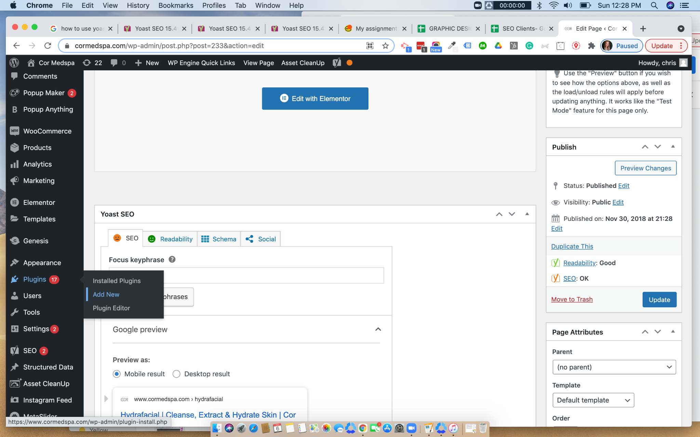
- Download the Yoast Plug-in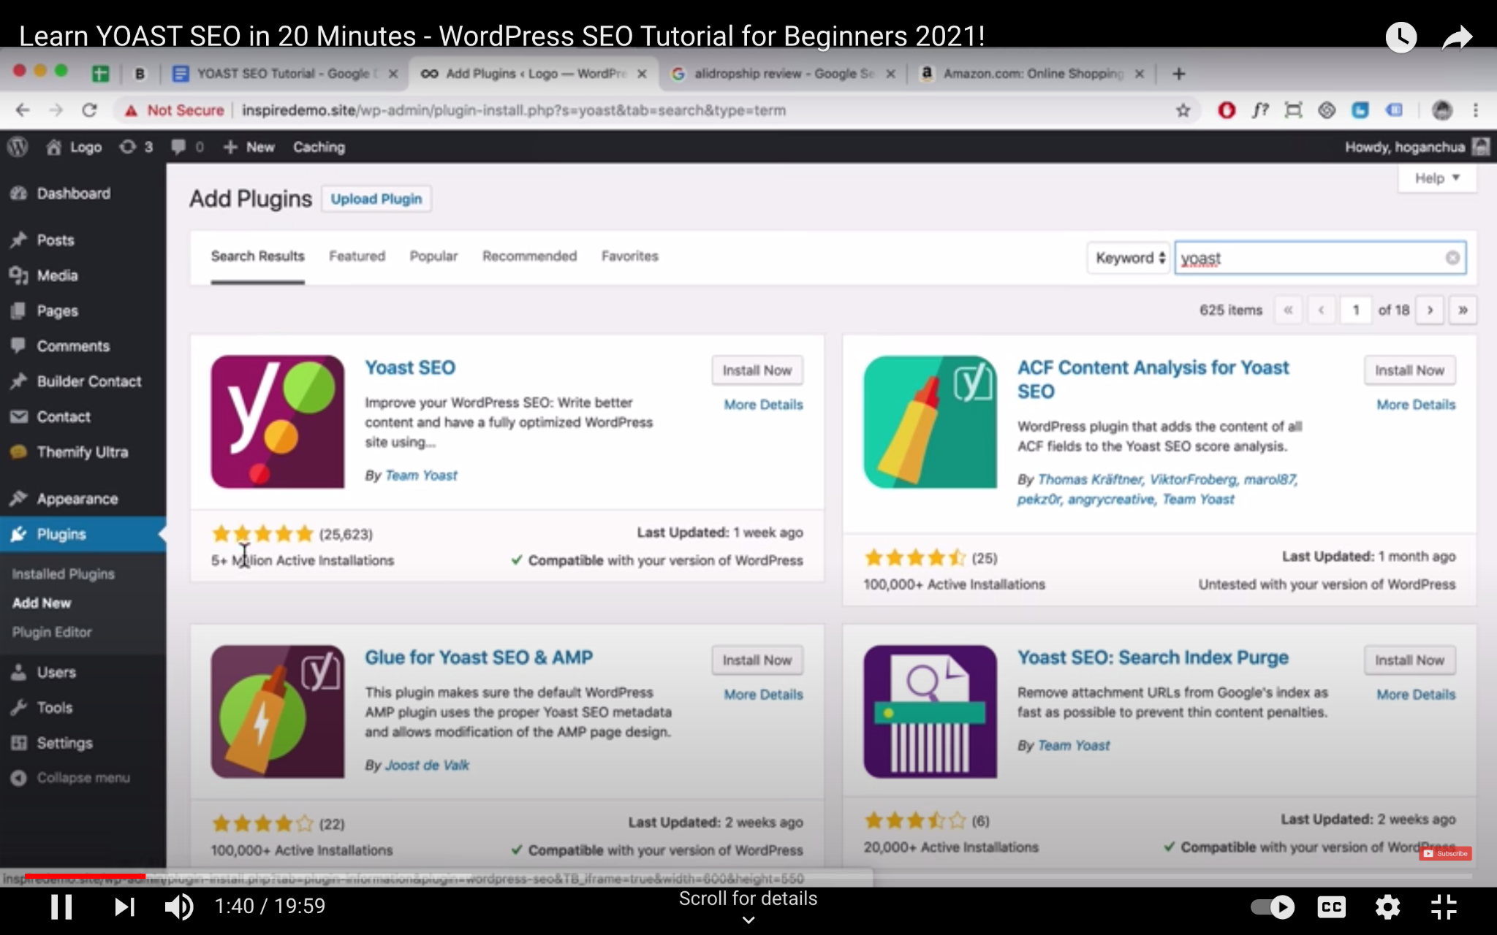
- Select if the site is either a.Under construction or b. Done and ready for crawling.
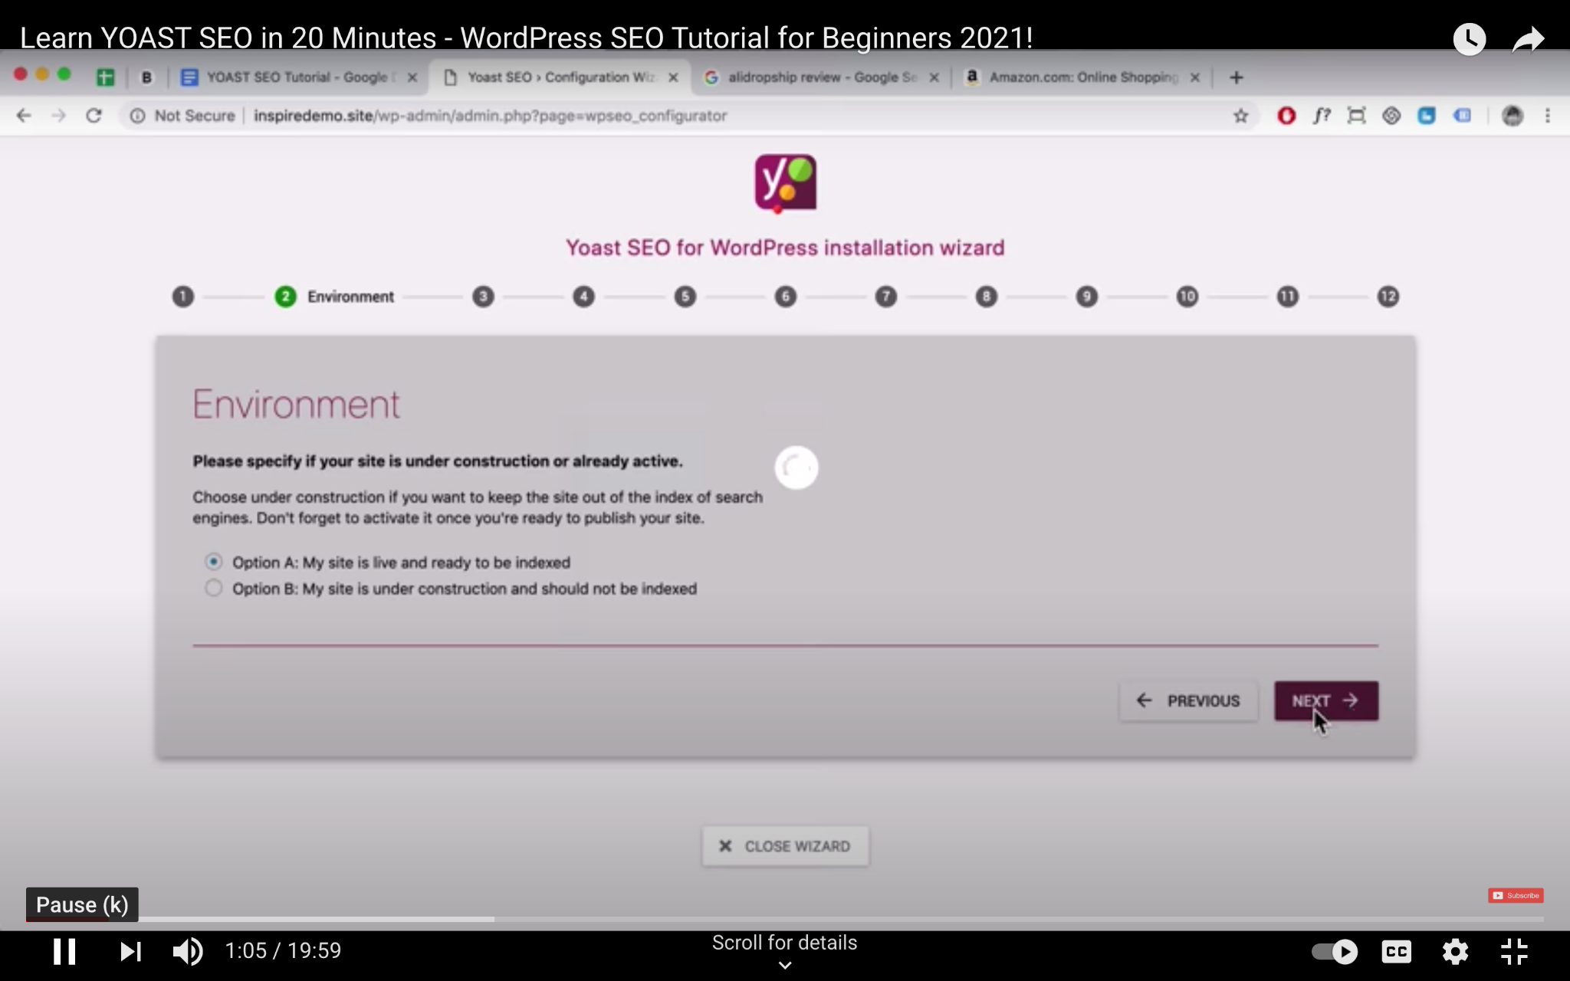
- Choose site type: i.e. blog, online shop, news, small office, corporation, portfolio, or something else
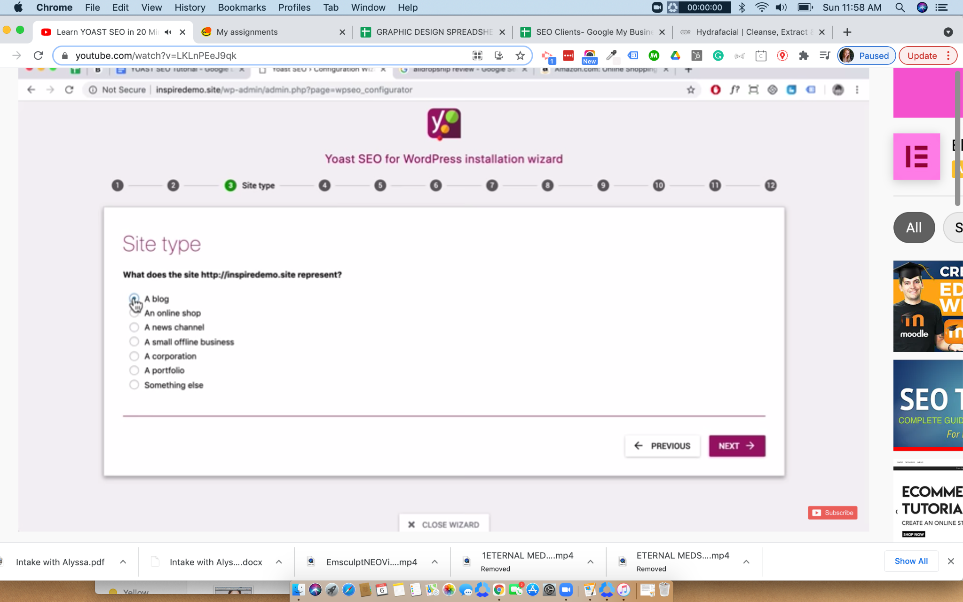
- Classify if site is for a person or a company
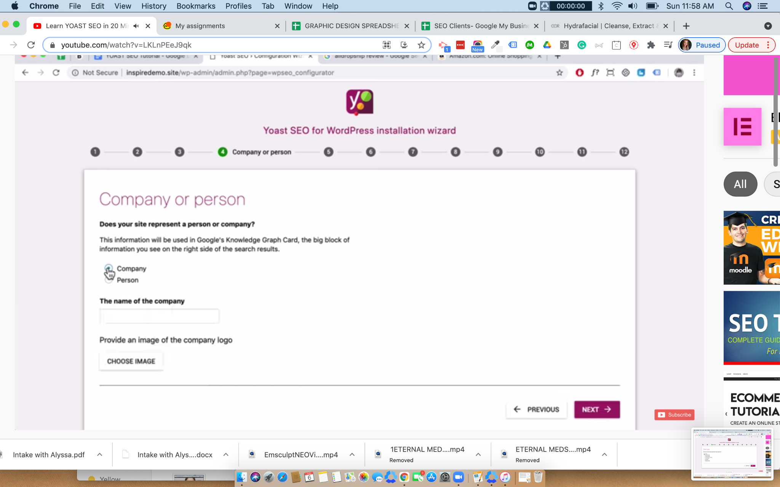
- Connect social profiles: i.e. Facebook, Instagram, Youtube, Linkedin, Twitter, Pinterest, Google+
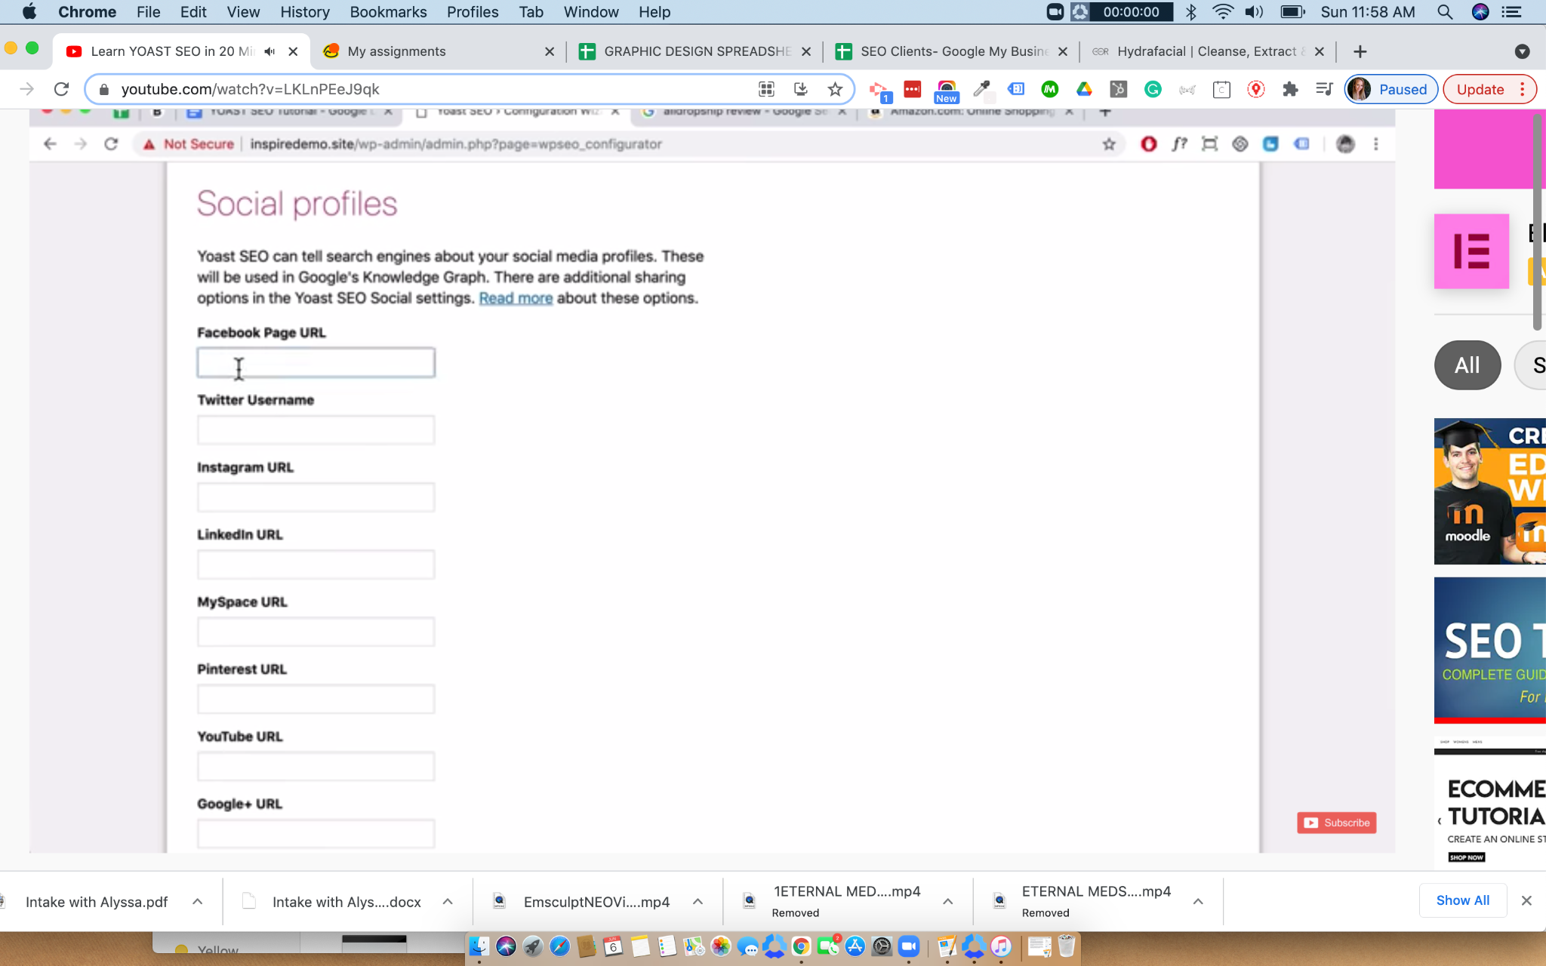
- Set search engine visibility options. *Most often turning off crawling for layouts and parts are recommended to be turned off.
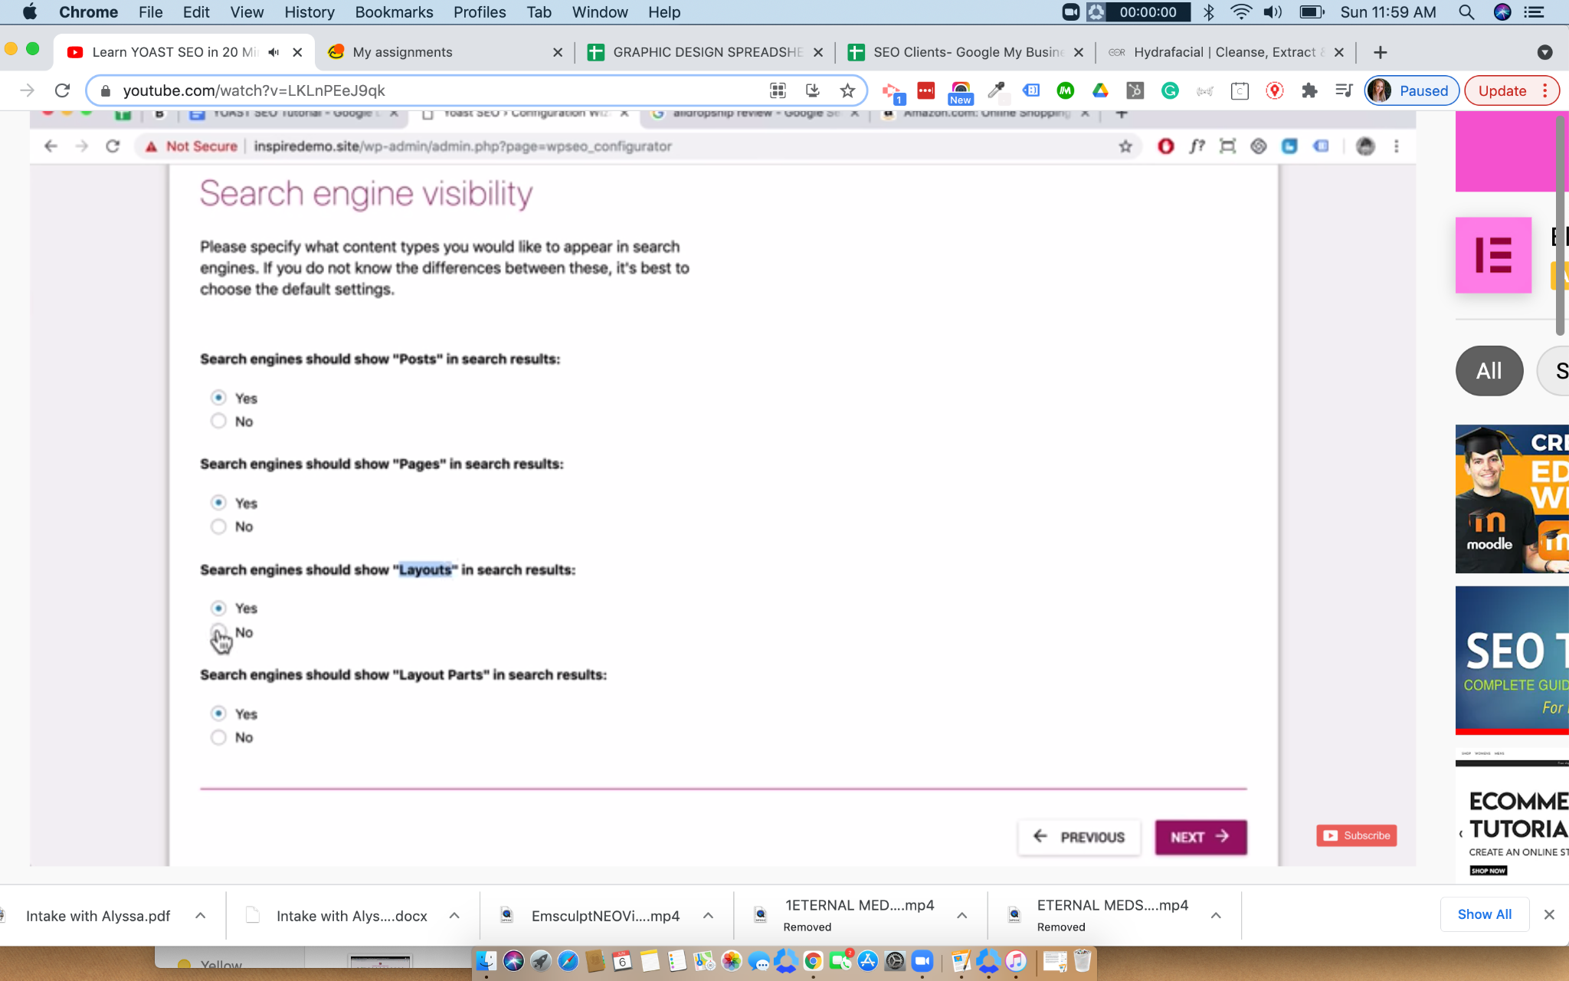
- Multiple authors option. Highly recommended to only have one author to avoid duplicate content issues.
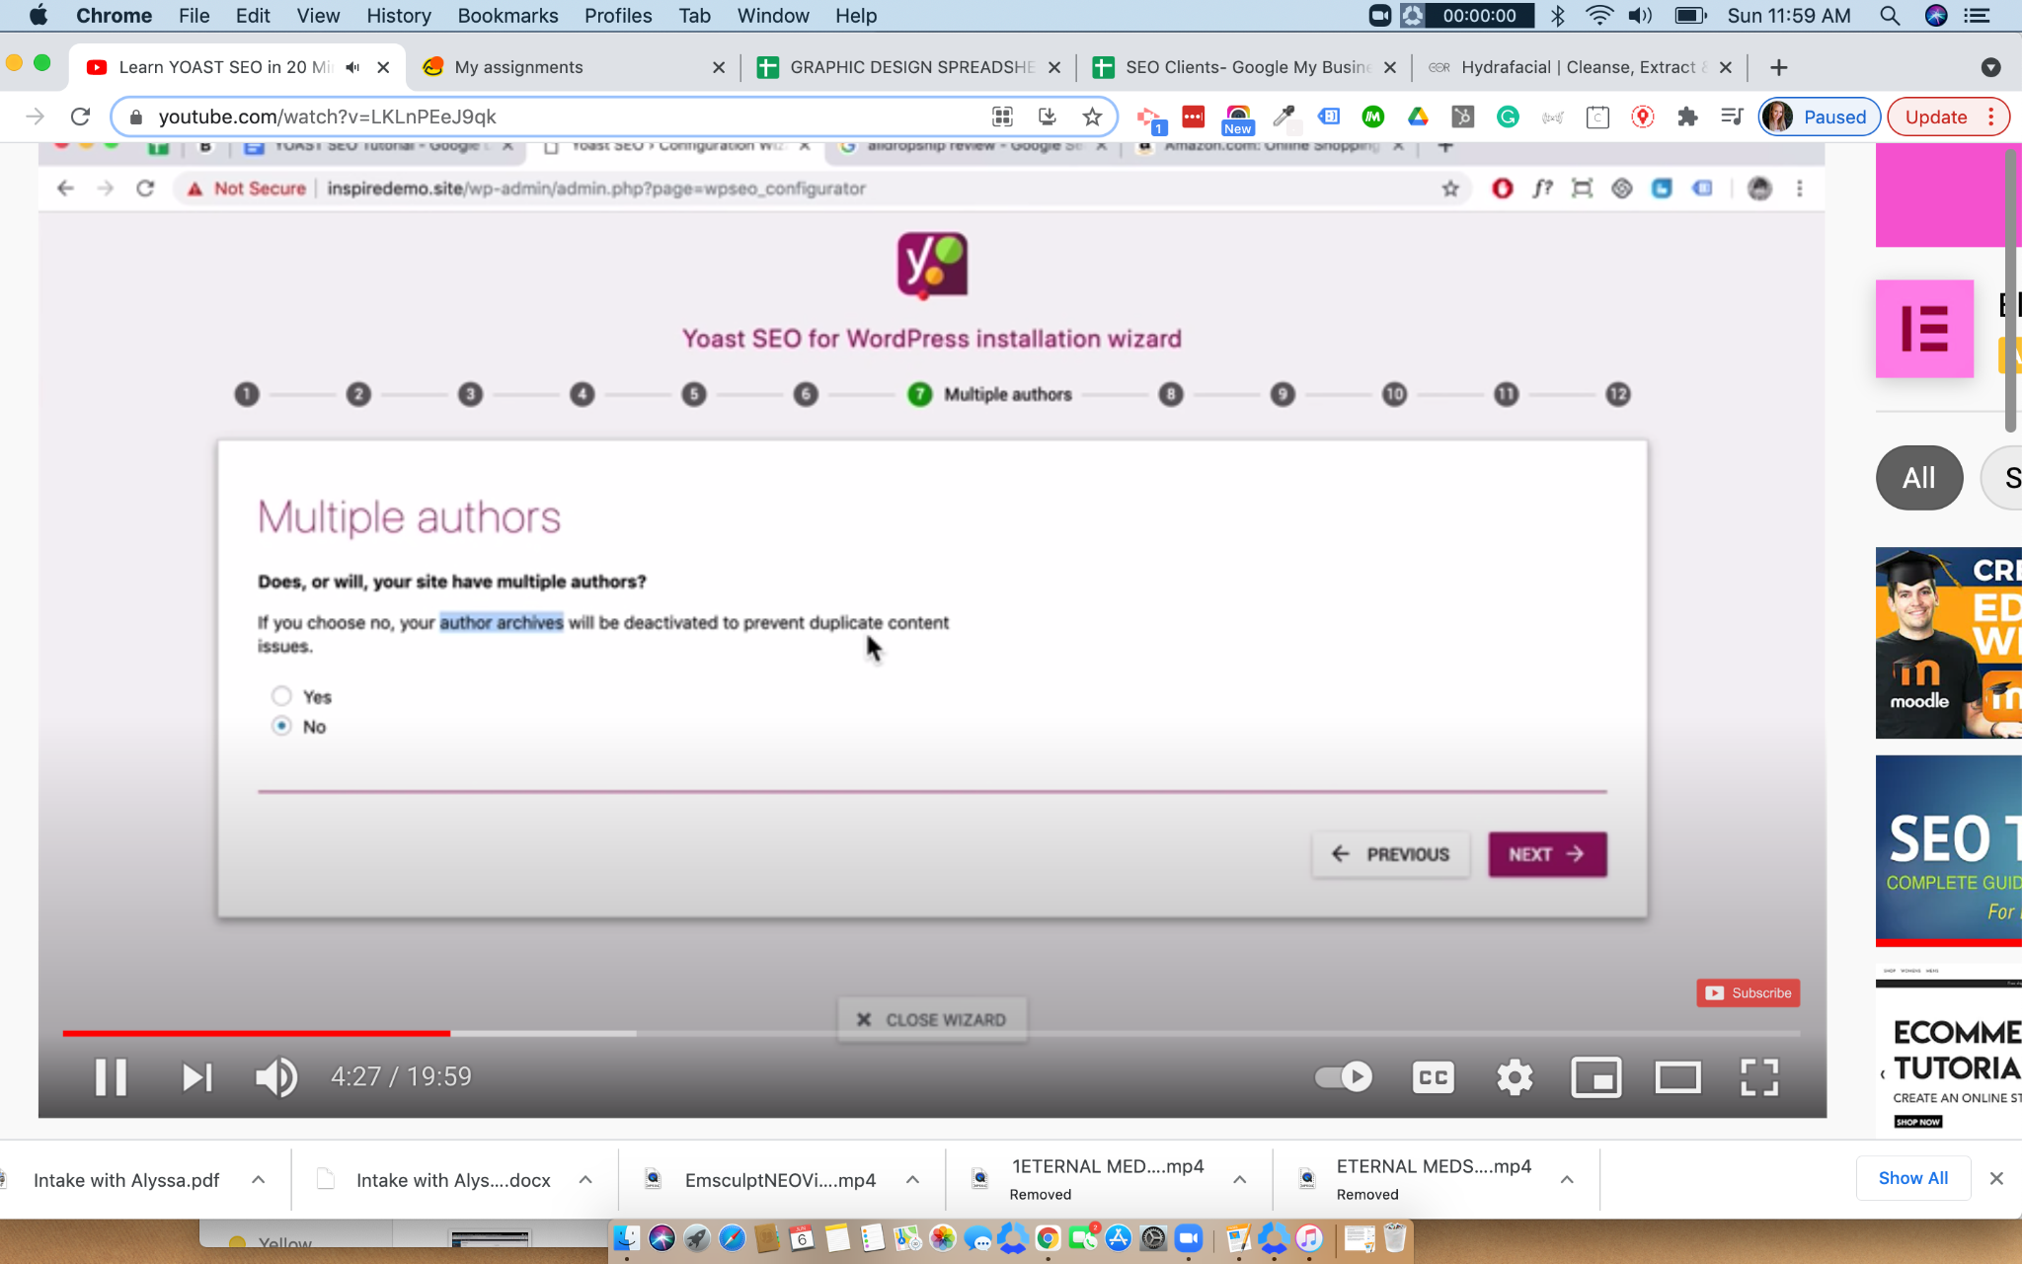
- Index site to Google Search Console (and/or other search engines of choice).
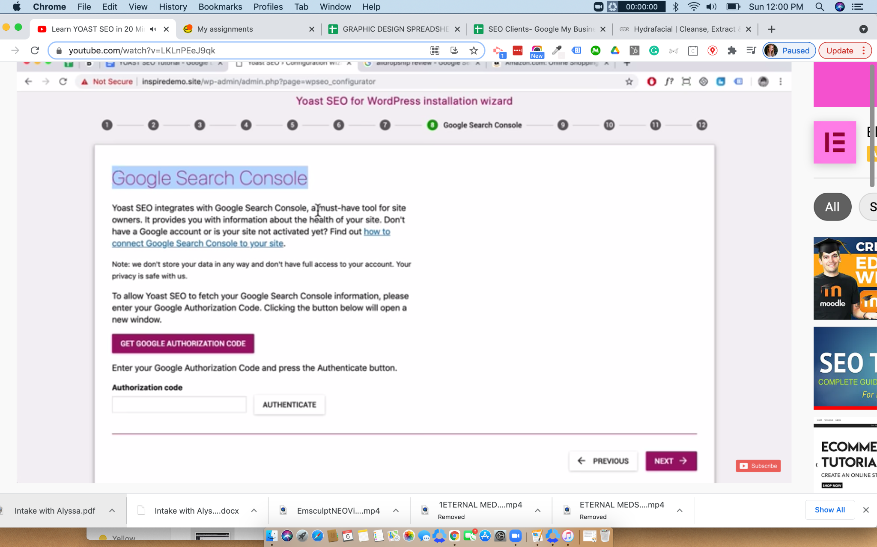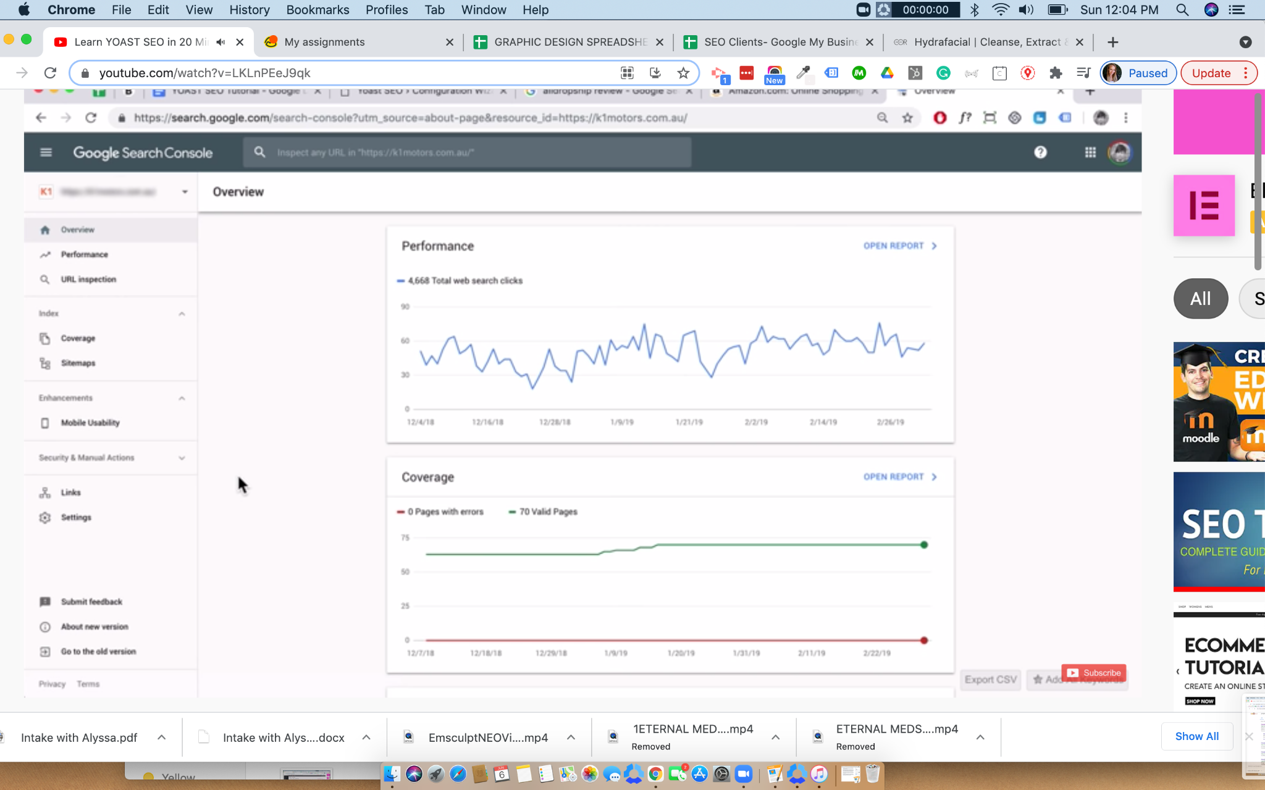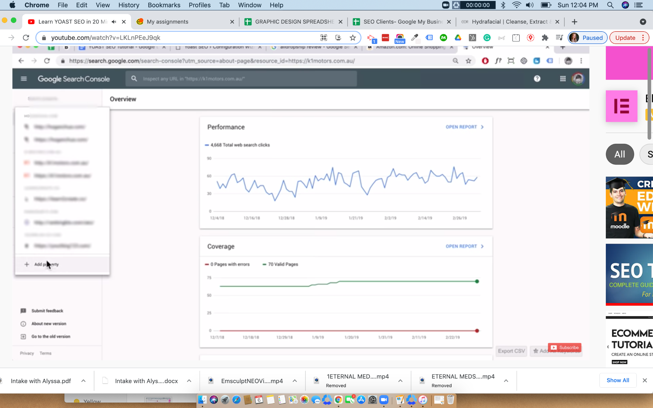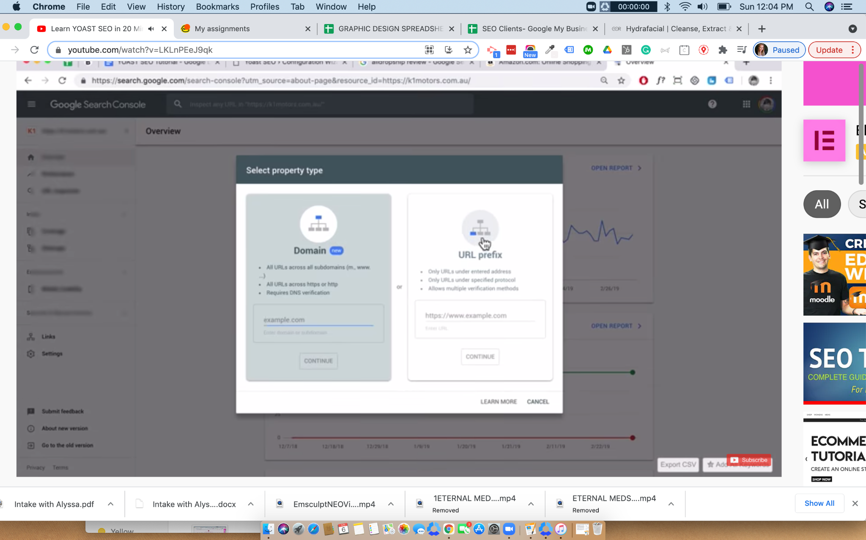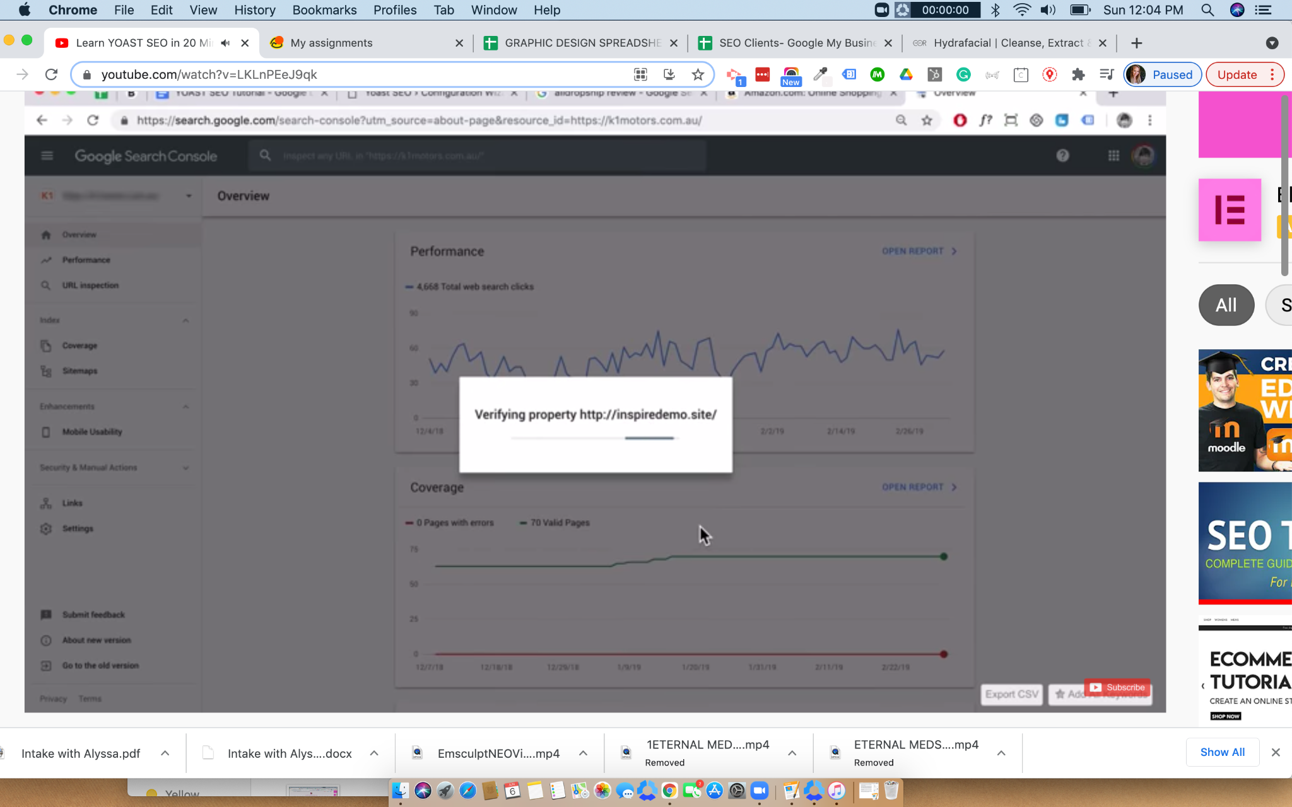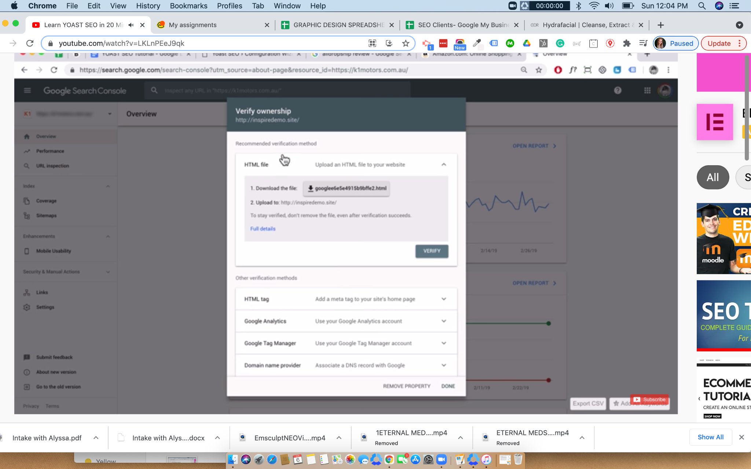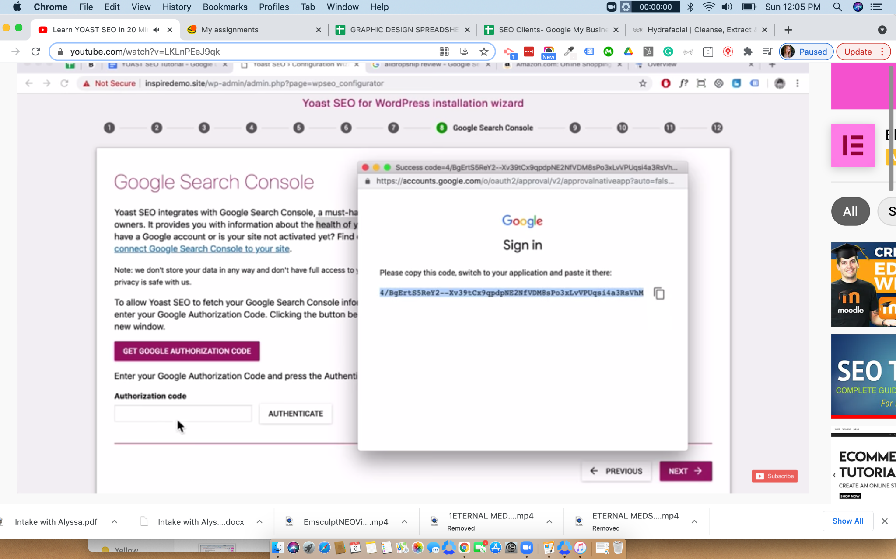
- Select site title and separator settings
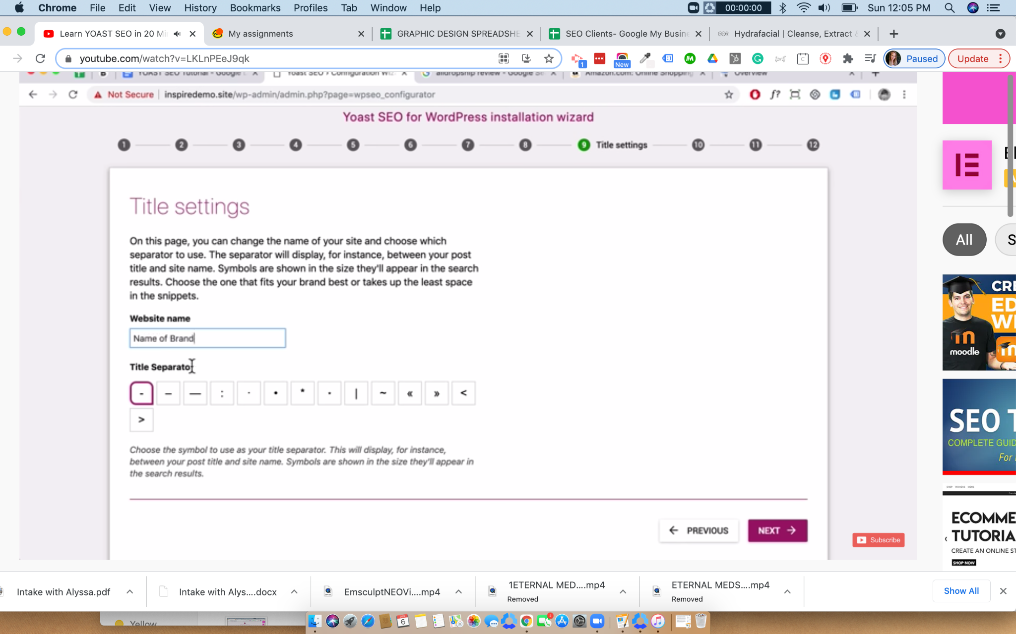
- Verify ownership of site with Google Search Console
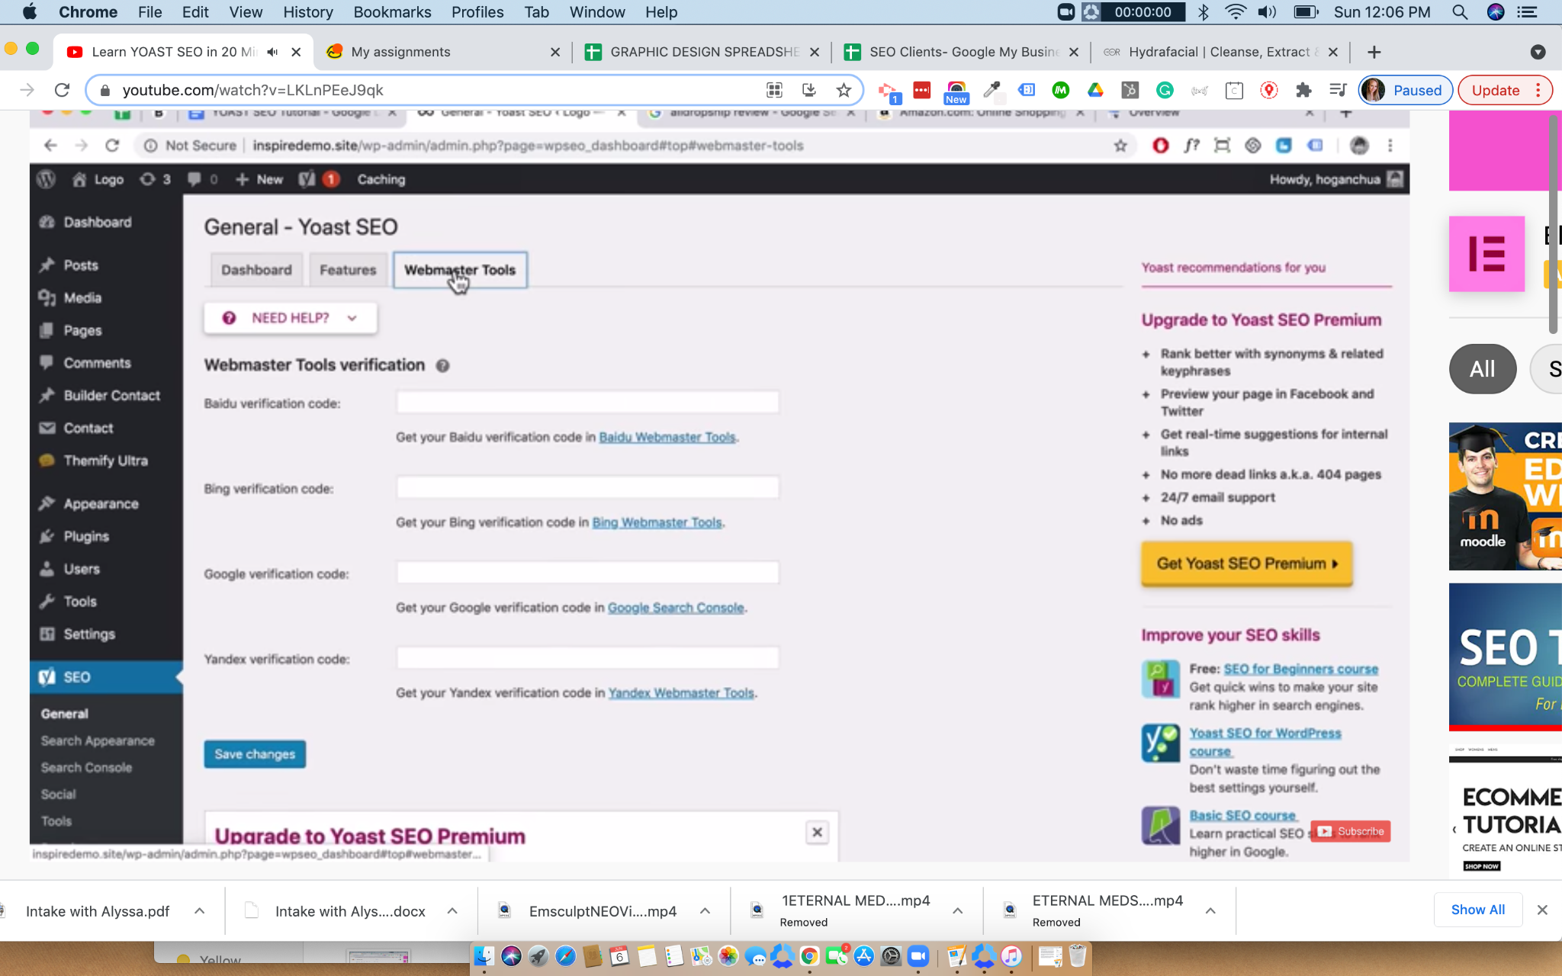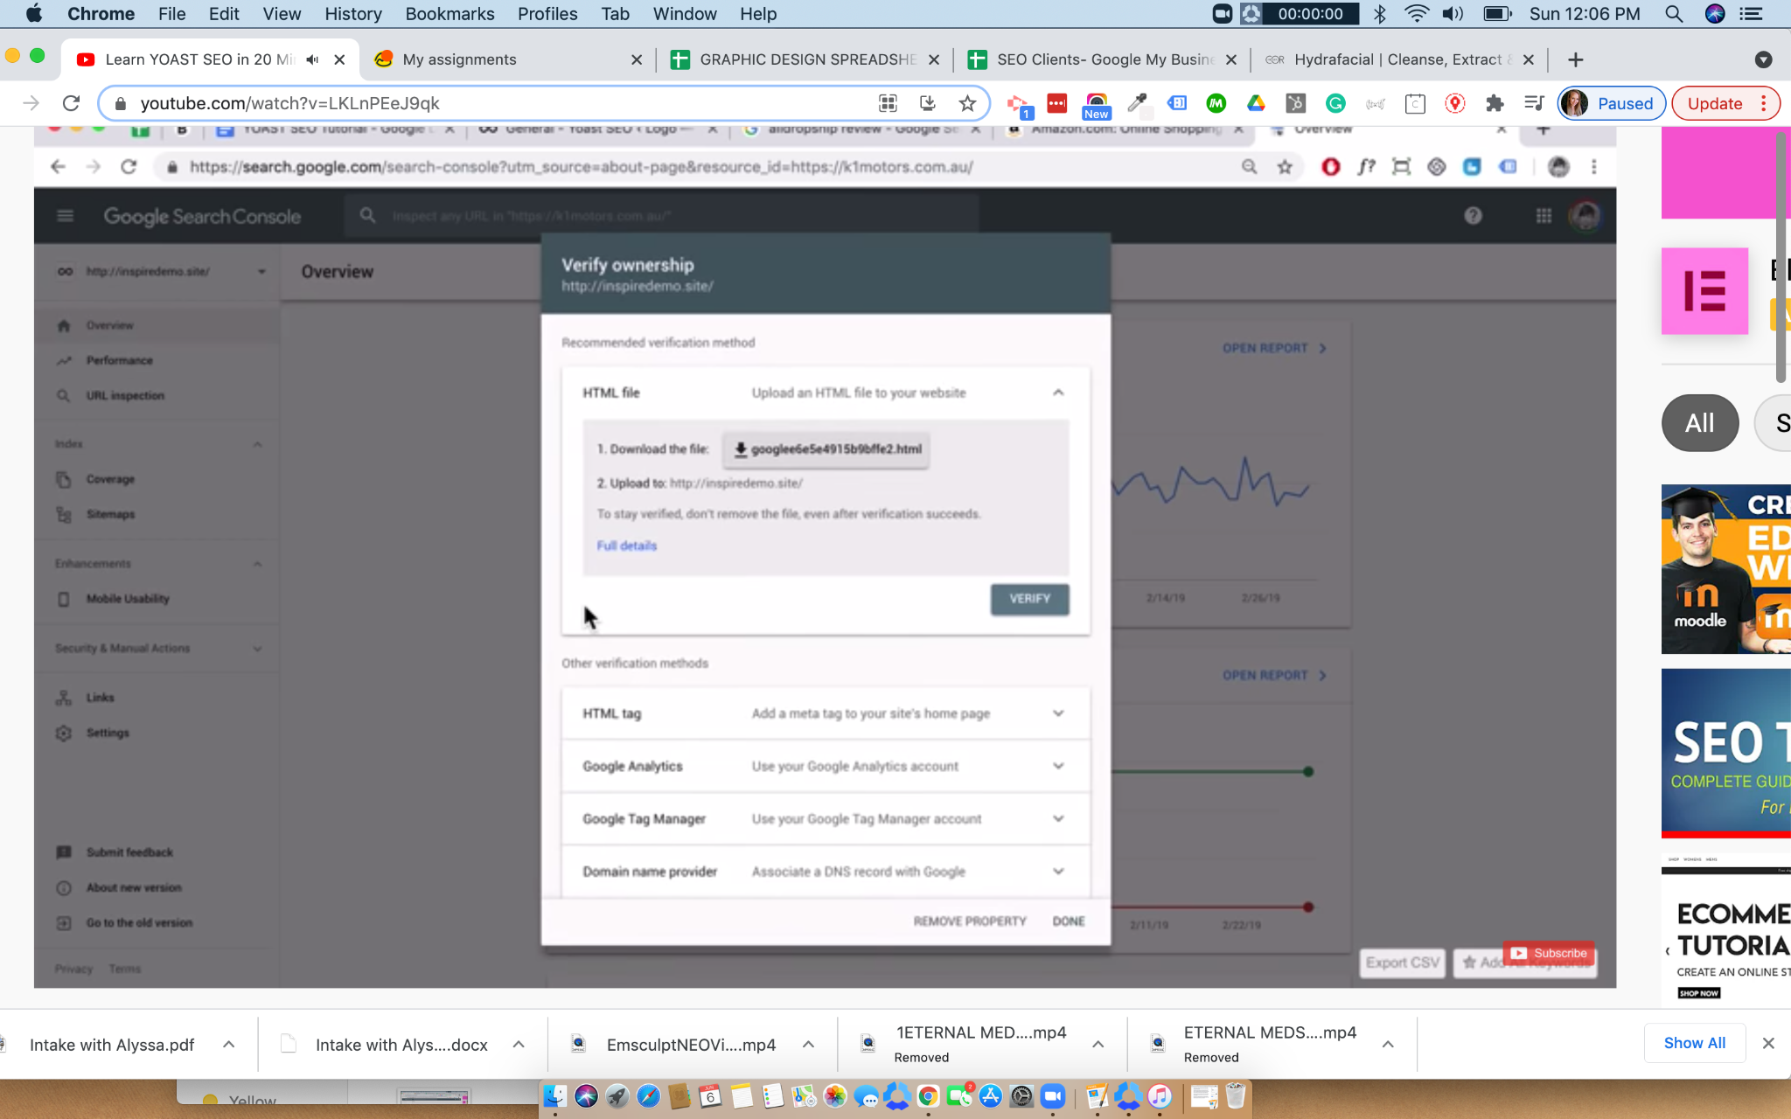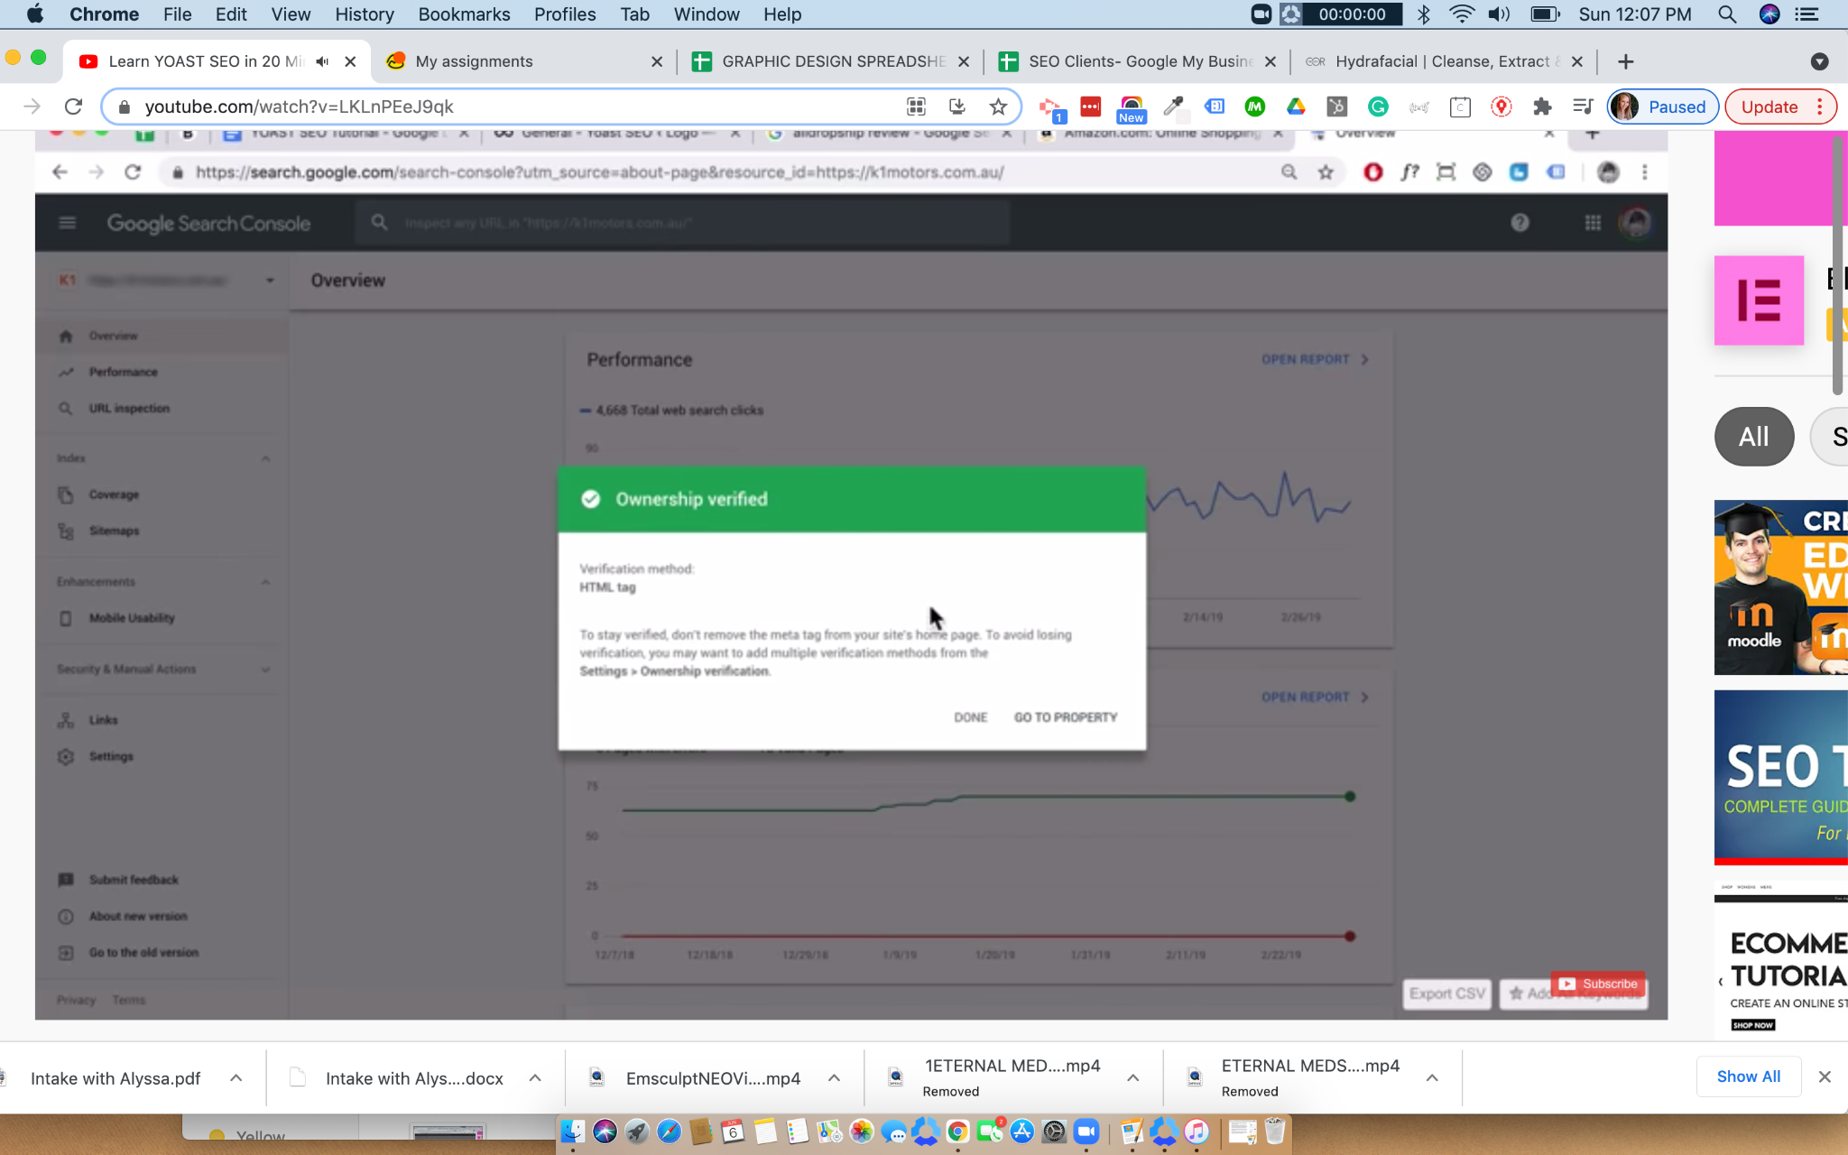
- Succes!
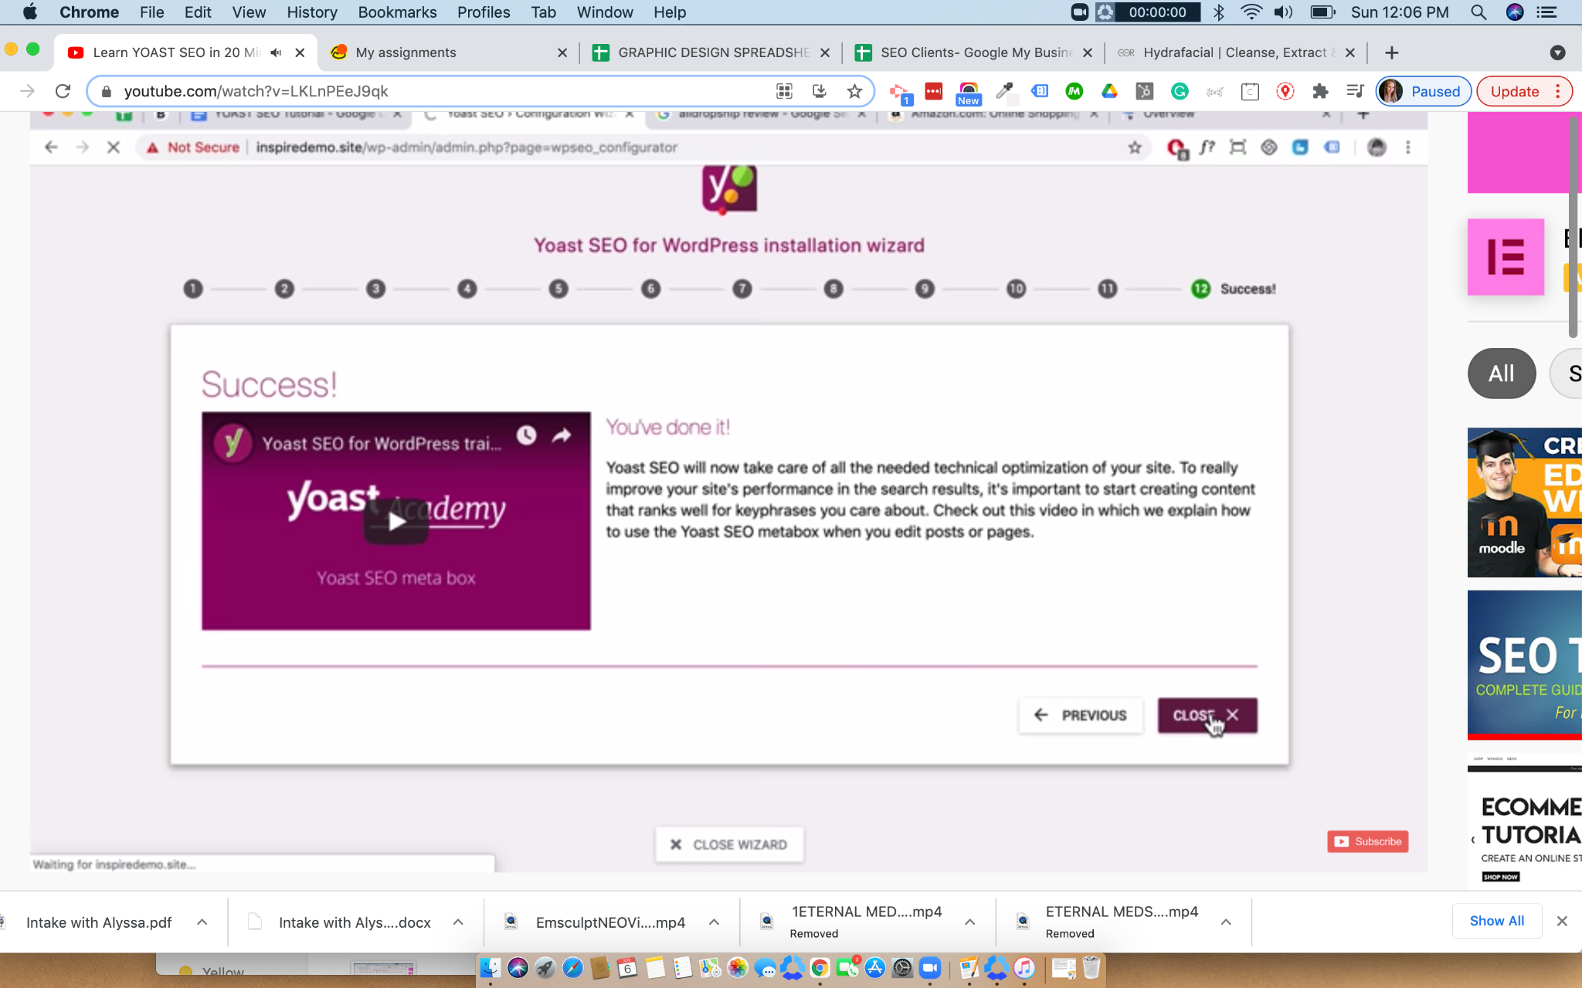
Yoast SEO Analysis & Readability

Suggested edits are provided from the Yoast plug-in for your website. They include edits on readability of the article or page and overall page search visibility options (i.e. site title, slug, and meta description). Each page will have unique keywords and descriptions, keep this in mind when having Yoast auto fill the site title and meta, or if it would be best to input that manually. All of these are aspects of how search engines crawl for relativity of content.

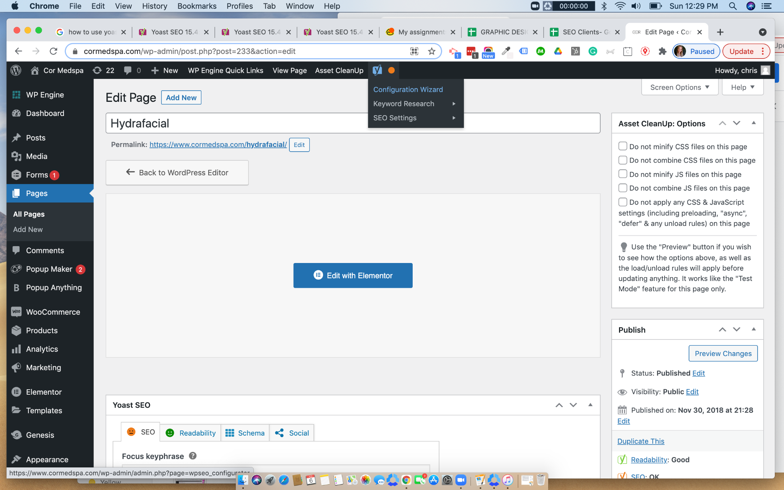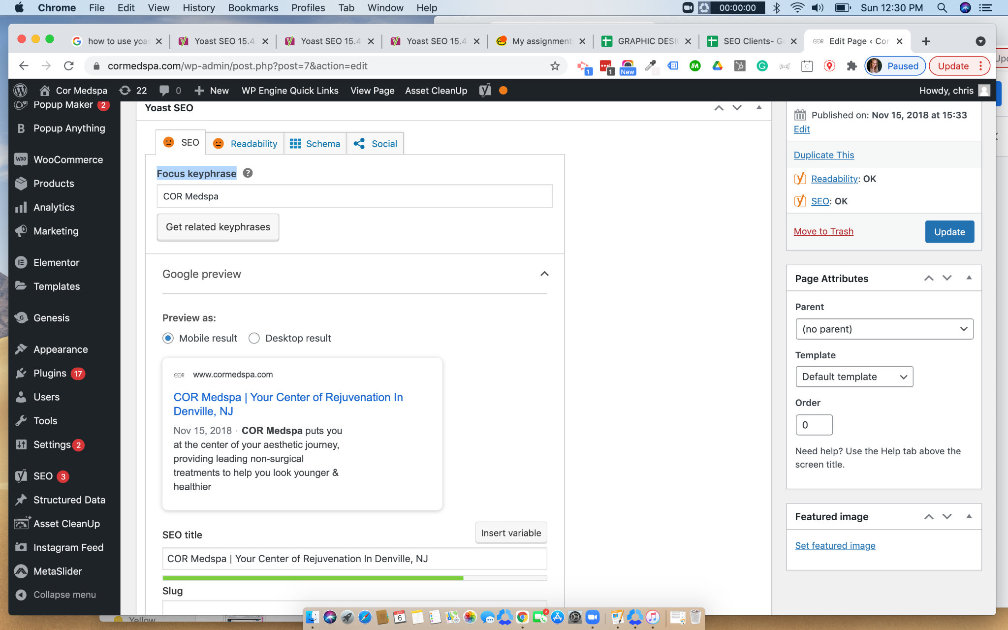
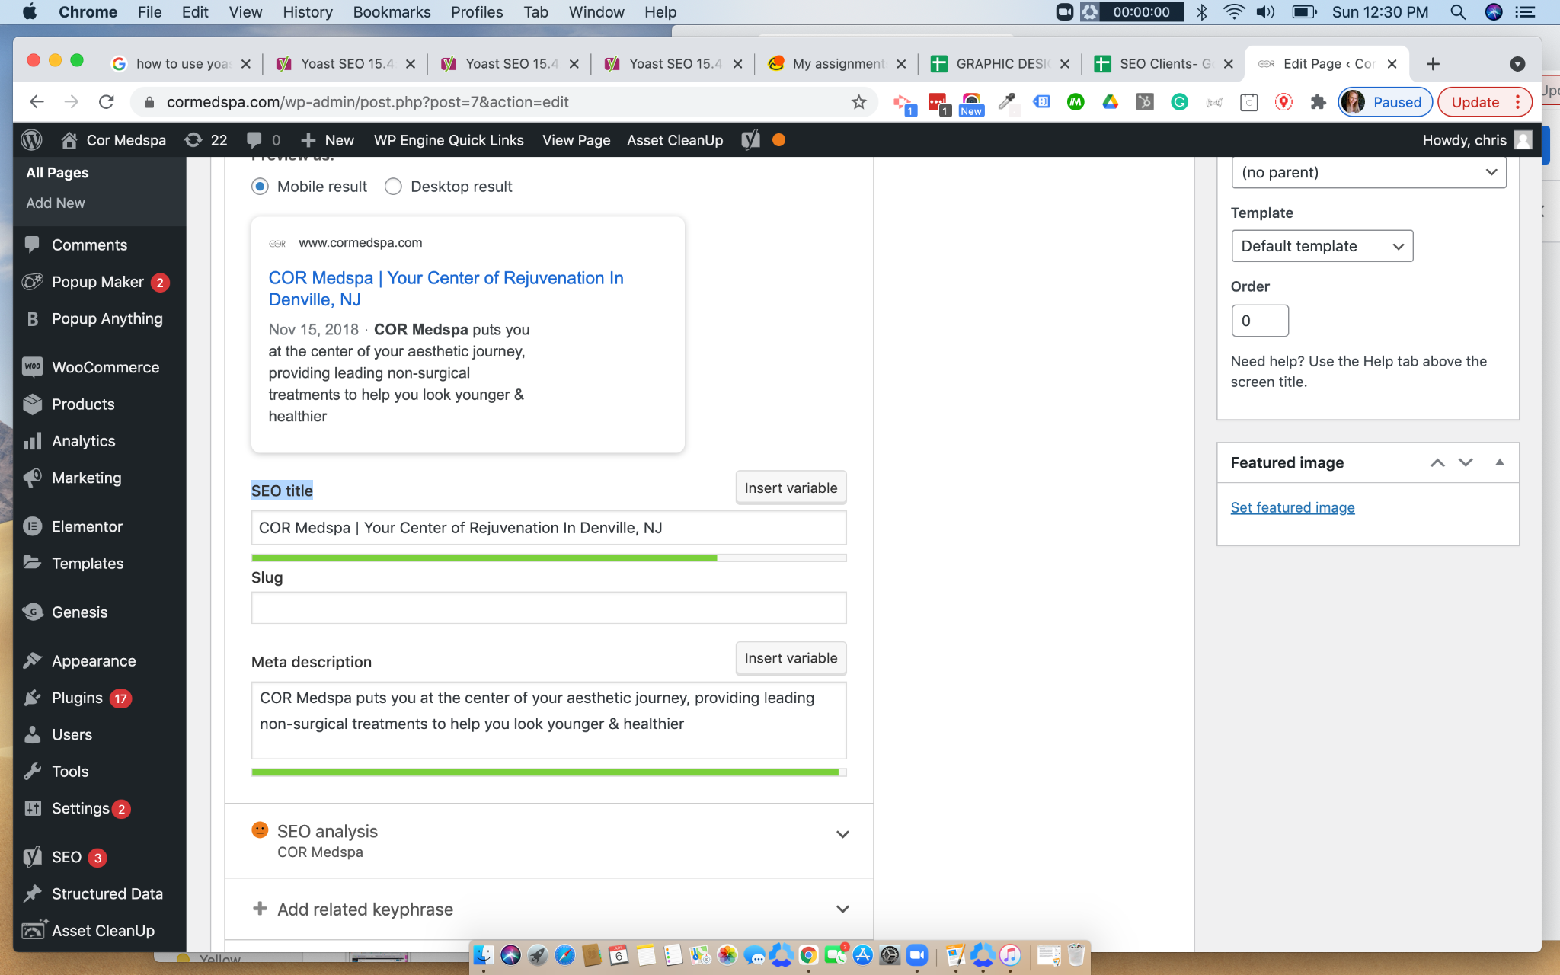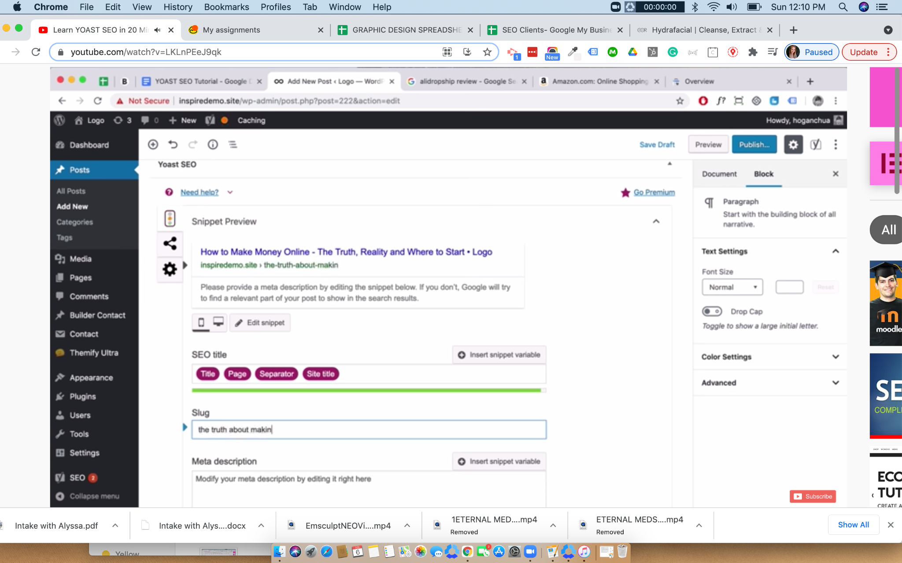

Readability and content with focus on keyphrase density play an important role in ranking well with search engines. Yoast offers tips and suggestions on optimizing based on keyphrase, so when writing keep these things in mind:

- When writing a blog, create on Google Docs first then paste it into wordpress page theme.
- Add focus keyphrase
- SEO Title
- Slug, should be relevant to content (Name after URL)
- Type focus key phrase in SEO title and meta description
- Yoast will show the following colors: Red (problems ) Orange (Needs Improvement) Green (Good) *not always accurate, use common sense with proved SEO methods that work.
- Internal links, link to another page/post on the website
- External links (usually open to a new tab)
- Keyphrase density (work it in naturally, not in a way that doesn’t make sense
- Images/ALT helps break up the text and makes it easier to read
- Stopwords negatively affect SEO
- Featured images help SEO

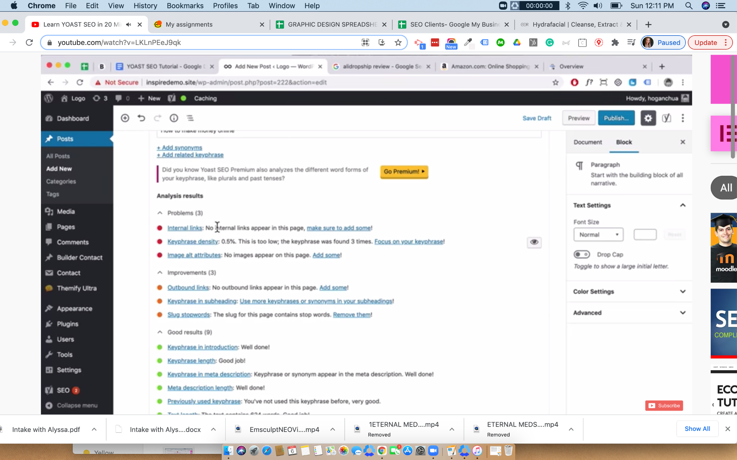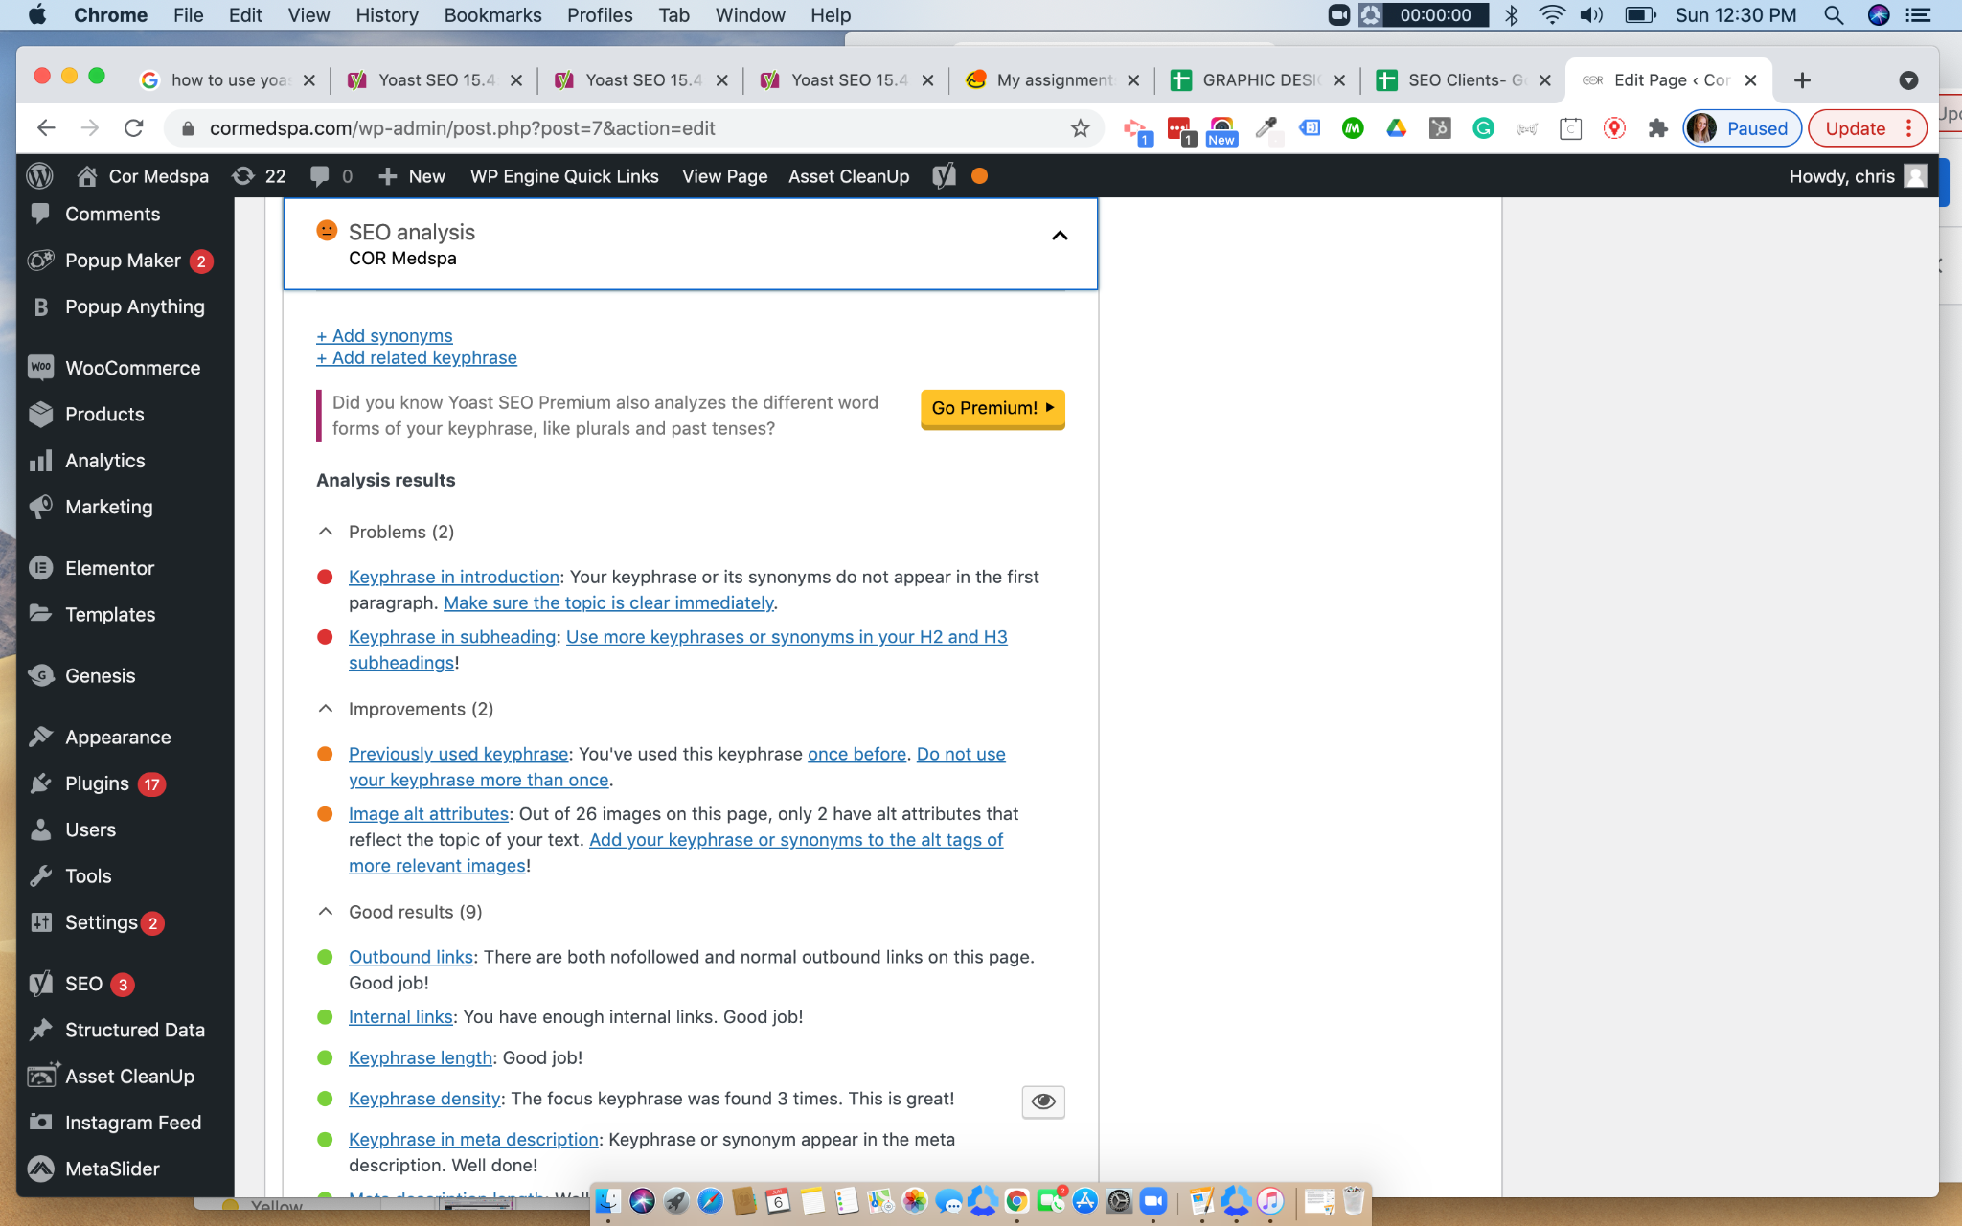

*A green bullet doesn’t mean that your content will be in the top results on Google. The age of a website can determine how well it will rank. Links from other websites to your page are called backlinks, and engagement plays a role as well.

On pages, Yoast is not very accurate, it is more so optimized towards blogs. The pages don’t need to be optimized as much.

Final Remarks and suggestions

Don’t keyword stuff with the content, use less than 3% in the article. The more content, the better. SEO Analysis on Yoast is more relevant to blogging. Write more than 500 words per post, and be informative. Include internal links and external links. GOOGLE LOVES interlinking. ALT attributes tell google what the image is and helps with ranking. Sometimes Yoast makes mistakes. Keep in mind the cornerstone content which is the core of the website or page.
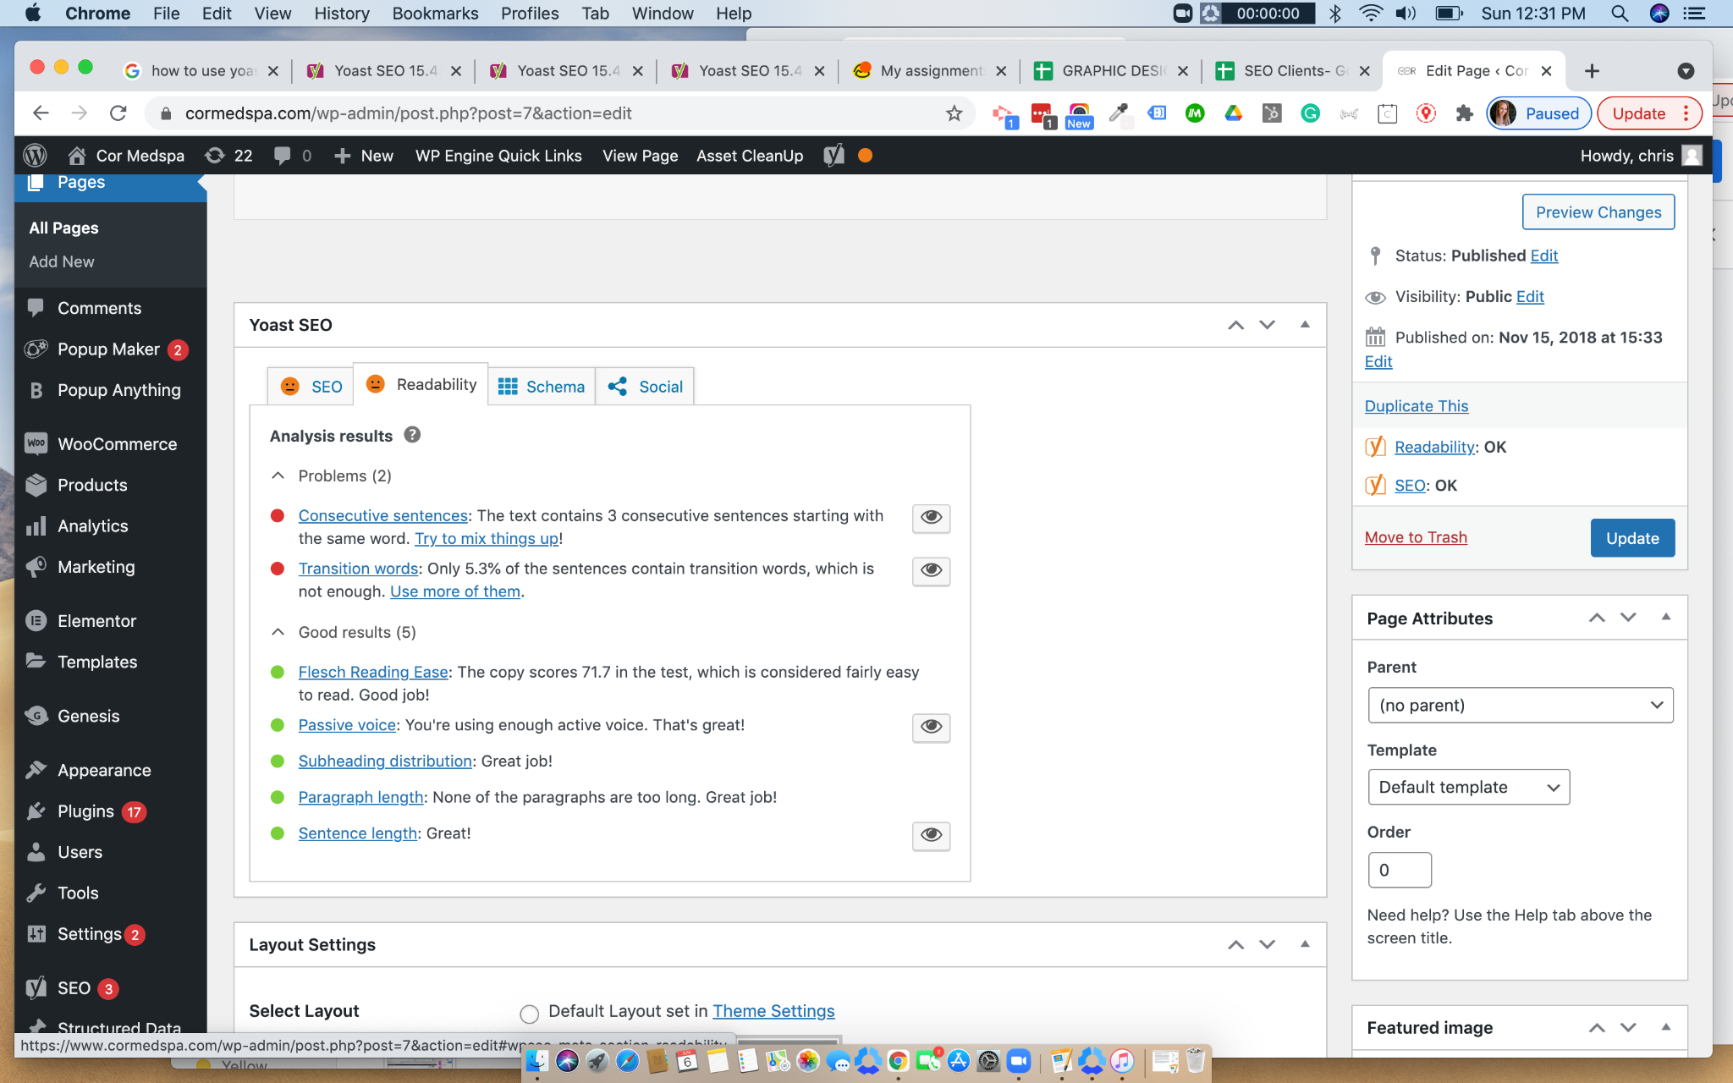

Sources
Some images & information captured from: https://youtu.be/LKLnPEeJ9qk
Information from: https://youtu.be/ihymaUI1ErY
Quick tip & Outline: https://yoast.com/help/how-to-use-yoast-seo-in-elementor/
Quick Intro on how to use Yoast: https://youtu.be/Taywzk3VVLs
https://yoast.com/features/elementor/

