

Header video with logo like Skinney

BOOK NOW

The Biologique Recherche treatment protocol is always based on a personalized dermo-cosmetic diagnosis with thorough analysis of each person's Skin Instant© – a distinctive approach that blends the physiological, the behavioral, and the tactile.
The methodology is designed to pinpoint the treatment protocol best suited to each individual's needs and skin concerns.
A bespoke power facial designed to show transformative and corrective results for all skin types.
“Skin is the reflection of ourselves; it isn’t consistent, but multiple over the course of a day, of a life. Everyone has different Skin Instants©. Biologique Recherche’s Methodology treats each person’s epidermis in a personally tailored way.”
Dr Philippe Allouche

Biologique Recherche is a French luxury skincare line utilizing unique formulas that are rich in botanical, marine and biotechnical extracts. Each facial is highly personalized and includes a deep cleanse, exfoliation, effective lifting, and face + décolleté massage, using a curated, state-of-the-art cocktail of raw and highly active ingredients.

Customized Face Treatments
Facial treatments are tailored to the needs of your Skin Instant® by one of our Biologique Recherche experts. The longer your skincare treatment is, the more specific techniques and additional treatments can be added to give you the best experience.
60 minutes $250
75 minutes $300
90 minutes $350

˅ Seconde Peau Treatment
60 minutes $450
90 minutes $550

˅ Micropuncture with Skinpen® & Cocktail D'actifs Regenerants
60 minutes $650

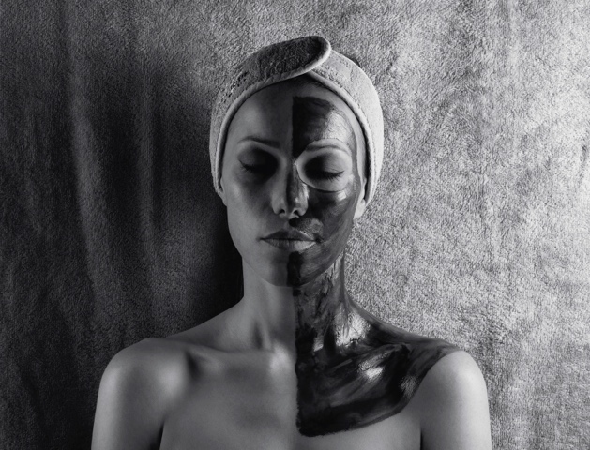
Treatments Available:

˅ SOIN RESTRUCTURANT ET LISSANT
For better toned skin
(Drop down) A reconditioning treatment that tones the epidermis, suitable for all Skin Instants©. The skin of your face, neck and décolleté is drained, smoothed and toned.

˅ MC 110
To reduce wrinkles
(Drop down) A treatment that smooths out fine lines and wrinkles for dull Skin Instants©. The skin of your face, neck and décolleté is toned and redefined.
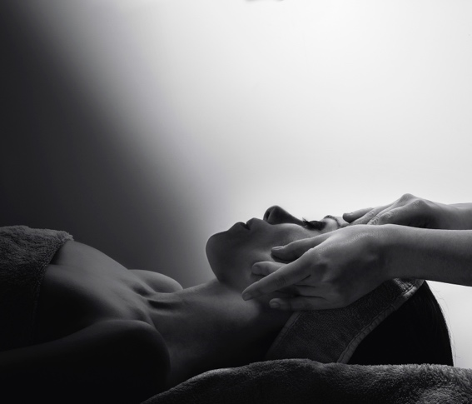
˅ LIFT C.V.S
For lifted, better toned skin
(Drop down) An exfoliating and lifting treatment combined with massage techniques for mature Skin Instants©. Skin is smoothed, toned and refined.

˅ SOIN MASQUE EXFOLIANT P50 VISAGE
For clearer skin
(Drop down) An exfoliating and regenerating treatment for keratinized Skin Instants© and skin with an irregular microprofile. Leaves skin even, smooth and radiant.

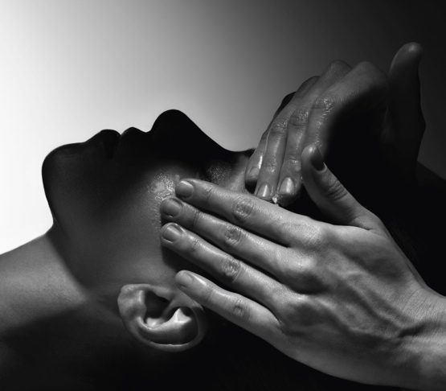
˅ PEELING AUX ACIDES DE FRUITS
For more beautiful skin
(Drop down) An exfoliating and revitalizing treatment for wrinkled, dull and thick Skin Instants©. Skin is smoothed and refined.

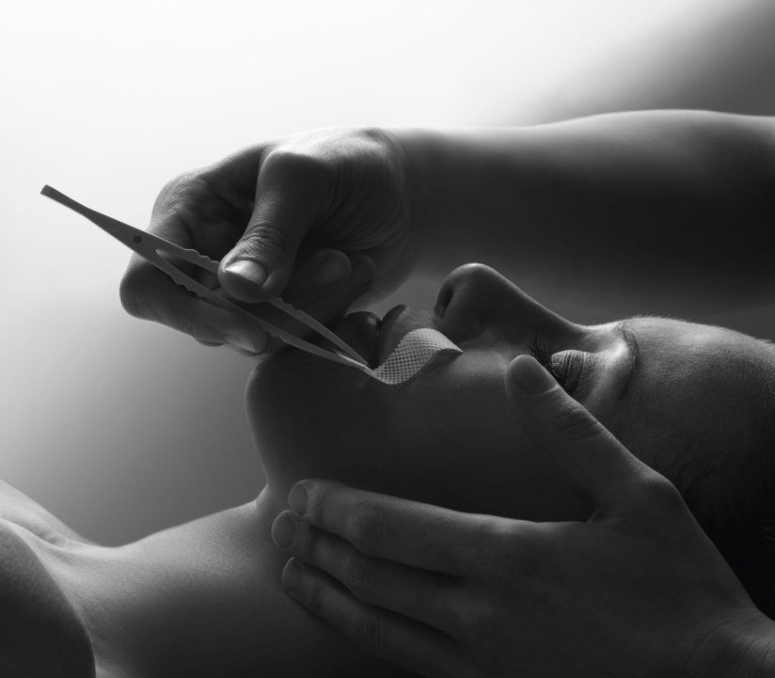

˅ SECONDE PEAU TREATMENT – The Red-Carpet Facial
Illuminating, reviving, & invigorating
A world first in professional esthetics, this regenerating and lifting treatment is created using an electrospun mask with 80% pharmaceutical grade hyaluronic acid for Skin Instants© damaged by the signs of ageing. This can smooth out wrinkles in addition to healing scars. We recommend 3 sessions at 1-week intervals and then one repeat session per trimester.

MICROPUNCTURE WITH SKINPEN® & COCKTAIL D'ACTIFS REGENERANTS
During your microneedling or micropuncture session, we infuse Biologique Recherche Cocktail d’Actifs Régénérants serum with over 58 active ingredients including vitamins B, E, C and A, amino acids and polypeptides that have been developed using cutting edge biotechnology. The Cocktail d’Actifs Régénérants is an over-boosted serum which reduces and prevents the appearance of fine lines and wrinkles by activating cellular regeneration and stimulating collagen and elastin production but also protects the skin from the harmful effects of free radicals by boosting the skins protective functions.

OTHER PERSONALIZED TREATMENTS
HYDRÉCLAT TREATMENT
For better toned skin
A hydrating and complexion-enhancing treatment designed for dehydrated Skin Instants©. The skin on your face seems plumped up.

BIOSENSIBLE TREATMENT
For soothed skin
A treatment that stabilizes Skin Instants© that are particularly fragile or prone to reactions. The skin of your face, neck and décolleté feels soothed and more comfortable.
Sebum-Rebalancing Treatment
For clearer skin
A treatment that controls excess sebum on the skin’s surface and detoxifies oily and acne-prone Skin Instants©. Skin is purified and unified, while pores are tightened.

PIGM 400 TREATMENT
To lessen pigmentation spots
A complexion-evening treatment to prevent and reduce the visibility of pigmentation spots for uneven and dull Skin Instants©. The skin of your face, neck and décolleté looks more uniform.

Pre- and Post- Operative Treatments
To heal and sooth
We offer targeted treatments for those who have undergone, or are planning to undergo, an esthetic surgical procedure. These treatments will help prepare your skin in order to optimize the results, or speed up your skin’s regeneration.

FORMULAS COMBINING AUTHENTICITY AND BALANCE
Biologique Recherche products meet specific criteria:
- Use plant, biomarine and biotechnological extracts at very high concentrations – above 20% in most products
- Rule out the use of synthetic fragrances, to preserve the integrity of the formulas and try to avoid any adverse reactions
- Retain the original structure of the active ingredients as far as possible, by maximizing the use of cold processing in our formulas
- Ensure the effectiveness of a Biologique Recherche product through the composition and quality of its active ingredients

You can move around things as you see fit. We love this BR page https://www.ambassade-biologique-recherche-losangeles.com/en/bespoke-face-treatments/
Let us know if we can be of any more assistance. We are still producing some content and will get it out to you soon. Thank you!

