H1 BOTOX IN WESTPORT | ANTI-AGING TREATMENTS
Botox is the most popular cosmetic treatment in America for good reason. It dramatically decreases the visibility of facial lines and wrinkles, allowing men and women to appear significantly younger and revitalized. This FDA-approved treatment is formulated for targeting wrinkles on the forehead and between the brow, and fine lines around the mouth and eyes and each year, millions of people choose Botox as a non-surgical substitute for invasive solutions like a brow lift or facelift. When administered by a skilled injector, Botox is safe and effective, requires no downtime, and results in a natural appearance that doesn’t interfere with facial expressions.*¹
Tired of looking tired and older than you feel? Botox may be the ideal, non-surgical solution for you. Learn more by signing up for a complimentary consultation or by calling New Beauty & Wellness at (203)-720-6609. New Beauty & Wellness is the top provider of Botox in Westport and is entirely committed to our patient’s safety and satisfaction.

H2 Benefits of Botox
- #1 Non-Invasive cosmetic treatment in the world
- The only FDA approved treatment to reduce frown lines & crow’s feet¹
- Proven Safe & effective in 470+ clinical studies
- Rejuvenates the area around the eyes, brow & forehead²
- Quick & convenient with no downtime
- Results look natural & preserve expression
- Popular among men & women, aged 20 on up
- Halts the formation of dynamic wrinkles in young adults³

H2: Botox Treatment Areas

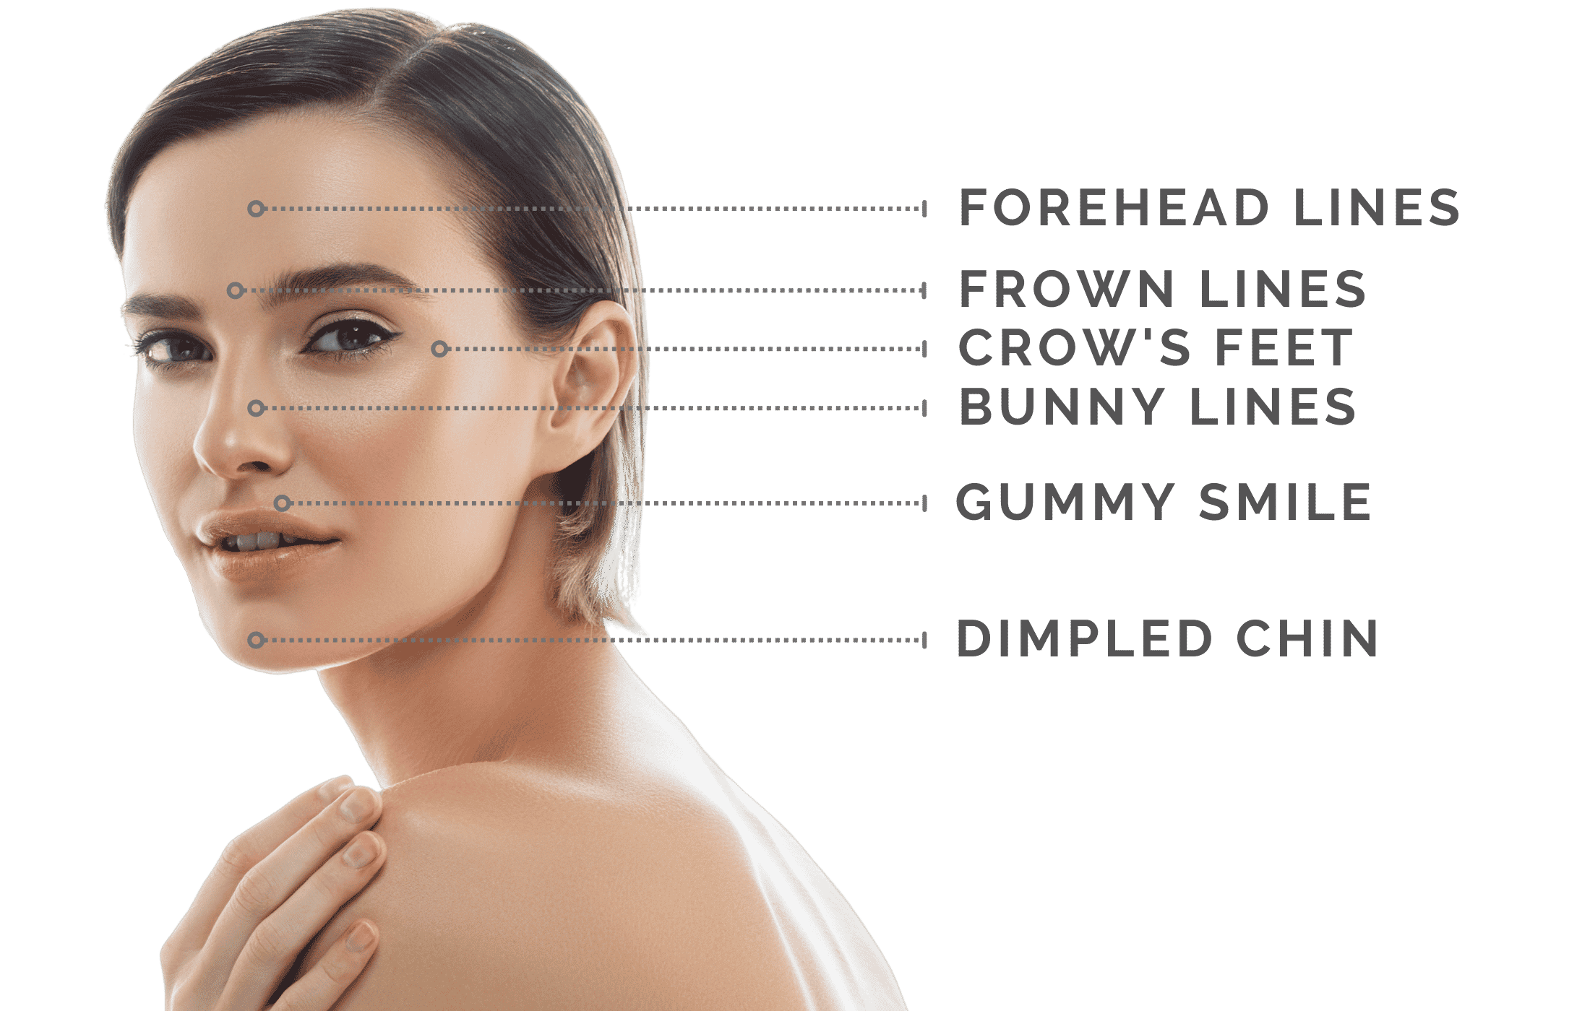

H2 Upper face:
- Frown lines (between eyebrows) – Glabella lines or frown lines are the vertical creases appearing between the eyebrows, generating a tired or angry scowling look. An expert practitioner at New Beauty and Wellness can smooth these frown lines, resulting in a rejuvenated and more relaxed appearance.
- Forehead lines – Forehead wrinkles or “surprise lines” appear more prevalent as we age. Excessive forehead lines give you a more aged appearance. Horizontal forehead lines are primarily due to genetic aging. Sun damage, smoking, and other forms of damage result in deep creases. Out anti-aging injections lessen the effect of forehead wrinkles.
- Top of the nose (bunny lines) – Bunny lines are creases that appear when the nose wrinkles up when we sniff or smell something, etc. Careful injections of Botox can improve the appearance of these lines.

H2 Eyes:
- Eyebrows/hooded eyes – Using an advanced technique, Botox injections can provide a “chemical brow lift” or “Botox facelift.” This procedure involves an experienced practitioner placing injections in specific areas on the upper face to open up the eye area and improve the appearance of droopy eyelids.
- Wrinkles around the eyes (crow’s feet) – One of Botox's most popular treatment areas are reducing crow’s feet. These appear at the outer corners of the eyes, and they show up the most when you smile. Botox is an effective treatment for reducing their appearance.
- Under the eyes (tear trough) – Under-eye bags can be treated with Botox injections using a cautious approach.

H2 Lower Face:
- Lipstick lines (around the mouth) – Fine lines around the eyes are known as “lipstick lines.” They become more evident as we age. Most practitioners recommend treating these with dermal fillers, but Botulinum Toxin helps turn the corners of the mouth up and improves a smile to reduce the appearance of lipstick lines.
- Gummy smile – Botox is often used during a procedure known as a Lip Flip. This procedure allows the upper lip to unfurl and look more full for the perfect-looking pout.
- Chin Botox (to prevent dimpling) – As we age, the chin muscles become overactive. Meaning they flex more often than they should, creating a dimpling appearance. Chin Botox relaxes these muscles, smoothing out their dimpled effect.
- Jawline & Neck – Lines and wrinkles develop on the neck as we age due to several reasons. Botox can smooth the neck in a procedure known as the “Nefertiti lift.” It effectively relaxes two lines around the neck: horizontal and vertical.

H2: How the Botox Neurotoxin Works
The Botox substance is a purified protein that is distilled from Botulinum toxin. It acts as a neuromodulator, which means that it relaxes the muscle activity that generates signs of aging like fine lines and wrinkles.¹

How Does it Work?
Botox is most often used to soften lines and dynamic wrinkles that are caused by repetitive muscle contractions. Every laugh, smile, squint, and frown, you fold and crease the skin. After years of repeated muscle contractions, these creases become permanent, developing into dynamic wrinkles. During treatment, your injector will inject Botox into the muscles that lay below these wrinkles. The neuromodulator suspends the muscle’s ability to contract, allowing it to relax and lengthen out. This in turn, relaxes the skin that sits on top of the muscle, smoothing out the fine lines and wrinkles.⁴

H2 Botox Before and After*
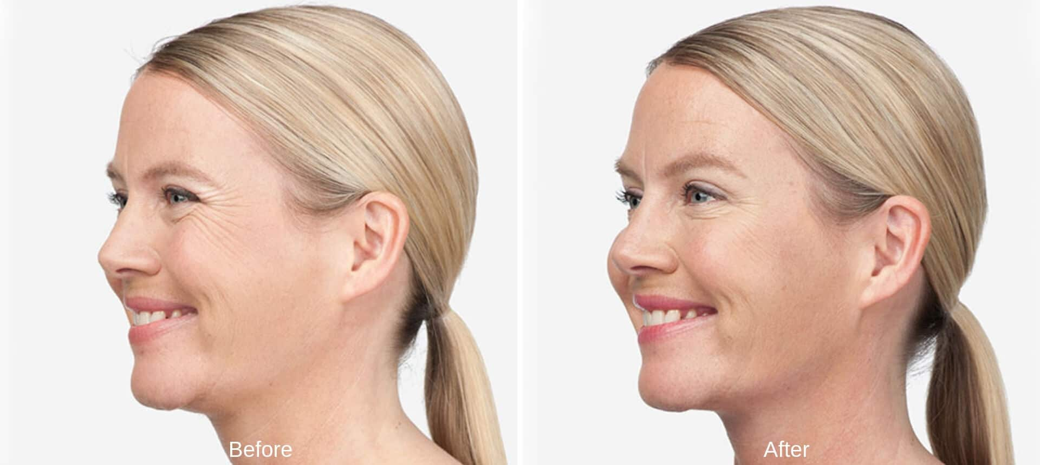
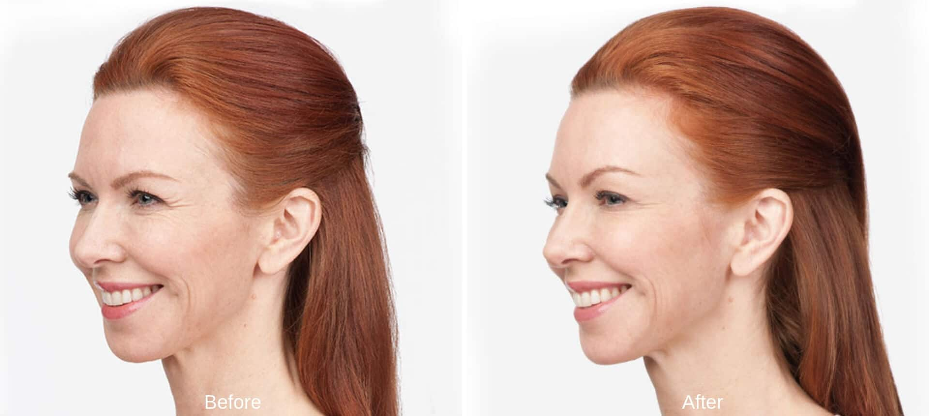
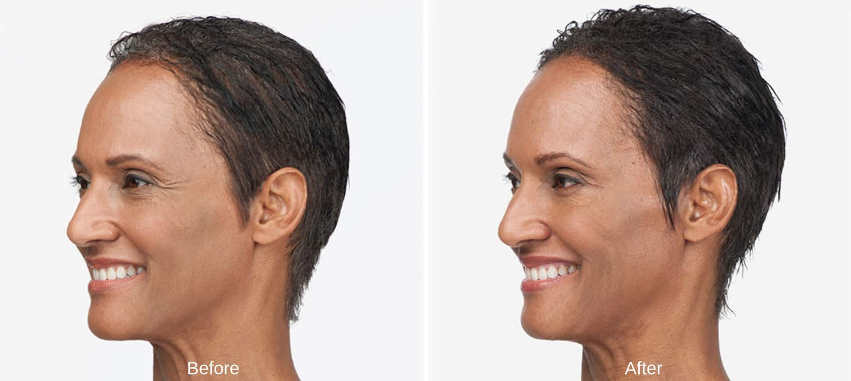
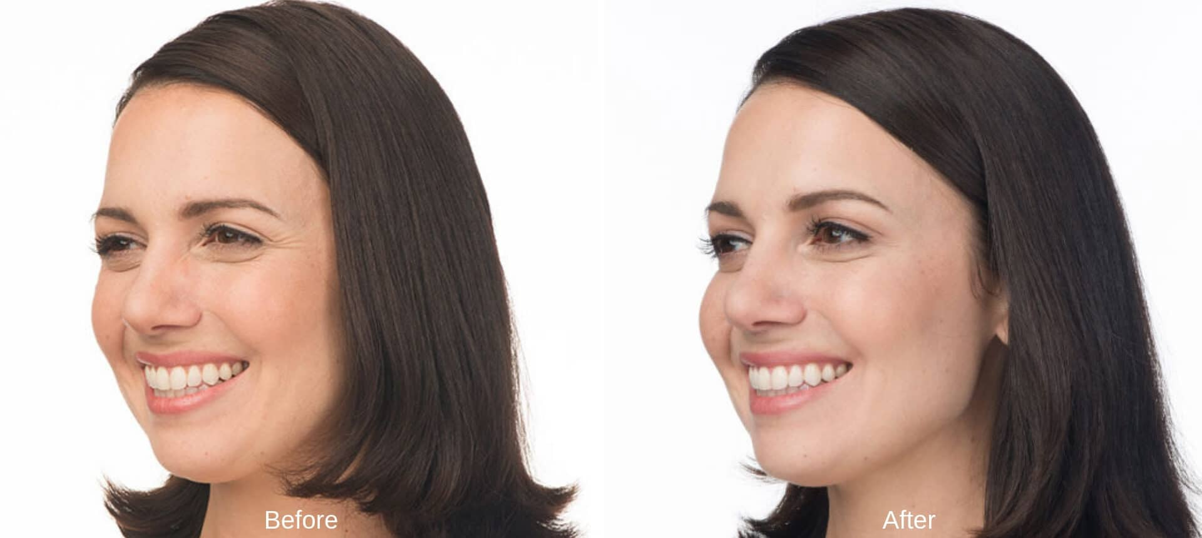
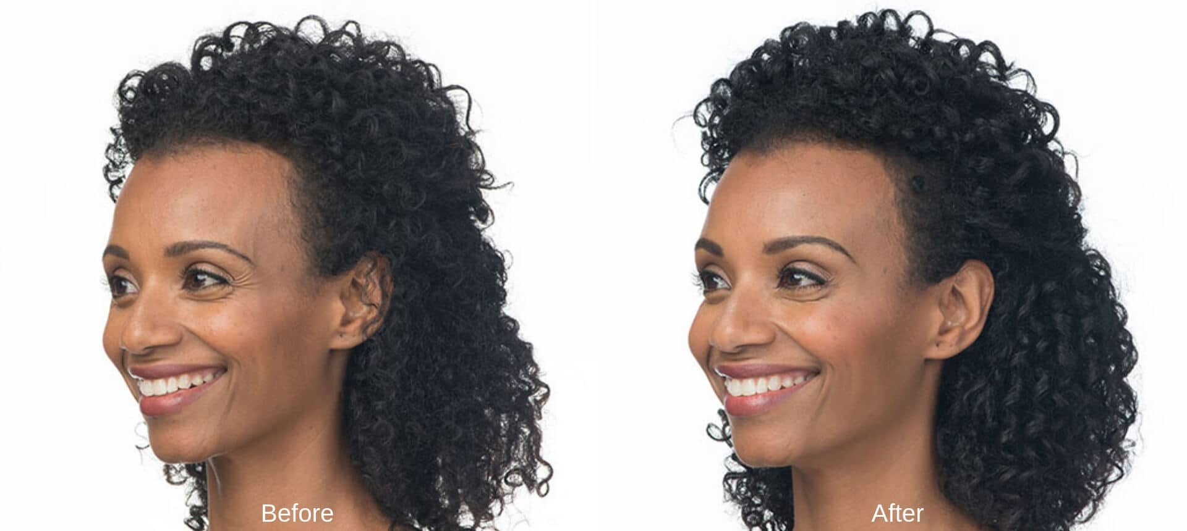
Botox Before and After pictures illustrate patients who are purposefully frowning or scowling in order to demonstrate the softening of facial lines that Botox can help you realize. Results may vary, as with any cosmetic procedure. However, these Botox before and after images depict real patients and real results.*
H2: Botox Results*
Treatment results usually become apparent within three to four days of the initial treatment, but some patients see results as quickly as 24 hours after the treatment. Individual experiences may vary, but results last up to four months for some of our patients.*
H2: Botox Side Effects*

Botox has been extensively researched and is approved by the FDA; making it a treatment with a markedly high safety profile.⁵ Botox side effects are not common. The lion’s share of Botox side effects occurs in cases in which counterfeit Botox solutions were used or inept and careless injectors were administering the procedure. By choosing a highly qualified and fully trained medical professional as your preferred Botox Westport provider, you can assure your safety and satisfaction.
During your complementary consultation at New Beauty & Wellness in Westport, we discuss side effects in detail, and we answer any other questions or concerns you might have.
H2 Botox Injections as a Preventative Treatment

While many people seem to think Botox is a reactionary treatment, meant to be used after lines and wrinkles crease the face, this treatment is popular among younger patients interested in maintaining their youthful appearance
Preventative Botox is the most popular cosmetic treatment for the 20-40 age group, and those who start to manage their skin care by preventing signs of aging can realize even more impressive gains in the future. Botox popularity among young adults is clinically validated by emerging research that shows Botox actively prevents the development of dynamic wrinkles by disabling expression muscles earlier in adulthood. This prevents the repetitive muscle contractions that lead to the permanent creases in overlying skin that Botox seeks to alleviate after-the-fact in other patients.²
As noted in a study published by JAMA Dermatology, “Initiating regular treatment with a neuromodulator in an individual’s 20s or 30s will have a dramatic effect on the appearance of the face as seen in the person’s 40s or 50s. There will be few, if any, imprinted lines of facial expression present.”³

A recent study published in Archives of Facial Plastic Surgery supports these findings. By following identical twins over a 13-year period, researchers were able to track results after one twin received regular Botox injections throughout their young adult life while the other twin received no injections. Comparison photos reveal that the twin receiving injections developed significantly fewer frown lines, forehead wrinkles, and crow’s feet. The researchers conclude, “Long-term treatment with Botox can prevent the development of imprinted facial lines that are visible at rest. Botox treatment can also reduce crow’s feet.”⁴

BOTOX FAQs
Botox Side Effects*
Botox has been extensively researched and is approved by the FDA; making it a treatment with a markedly high safety profile.⁵ Botox side effects are not common. The lion’s share of Botox side effects occur in cases in which counterfeit Botox solutions were used or inept and careless injectors were administering the procedure. By choosing a highly qualified and fully trained medical professional as your preferred Botox Westport provider, you can assure your safety and satisfaction.
During your complementary consultation at New Beauty & Wellness in Westport, we discuss side effects in detail and we answer any other questions or concerns you might have.
How much does Botox Cost?
Botox is a relatively inexpensive method of ensuring you look youthful and rejuvenated. The exact cost of Botox depends largely on each client’s individualized course of treatment. During your consultation, exact Botox prices will be fully discussed. If this treatment is right for you, we will customize a treatment plan that fits both your goals and your budget.
Botox Results
Treatment results usually become apparent within three to four days of the initial treatment, but some patients see results as quickly as 24 hours after the treatment. Individual experiences may vary, but results last up to four months for some of our patients.*
When should I start Botox Treatments?
While many people seem to think Botox is a reactionary treatment, meant to be used after lines and wrinkles crease the face, this treatment is popular among younger patients interested in maintaining their youthful appearance
Preventative Botox is the most popular cosmetic treatment for the 20-40 age group, and those who start to manage their skin care by preventing signs of aging can realize even more impressive gains in the future. Botox popularity among young adults is clinically validated by emerging research that shows Botox actively prevents the development of dynamic wrinkles by disabling expression muscles earlier in adulthood. This prevents the repetitive muscle contractions that lead to the permanent creases in overlying skin that Botox seeks to alleviate after-the-fact in other patients.²
As noted in a study published by JAMA Dermatology, “Initiating regular treatment with a neuromodulator in an individual’s 20s or 30s will have a dramatic effect on the appearance of the face as seen in the person’s 40s or 50s. There will be few, if any, imprinted lines of facial expression present.”³
A recent study published in Archives of Facial Plastic Surgery supports these findings. By following identical twins over a 13-year period, researchers were able to track results after one twin received regular Botox injections throughout their young adult life while the other twin received no injections. Comparison photos reveal that the twin receiving injections developed significantly fewer frown lines, forehead wrinkles, and crow’s feet. The researchers conclude, “Long-term treatment with Botox can prevent the development of imprinted facial lines that are visible at rest. Botox treatment can also reduce crow’s feet.”⁴

H2 Choosing a Botox Provider in Westport, CT
Cosmetic injections are technique sensitive treatments. The skill and training of the individual administering the injection has a huge impact on the appearance and longevity of Botox results. An unskilled operator greatly increases the likelihood of encountering side effects and sub-par results. When an expert performs this procedure, Botox results have a natural look and offer no impediments to full facial expression. Therefore, trusted expertise is essential when finding a Botox provider. Hence, informed patients living in Westport, and surrounding communities such as Fairfield, Weston, Easton, and New Canaan choose New Beauty & Wellness as their trusted Botox CT provider.

H2 Botox in Westport
Turn back the clock with the #1 cosmetic treatment in the world from the #1 Botox provider in Westport. Sign up for a free consultation with New Beauty and Wellness today by calling us at 203-720-6609 or by filling out the online form below.

H2 BOTOX FAQs
H3 How much does Botox cost in Westport?

Botox is a relatively inexpensive method of ensuring you look youthful and rejuvenated. The exact cost of Botox depends mainly on each client's individualized course of treatment. During your consultation, exact Botox prices will be thoroughly discussed. If this treatment is right for you, we will customize a treatment plan that fits your goals and budget.

H3 How long does Botox last?*

Botox injections tend to last about 3-4 months. Certain patients see their Botox results last longer, in about the 4-6 month rage, or shorter, in that 2-month rage. It is also common for first-time Botox patients. They may notice it lasts longer. As always, results may vary per person.*

H3 Who shouldn't get Botox?

Botox is not suitable for women who are pregnant or breastfeeding. It is also not acceptable for people who have a neurological disease.
H3 Is Botox painful?

Using topical anesthetic or numbing cream, Botox can be virtually painless. Even without a numbing agent, pain is minimal. Injections are quick and effective—especially if trained medical professional treats you.

H3 Will you notice Botox results right away?*

Usually, Botox patients can see results as early as 3-4 days after injection. However, it typically takes 10 to 14 days after the procedure for the anti-aging treatment's full effects to show up. As always, results vary per person.*

