Semaglutide Westport, CT | Weight Loss with Ozempic + Wegovy

Semaglutide medications, more popularly known as Ozempic, Wegovy, or Rybelsus, are a new form of weight management treatment. They each provide a way to reduce body weight, decrease hunger and cravings, and increase fat burn. The weight loss treatment improves your overall health and well-being, in general. The simple subcutaneous fat injections or oral tablets are administered by yourself weekly. The injections and tablets are FDA-approved for chronic weight management in adults struggling with obesity. In addition, they are perfect treatments for anyone struggling with their weight and at least one weight-related condition, i.e., high blood pressure, type-2 diabetes, or high cholesterol.
If you are struggling with being overweight and nothing seems to be helping, Semaglutide may be the best solution for you. New Beauty and Wellness is proud to be the primary provider of Semaglutide in Westport, Connecticut. Contact us today by calling 203-720-6620 or reach out to us online to learn more about this revolutionary weight loss treatment.

Benefits of Semaglutide Treatments

- Long-term weight loss medication
- Chronic weight management tool
- Suppresses appetite
- Reduces cravings
- Boosts metabolism
- Increases fat burning
- Helps you feel fuller for longer
- Can improve blood sugar levels
- Non-mood-altering
- FDA-approved as an injection or oral tablet

Semaglutide Weight Loss Before and Afters*

Semaglutide weight loss before and after images show the type of weight loss possible with this new treatment. As with any weight program or treatment, results and the amount of body weight lost will vary from person to person.* However, this weight loss treatment changes how your body metabolizes food. This means you can burn fat more efficiently. When paired with a healthy diet and exercise, Semaglutide treatments provide exceptional weight loss results. In addition, this medication also improves your overall health and well-being.







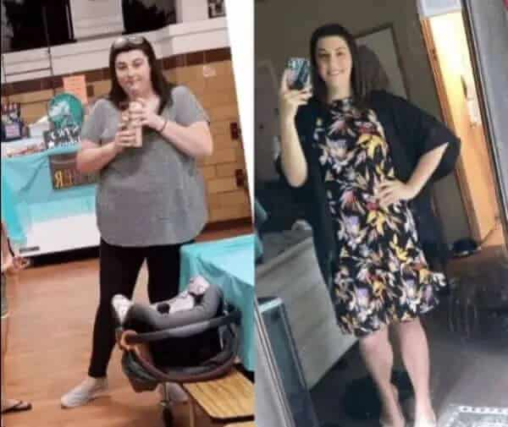

*results may vary

How Semaglutide Helps You Lose Weight

With a staggering 70% of American adults obese or overweight, it is no surprise that the new Semaglutide weight loss treatment is becoming increasingly popular. So many people in the United States struggle with their weight and serious weight-related conditions like heart disease, type-2 diabetes, and other conditions. Thankfully, treatments with Semaglutide are giving people hope for finally losing weight and taking back their health.
This new weight loss medication is a long-term weight management tool. It reduces appetite, reduces cravings, increases metabolism, reduces body fat, and overall improves your health. Semaglutide, also known as Ozempic, Wegovy, or Rybelsus, mimics the hormone glucagon-like peptide-1 (GLP-1). This hormone targets the area of the brain that regulates appetite and controls food intake. The dose of the medication gradually increases over a treatment period which will vary by individual. ranging from 16 to 20 weeks. The dosing schedule helps to alleviate the gastrointestinal distress you may experience from this new form of weight management.

Mounjaro (Trizepatide) vs Ozempic (Semaglutide)

Mounjaro (Trizepatide) is another popular medical weight loss treatment in the same class as Ozempic, Wegovy, and Rybelsus (Semaglutide). Like Semaglutides, Mounjaro is another incretin mimetic medication. However, there are differences. Mounjaro acts on GIP and GLP-1 receptors. Semaglutides only work on GLP-1 receptors.
As a dual-acting GIP and GLP-1, Mounjaro lowers fasting and postprandial glucose concentrations. In addition, it decreases food intake, reduces body weight, and improves the health of patients with weight-related issues, including type-2 diabetes mellitus.

** Not sure if we should mention Mounjaro as we will not be offering this?? I have changed the below to just explain semaglutide alone..
Semaglutide acts as a GLP-1 receptor agonist that binds to and activates the GLP-1 receptor. This stimulates insulin release from the pancreas in a glucose dependent manner. This medication works to slows down digestion. In response, you can feel full for extended periods of time and your appetite is decreased therefore leading to weight loss.
It is important to note that you should never use these medicines with other GLP-1 or GIP receptor agonists.

Candidates for Semaglutide Weight Loss Treatment

Semaglutide isn’t a suitable treatment for everyone. The FDA-approved weight loss injection is approved for adults’ general weight management and loss. The adult candidates should have a BMI greater than 30 or a BMI of 27 and up with one or more weight-related medical problems, including high cholesterol, high blood pressure, or type-2 diabetes.
Semaglutide treatment is not suitable for anyone with a personal or family history of Medullary Thyroid Cancer (MTC), Multiple Endocrine Neoplasia Syndrome (MEN), personal history of Pancreatitis or those with allergies or sensitivities to the medication or any of the solution ingredients.

Begin Your Weight Loss Journey with Semaglutide Treatments

Take control of your health and finally shed the weight hindering your well-being. New Beauty and Wellness offers Semaglutide treatments to our clients in Westport, CT. We also proudly provide Semaglutide to clients living in the surrounding communities of Fairfield, Weston, Easton, and New Canaan. Call us today at 203-720-6620 and learn how Semaglutide, Ozempic, Wegovy, or Rybelsus, can help turn your body into a fat-burning machine, control your hunger, and help you finally lose weight.

