500 Word Botox Service Page Update.NS Medical.KA

Link to page: https://nsmedicalwellness.com/botox-huntington-ny/

NEW H1 Botox Long Island: Experience the Best in Anti-aging Injectables
Botox is the leading cosmetic injection in the United States. Men and women enjoy it because they can look younger, no matter their age, without going under the knife. People get Botox to diminish fine lines and wrinkles around the forehead, brows, and eyes. The results are natural-looking when you choose a qualified professional to deliver the injections.
Look your best by selecting North Shore Medical Wellness as your preferred medical spa on Long Island. Located in Huntington, NY, we proudly serve people in the Suffolk County area. Call us at (631) 438-8184 to discover how Botox can rejuvenate your appearance and restore your confidence.

H2 Benefits of Botox Injections
- FDA-approved
- Non-surgical procedure
- Diminishes aging signs
- Restores a youthful appearance
- Stunning and natural results that last for 3-4 months
- Proven as safe and effective in countless clinical studies
- No recovery time
- Incredible anti-aging solution for people ages 20+

H2 BOTOX TREATMENT AREAS
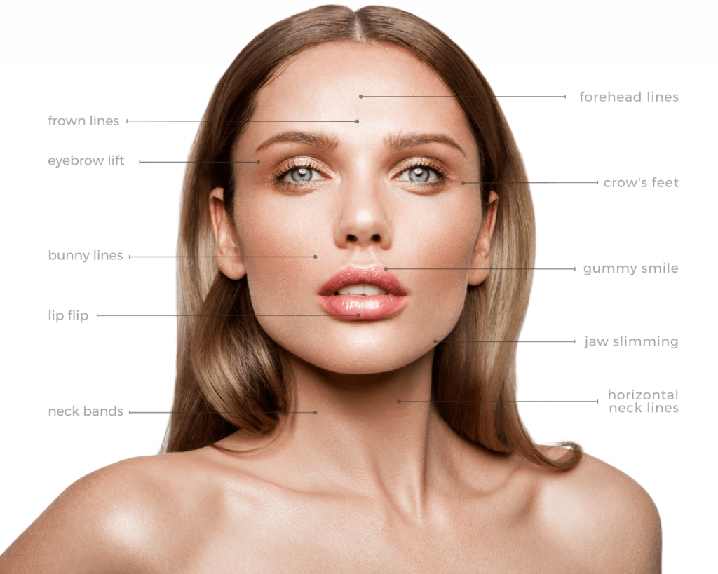
Forehead Lines (Glabellar Lines): The lines above the brows run horizontally. These lines are caused by expressions like scowling, frowning, or laughing.
Frown Lines: Vertical lines between the eyes. Frown lines are commonly caused by repetitive frowning or scowling. They can make you appear old or tired.
Eyebrow Lift: When Botox is used for a brow lift, the toxin relaxes the forehead muscles, resulting in a more lifted forehead and brow area.
Crow’s Feet: One of the most common aging concerns. Lines in the outer corners of our eyes show up primarily when we smile.
Bunny Lines (Transverse Nasal): Horizontal lines at the top of the nose.
Gummy Smile (Non-surgical Lip Augmentation): Botox is used during a Lip Flip, where injections are strategically placed to make the top lip unfurl, appearing fuller.
Jaw Slimming: Botox can be used to slim the face, helping you achieve a more symmetrical and contoured facial appearance.
Dimpled Chin (Chin Dents): Dents in the chin due to underlying muscles. They are also known as orange peel chin.
Perioral Lines (Smoker’s Lines): Fine vertical lines around the mouth.
Marionette Lines: Commonly corrected with dermal fillers, Botox can smooth marionette lines.
Vertical Platysma: Botox improves overactive platysmal bands in the neck that create vertical bands.

H2 Other Botox Treatment Applications

While Botox is mainly known for being an anti-aging treatment but has several other uses, these uses include:

H3 Botox for Migraines: Botox has FDA approval for treating migraines. When Botox is injected into the pain fibers responsible for causing headaches, it provides relief for migraine sufferers. This is because Botox enters the nerve endings around where it injects into and blocks the release of chemicals in pain transmission. This prevents the activation of pain networks in the brain for relief.

H3 Botox for Excessive Sweating: The FDA also approves Botox for treating excessive sweating. Botox selectively turns off the sweat glands resulting in normal sweating without wetness. Treatments can be administered in-office with no special care needed after.

H3 Botox for Feet: A newer use for Botox is foot injections. Administering Botox into the foot can alleviate pain associated with foot issues like plantar fasciitis. In addition, Botox injections in the feet can eliminate foot sweating.

H2 Botox Before and After Images*
One of the best ways to see what Botox can do for you is to see our patients’ before and after pictures. Just like with any cosmetic treatment, results vary per person.* But our clients enjoy fantastic outcomes. People love how they look years younger after getting the injections. Since Botox is a skill-sensitive procedure, you must pick the most experienced provider in your area for optimal results.
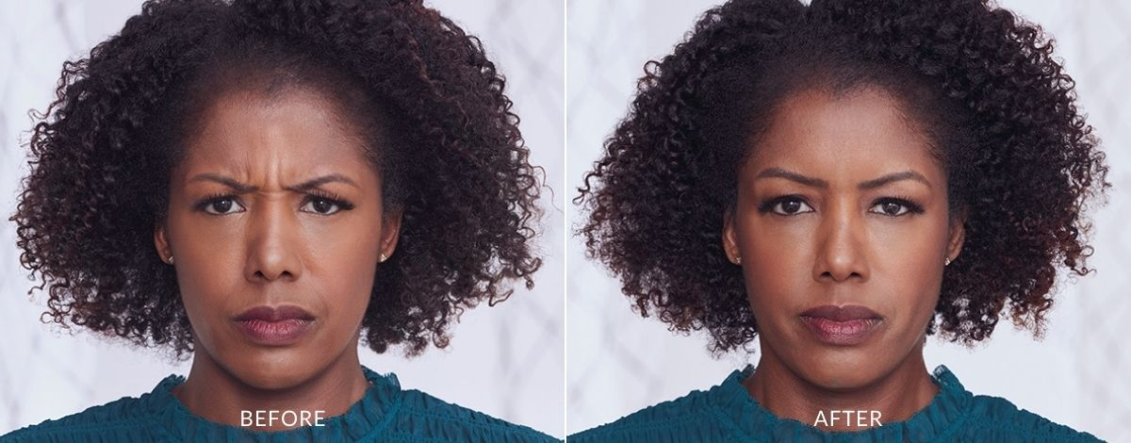
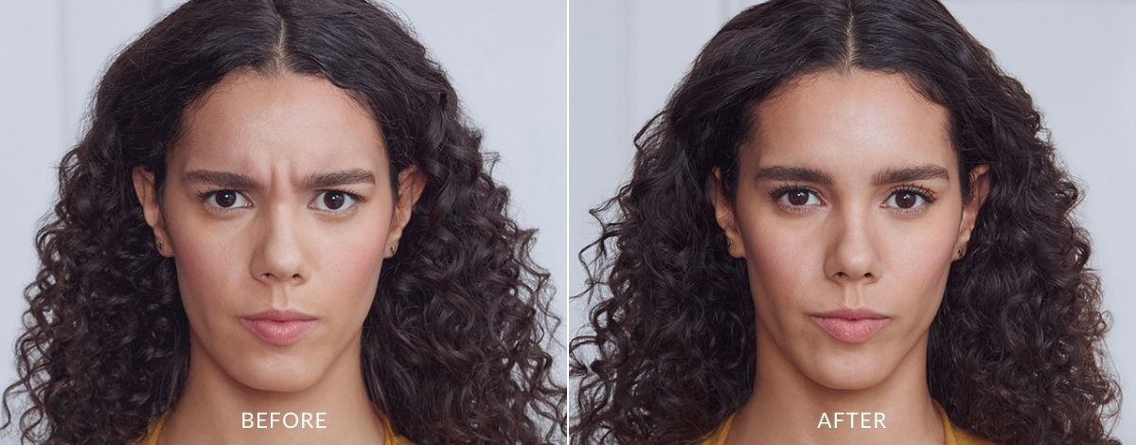
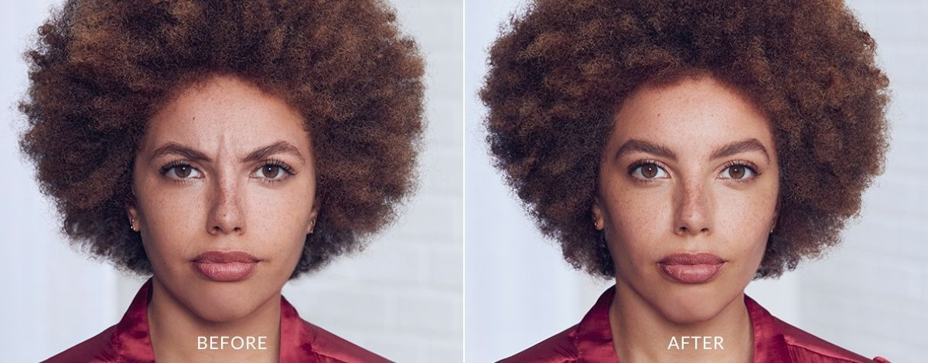
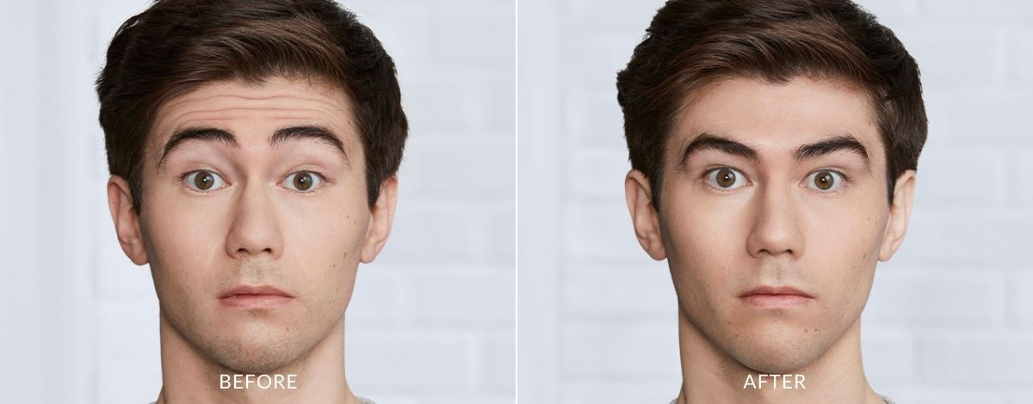
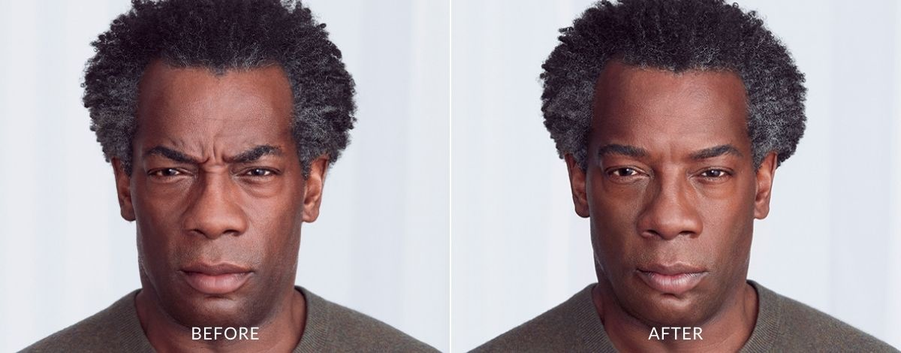
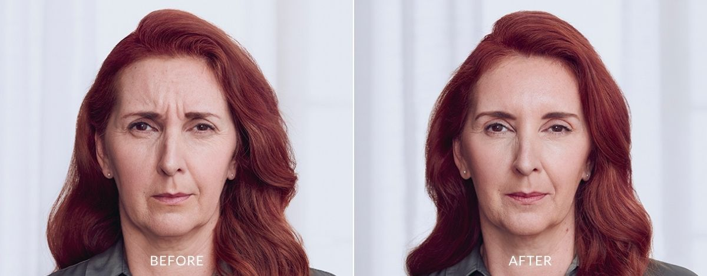
*results may vary

H2 Botox: America’s #1 Cosmetic Injection
Botox may be the perfect solution if you want to restore your youth without downtime. Botox’s main ingredient, Botulinum Toxin, targets wrinkles around the forehead, brows, and eyes to give patients smooth, healthy skin.

H2 Understanding How Botox Works
Wrinkles form after years of repeated facial expressions. For example, your muscles contract each time you frown, squint, smile, or laugh. These muscle contractions cause creases in the face. As collagen production slows in the body with age, these dynamic wrinkles become more noticeable and permanent. You may see these lines on your forehead and around your brows, eyes, and mouth.
Botox smooths out facial lines by relaxing the muscles causing them. First, your provider injects the toxin into the desired treatment area. Then, the neuromodulator paralyzes the muscles. This results in a relaxed and fresh complexion for 3-4 months.

H2 Botox vs. Dysport vs. Xeomin
Dysport and Xeomin are similar to Botox in some ways. But they also offer unique benefits. All three are FDA-approved neuromodulators that temporarily relax underlying muscles to soften lines on the skin. Some prefer Dysport if they need to treat larger areas of the face, such as the forehead. Botox is ideal for smaller areas like around the eyes or the mouth. Similar to Botox, Xeomin requires up to two weeks for full treatment effects to show. Dysport may be the way to go if you need a quicker onset.

H2 Botox Cost Long Island
Botox is an affordable cosmetic treatment, especially when you stack it up against invasive alternatives. The exact cost varies per patient. Various factors determine the cost:
- Targeted area(s)
- Geographic location
- Injection specialist’s expertise
- Number of units required
Are you curious about how much Botox will cost you? Schedule a free consultation with us. We will cover Botox pricing in detail and propose a unique treatment plan to suit your aesthetic goals and budget.

H2 Botox Risks and Side Effects
Why do so many people pick Botox over invasive anti-aging procedures that may produce longer-term results? Well, Botox is a much safer procedure. In fact, the risks and side effects are minimal if you go to a reputable injection specialist. If you have any concerns about the procedure, book a consultation with North Shore Medical Wellness. We are happy to answer your questions.

H2 Botox Results*
You can achieve exceptional, natural-looking results with Botox if you choose a skilled provider. People who are new to Botox often worry that they will look frozen afterward. But if you get it from someone who knows what they are doing, you will get a beautiful outcome.

It typically takes about 72 hours for Botox effects to manifest after the treatment fully. Each body metabolizes the toxin differently. Some patients need another treatment after 3-4 months, while others enjoy optimal anti-aging results for up to 6 months. Individual results vary.*

H2 Experience the Best Botox on Long Island
Everlasting youth is possible with Botox. Contact North Shore Medical Wellness in Huntington, New York, by calling (631) 438-8184. We are a top provider of cosmetic injections, including Botox, on Long Island where we serve the amazing clients of Suffolk County. Book a FREE consultation today to discover how Botox can bring out your natural beauty and bolster self-love.

LEAVE FAQ SECTION THE SAME

