FRONT DESK TRAINING
FOR
EMSCULPT PROVIDERS

MEDSTAR MEDIA

Front desk training is a critical, yet often neglected, part of becoming a successful Emsculpt provider. Enhancing your front desk practices is one of the most effective ways to book more consults, decrease no shows, and increase the number of potential customers who buy Emsculpt treatments.

TABLE OF CONTENTS

FRONT DESK BEST PRACTICES ………………………………………………………………………2

EMSCULPT CALL SCRIPT ……………………………………………………………………….6

ANSWERS TO FREQUENTLY ASKED QUESTIONS………………………………………………9

FRONT DESK BEST PRACTICES: TIPS

A caller’s initial interaction with the front desk staff has a profound impact on the person’s reception of your practice and the Emsculpt® procedure. An effective and efficient call with your front desk staff also sets up your Emsculpt specialist to conduct a successful consultation.

THE 3 OBJECTIVES WHEN ANSWERING A CALL ABOUT EMSCULPT

- Answer questions / Share Information
- Develop elevator pitch explaining what Emsculpt is and why it is so popular. (See the FAQ section for examples.)
- Try to use personal experience when answering questions. (See call script for examples.)
  - Avoid questions covered in the consultation (anything that would determine the treatment parameters or the caller’s candidacy for Emsculpt.)

- Share Excitement
- Use personal experience. Talk about why Emsculpt is great.
- Explain why your practice is the best choice for the Emsculpt treatment. (Develop an elevator pitch on practice uniqueness.)

- Book a Consultation

TIPS FOR EXCELLENT CUSTOMER SERVICE OVER THE PHONE

- Use “verbal nods” like “Mhm” or “Ah yes, I understand”

- Use plain language. Avoid technical terms, jargon, and acronyms. Be professional, concise and clear.

- As soon as you receive a customer’s name, use it. Dale Carnegie said, “Remember that a person’s name is to that person the sweetest and most important sound in any language.”

- Try to validate questions: “That is a good question” “that is a common concern” etc.

- Be knowledgeable about the treatments callers may inquire about

- Share personal experience

- Avoid Yes or No questions.

- Use assumptive phrases and questions (See call script for examples.)

- The receptionist should NOT perform a consultation over the phone. Re-focus the caller to book a consult.

- Avoid the topic of cost

REQUIREMENTS FOR ANSWERING THE PHONE

Anyone answering the phone should be able to:

- Successfully field an Emsculpt inquiry.

- Book an Emsculpt consultation.

- Answer questions about the Emsculpt treatment.
If a staff member does not know about Emsculpt and does not know how to book a consultation, they should not answer the phone. This may require that all staff know the proper protocol for answering Emsculpt inquiries.

AN INVESTMENT THAT MAKES A LOT OF DIFFERENCE

Anyone playing a role in your Emsculpt sale’s funnel should undergo a Emsculpt treatment. This is especially important for front desk receptionists who need to share excitement and experiences with callers inquiring about Emsculpt.

Being able to answer caller’s questions with personal experience makes the call sound more genuine, endorses the Emsculpt procedure, helps develop a connection with the caller, and allows the person answering the phone to express passion for the treatment.

4 THINGS THE RECEPTIONIST SHOULD KNOW BY HEART

- Uniqueness statement. Why is your spa unique? Why should a potential customer choose your facility over the competition? This statement should be one to two sentences or 15 seconds long.

- Emsculpt elevator pitch (brief statement on what Emsculpt is and why it is so popular.

- Answers to frequently asked questions

- The Emsculpt call script and front desk best practices.

THE IMPORTANCE OF FAST RESPONSE TIMES

According to an MIT study, response times significantly affect conversion rates:

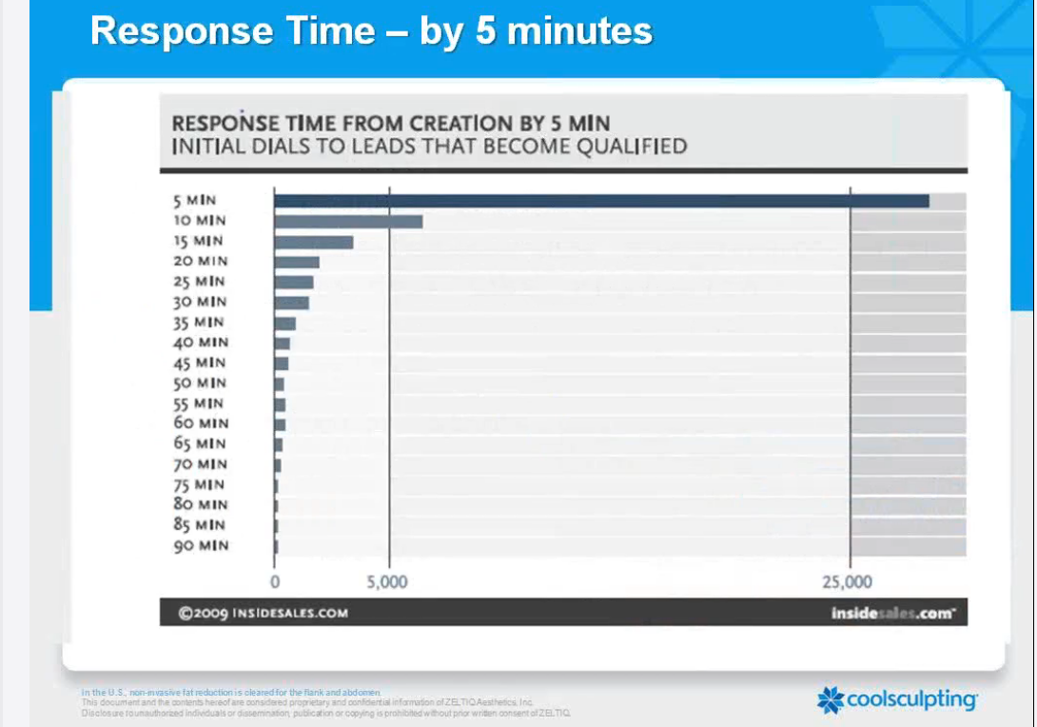

*4X less effective by waiting 10 minutes

IF YOU HAVE TO PLACE A CALLER ON HOLD

Being placed on hold for too long, or put on hold instantly is one of the MAIN reasons callers hang up or decline to book a consultation.

WHY CALLS DON’T CONVERT TO CONSULTATIONS

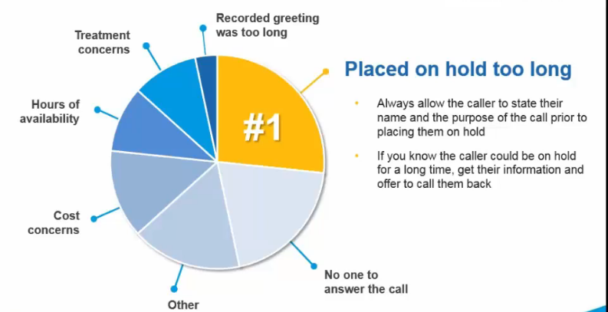

If you have to put someone on hold, make sure to get the caller’s name and purpose for calling before putting them on hold.

Receptionist: Hello. Thank you for calling [SPA.] My name is [Name.] May I ask with whom I am speaking?

Caller: My name is Melissa, I am calling about Emsculpt

Receptionist: Hello Melissa. You’re interested in Emsculpt, that’s fantastic. May I ask you to hold for a brief moment, I have another caller on the opposite line?

Caller: Yes

Wait until they answer yes before placing them on hold.

*If the caller has to be on hold for a long time, get their information and call them back.

FRONT DESK CALL SCRIPT

SUGGESTED SCRIPT FOR A EMSCULPT PATIENT CALL

STAFF MEMBER “Thank you for calling [Name of Practice], this is [Name of Staff Member].
How may I help you?”
PROSPECTIVE PATIENT “I was calling about Emsculpt…”
STAFF MEMBER Respond with a brief statement about why your spa is the best place to get Emsculpt. (Uniqueness statement.) Be enthusiastic. Remember, passion is contagious.
“Great. You’ve called the right place! [SPA] is proud to be… [Distinguishing characteristic].
List your Spa’s experience (experience is an important factor for people choosing an Emsculpt provider.)
“We’ve performed hundreds of treatments.”

Collect name and number
“Just in case we get disconnected, may I please have your name and phone number?”
PROSPECTIVE PATIENT “Yes, my name is Melissa and my number is 888-888-8888.”
STAFF MEMBER “Great! Thank you, Melissa.”

Emsculpt® 15-second Elevator Pitch
“Emsculpt® is the first body contouring treatment cleared by the FDA to build, strengthen, and tone muscles in the abdomen, upper arms, upper legs and glutes.

Receptionist’s Personal Emsculpt experience
“I just had the Emsculpt treatment performed on my abdomen three months ago and I love my results.
Next, ask the caller if they have any questions about the Emsculpt treatment. This will show the caller you are there to help them. It will also help you gauge where the caller is at, what concerns they have, and other insight that will help you customize the conversation to the caller’s needs and lead the caller to book a consultation over the phone.
STAFF MEMBER “Are there any questions I can answer for you?
PROSPECTIVE PATIENT [Patient question] “How long does it take to see the results?”
STAFF MEMBER After my treatment, I started seeing results about a month later. Most patients see their results between one and three months.”
If the caller does not articulate any specific questions, move on in the conversation by asking:
STAFF MEMBER “What made you interested in Emsculpt?”
PROSPECTIVE PATIENT [Indicates reason] i.e. “I want a six-pack.”
STAFF MEMBER This is a great opportunity for the receptionist to validate the caller, connect with the caller, and learn more about the caller’s selling points. Whatever the caller’s concern is, validate it and then explain how Emsculpt from your spa can address that concern.
“That is actually our most popular treatment area. Emsculpt is great at developing ab muscles. In fact, a single treatment is the equivalent to performing 20,000 crunches. In fact, I just saw a patient who received Emsculpt in that area a few months ago and she said her results look amazing.”

PROSPECTIVE PATIENT “How much does it cost?”
STAFF MEMBER Remember, it’s best not to discuss the price over the phone.
“Emsculpt® is a highly customized treatment. I would not be able to quote a price over the phone without our Emsculpt® Specialist assessing you first.
Lead into the consultation

Our Emsculpt® Specialist would love to meet with you privately to develop a custom treatment plan that meets your personal goals and matches your budget.

Mention a special, a deal, some financial incentive that has a time limit.

“We currently have a June special offering 25% off Emsculpt I’d love to get you in for your complimentary consultation with our Emsculpt® Specialist, [Name of the specialist who will perform the consultation].”
Do not ask if they want to book a consultation. Use ASSUMPTIVE PHRASES. (Assume every caller wants to book a consultation.) Just continue straight into the scheduling portion of the phone call. Remember; try to avoid yes and no questions when possible.
“We have new patient consults available on Tuesdays and Thursdays; Melissa, which day works better for you?”
PROSPECTIVE PATIENT “Tuesdays.”
STAFF MEMBER “Do you prefer mornings or afternoons?”
PROSPECTIVE PATIENT “Mornings.”
STAFF MEMBER “Great! I have possibilities for you to come in for your consultation on this
Tuesday afternoon at 9:00 am or 11:00 am. Which works better for you?”
PROSPECTIVE PATIENT “9:00pm.”
STAFF MEMBER “Great, we look forward to seeing you [Day and time.]
“Melissa, we are delighted that you have chosen our practice for your Emsculpt® treatment. We can’t wait to see you on [date and time.]”

ANSWERS TO FREQUENTLY ASKED QUESTIONS

 WHAT IS EMSCULPT®?

Rehearse a 15-second “elevator pitch”, such as:
- “Emsculpt® is revolutionary body contouring treatment that reduces fat and builds muscle. It is painless and requires no downtime.
-or-
- “Emsculpt is the first FDA-cleared energy device approved to burn fat and build muscle mass. It’s a no-downtime, pain-free, non-surgical way to define the abs, lift the buttocks, and develop the arms and legs.”

 IF A PATIENT ASKS ABOUT “HOW IT WORKS”:

Rehearse a 15-second “elevator pitch”, such as:
 “Emsculp utilizes electromagnetic energy to cause super powerful muscle contractions. These muscle contractions strengthen the tissue and also disrupt surrounding fat cells. The result is bigger, stronger muscles and a reduction in fat.

 WHAT’S THE COST?

Cost is best discussed during the consultation process; avoid the conversation about the cost on the phone. If not, then explain:
- “Emsculpt® is a highly customized procedure, and I would not be able to quote a price over the phone without our Emsculpt® Specialist assessing you first.
- Some people call numerous practices to find the cheapest quote. Don’t lose a potential customer because you won’t quote them over the phone. If the caller asks more than once or says they are price shopping, give them a price for a single treatment. Follow up the cost with a deal or special or some other kind of incentive. Do not give price ranges. People will only remember the higher price. Quote the least expensive price (a single treatment.)

- “The initial cost of a single treatment is $xxxx, but there is a discount offered based upon the treatment package.”

 HOW MANY TREATMENTS DO I NEED?

Do not perform the consultation over the phone! Instead, re-focus the patient to discuss this question with the Emsculpt® Specialist.
- “That’s a great question. Honestly, it depends on a lot of individual factors. The Emsculpt® Specialist is the expert and is far better prepared to answer your questions.”
-or-
- “Most patients see results after one treatment. I elected for 4 treatments, spaced 2 to 3 days apart for optimal results.”

WHEN DO I SEE RESULTS?

This is a great reason to ensure that the Front Desk Staff has experienced a Emsculpt® treatment. They can confidently share their own experience and/or results, such as:
- “My core felt stronger almost immediately. I began to see added definition about 4 weeks after my treatment.

 IS THERE ANY PAIN OR DOWNTIME?

Again, another reason to make sure the receptionist has received the Emsculpt treatment. If there is some luxury that distinguishes your Emsculpt treatment, room or process, feel free to add that detail into the answer.

“My treatment wasn’t painful at all. You can feel your muscles contracting but it doesn’t hurt.

– and –

“Afterwards it felt like I had done an extensive ab workout for the following day or two.”

