Blurbs.Pilchuck Dental.KL
New Site: https://go.pilchuckdental.com/
Reference Site: https://www.pilchuckdental.com/
Plagiarism:

SERVICES TO HIGHLIGHT: Invisalign, Implants
Please mention financing options on the homepage
Lending Point, Care Credit, 0% financing available + flexible options. Write something along the lines of Tooth Docs.

HOMEPAGE HERO IMAGE BLURB 25//93

Your Smile is
Our Mission
Excellent dental care in Arlington, WA providing long-lasting results for brighter & bigger smiles.
HOMEPAGE SERVICE BLURBS 284

Invisalign
Modern teeth-straightening for all those looking to enhance their smile. The Invisalign system allows teeth to shift into desired positions gradually and gently through a series of custom-fitted trays. These virtually undetectable trays cost relatively the same as traditional braces.

Implants
Complete your smile with a strong, lasting solution for tooth loss. State-of-the-art dental implants replace both the tooth and roots. They function like real teeth and will not slip or slide. Implants help to improve overall oral health and have no need for specialized care.
HOMEPAGE ABOUT US BLURB 284

About us
Pilchuck Dental is dedicated to providing stress-free, personalized treatments & outstanding results that fit your budget. We offer Lending Point, Care Credit, 0% financing & other flexible financing options. Contact us today to learn more about how we can help you get the smile you deserve!
HOMEPAGE ABOUT US ICON BLURBS 93


INVISALIGN
The most advanced clear aligner system
to straighten teeth & improve your
smile without braces.

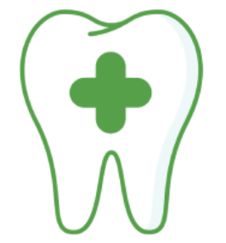

MODERN CARE
A friendly, comprehensive approach
using advanced technology for
oral health and dental care.

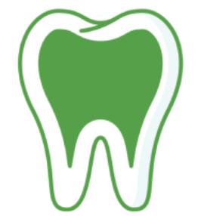
CROWNS
Crowns and bridges strengthen teeth &
correct dental problems with a
natural-looking, versatile solution.

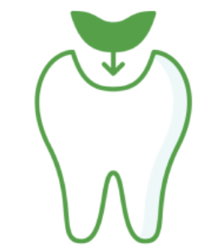

FILLINGS
Tooth-colored fillings restore
damaged teeth & blend seamlessly
for a flawless, perfect smile.



DENTAL IMPLANTS
A simple, permanent solution to
missing teeth. State-of-the-art
implants improve oral health.

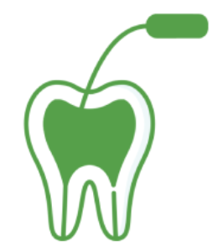
ROOT CANAL
Relieve pain, reduce stress,
& stop infection from spreading
with expert root canal therapy.

HOMEPAGE REVIEW/TESTIMONIAL BLURB

Top-Rated Dental Practice

ABOUT US PAGE ICON BLURBS 11//26

https://go.pilchuckdental.com/about-us/

MODERN DENTAL CARE
Versatile solutions for oral health

ADVANCED TECHNOLOGY
Safe & effective expert services

FRIENDLY SERVICE
Personalized, affordable patient care

INVISALIGN PAGE HERO IMAGE BLURB 93

https://go.pilchuckdental.com/invisalign/

Invisalign®
The clear alternative to braces.
Straighten your teeth with the most advanced aligner system.
https://go.pilchuckdental.com/implants/

Implants
A long-lasting solution for tooth loss.
State-of-the-art implants function just like real teeth.

