WHAT IS REVANESSE® VERSA?
Revanesse® Versa™+ is an FDA approved hyaluronic acid dermal filler that can be used to treat moderate to severe facial wrinkles and folds, including nasolabial folds in patients 22 years of age or older.

WHAT MAKES REVANESSE® VERSA™ UNIQUE?
LESS SWELLING
In one of our clinical trials, 50% more patients treated with a comparative product experienced swelling, than patients who were treated with Revanesse® Versa™. 1
LONGEVITY
You may find that Revanesse® Versa™ will help in the improvement of your nasolabial folds (laugh lines) for up to 12 months with optimal correction. 2
DESIGNED FOR SAFETY
The Revanesse® Versa™ formula is well-studied, with over 300 patients of multiple skin types, treated in three clinical trials, with no serious adverse events reported.
IMMEDIATE RESULTS
A Revanesse® Versa™ treatment is minimally invasive and provides immediate results. Take control of the signs of aging and ask your healthcare provider if Revanesse® Versa™ is right for you.

THE NEW 1.2ML SYRINGE
Revanesse® Versa™ is the only hyaluronic acid (HA) dermal filler in the US available in a 1.2mL syringe size.
Whether you require more product to be brought to full correction or are seeking a more cost-effective treatment option; 20% more product in our syringe is another example of the Revanesse® difference and our commitment to providing pathways for patients to achieve the best possible results.

INJECTION DEPTH
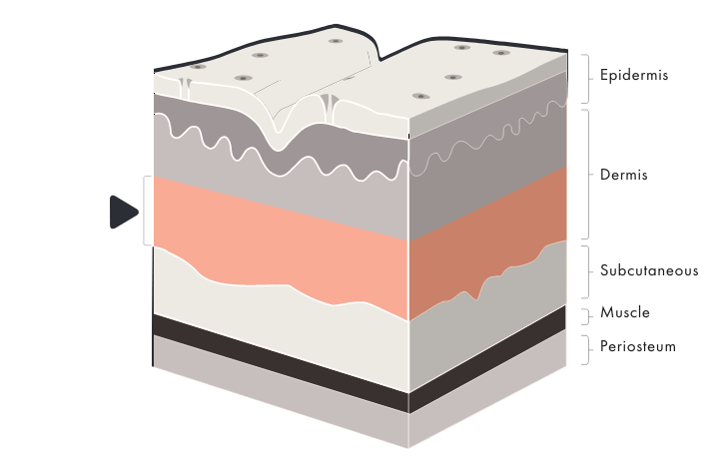
Revanesse® Versa™ is indicated for injection into the mid to deep dermis for correction of moderate to severe facial wrinkles and folds, such as nasolabial folds, in adults 22 years of age or more.

