New at Renovo MD | April 2021

This month we are excited to debut three new aesthetic treatments already creating a buzz among the beauty industry for their ability to rejuvenate and enhance. We are among the first providers in the Northborough, MA area to feature these new beauty treatments and are beginning to schedule free consultations for these dramatic new procedures.
If you are interested in learning more about any of these treatments please call (508) 393-6398 to schedule your initial consultation.

PRX-T33 | Bio Revitaliser Peel
The PRX-T33 is the next generation of rejuvenation treatments, it contains 33% TCA, Hydrogen Peroxide and Kojic Acid. This formulation provides all of the benefits of a high percentage TCA peel but without the associated side effects – discomfort and peeling, best of all there is no downtime thanks to the addition of the Hydrogen compound.

Ideal to reduce fine lines, crepe skin, rehydrate and thicken the dermis. The addition of Kojic Acid to the formula also helps to deal with pigmentation issues. RenovoMD is proud to be one of the first medical aesthetics centers in the area to carry this exciting new product.
((insert images below))
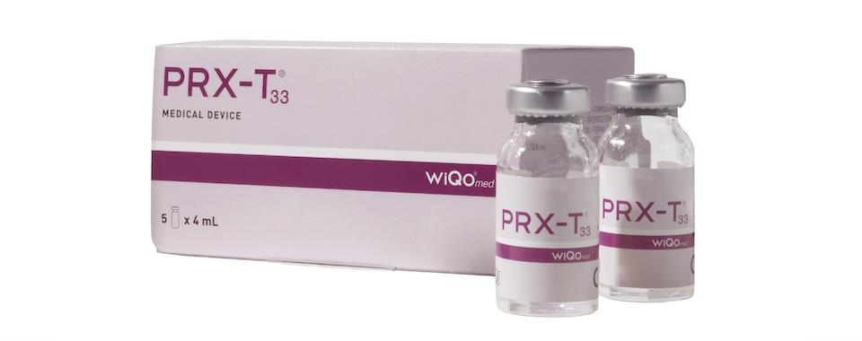
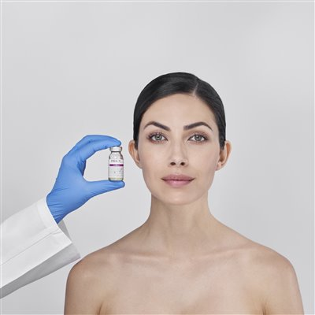

(( and please link to this page https://renovomd.com/chemical-peels/)

Qwo | Cellulite Injectable

((insert logo below))

Most women will have cellulite in their lifetime–about 9 out of 10 women, in fact.
That means your tough workouts and healthy eating habits are fantastic for your fitness and overall wellness—but won't do much to reduce your cellulite.
QWO is the first and only FDA-approved injectable for moderate to severe cellulite in the buttocks of adult women. It is a non-surgical treatment clinically proven to reduce the appearance of cellulite. Injections take as little as 10 minutes and visible results may be achieved in 10 weeks. Most women received 3 treatments 21 days apart.

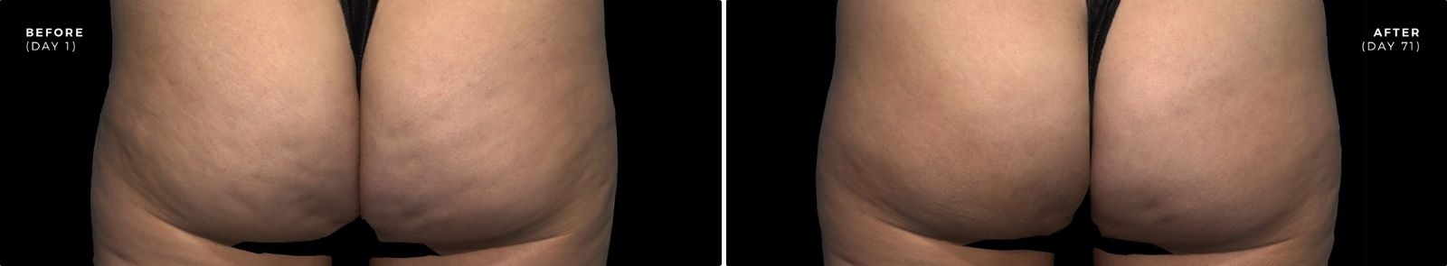

(( and please link to this page https://renovomd.com/cellulite-injectable/))

Silhouette Instalift | Non-surgical facelift
((insert logo below))
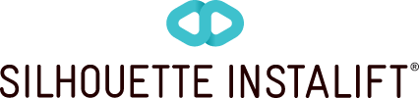

You know that moment you push up your cheeks to envision the youthful appearance they once had? Thanks to InstaLift, you don’t have to.
This innovative treatment is the ideal choice if you’ve had your fill with fillers but aren’t looking to go under the knife. Using Micro-Suspension Technology™, InstaLift is the only non-surgical procedure that immediately lifts your mid-facial skin while adding volume over time that may be long-lasting.
It’s the only non-surgical treatment with advanced Micro-Suspension Technology™ that uses micro-cones to provide an immediate lift and a gradual boost in natural collagen production.

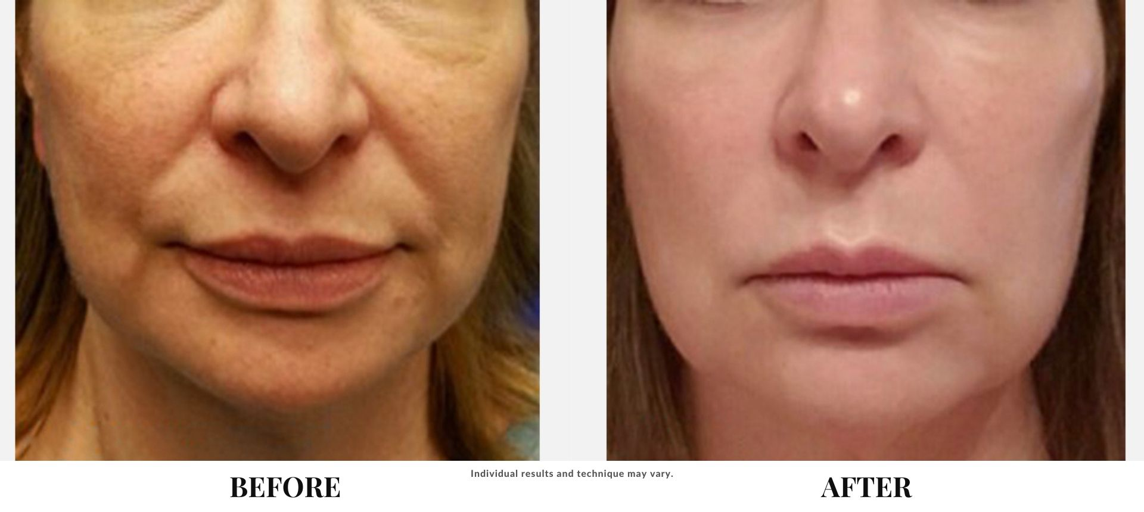

(( and please link to this page https://renovomd.com/silhouette-instalift/ ))

