Aqua Gold Packages
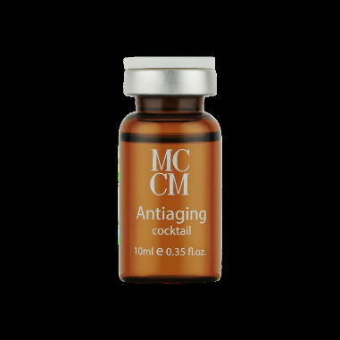
Antiaging
Use- Antiaging cocktail is rich in revitalizing ingredients used for rejuvenation, such as panthenol, DMAE, organic silicon, Centella Asiatica and Hyaluronic Acid. This super combination will reduce the signs of extrinsic and intrinsic aging.
Recommended for | Mature skin
Main Functions | Rejuvenation, collagen/elastin activator
Effects | Smooth and revitalized skin
Main Ingredients | PantheolDimethyl MEA, Methylsilanol  Mannuronate, Centella Asiatica Extract, Sodium Hyaluronate
Add ons: B Complex, Collagen Pyruvate, DMaE, Vitamin ACE, hyaluronic acid
Hydrate and Lift
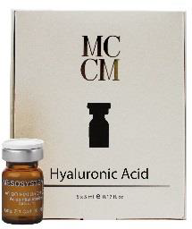
Use Hyaluronic Acid 3.5%-
Recommended for | All skin types, strong anti-aging ingredient
Main Functions | Reduce trans-epidermal water loss, effective skin hydration, revitalization
Effects | Keeps water molecules in the tissue, helps treat visible wrinkles and expression lines with immediate results, activates fibroblastic
Main Ingredients | PantheolDimethyl MEA, Methylsilanol  Mannuronate, Centella Asiatica Extract, Sodium Hyaluronate
Add ons: DMAE, Arireline
Pigment Eraser
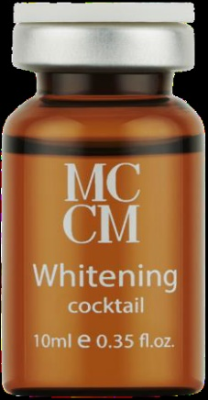
Use- Whitening cocktail combines glutathione, vitamin C, and pyruvic acid, a powerful antioxidant blend designed to offer a more uniform, glowing, and smooth skin. Ideal for depigmentation treatments providing whitening properties that help reduce blemishes of melanic origin.
Recommended for | Hyperpigmentation, photo-aging
Main Functions | Inhibits melanin synthesis, neutralize free radicals, stimulate collagen induction
Effects | Reduction of melanic spots, whitening of the skin, smooth and bright skin
Main Ingredients | Glutathione, Ascorbic acid, Pyruvic Acid
Add ons: Tranexamicum acid, melasmin, antianflamitory/antioxidant

Under Eye Bright
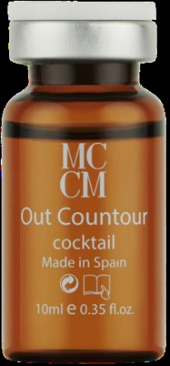
Use Out Contour-eye bags, dark circles and wrinkles can make you look tired, unhealthy and aged long before your time. The active ingredients in Out Contour are specifically indicated to reduce and prevent these conditions. It reinforces firmness, increases moisture and reduces wrinkles in the sensitive area around the eyes.
Recommended for | Undereye and face treatments
Main Functions | Fortifies blood vessels and microcirculation, blocks free radicals, eliminates accumulated liquids
Effects | Reduces appearance of dark circles and eye bags, firms the eye contour
Main Ingredients | Acetyl Hexapeptide-8,Dimethylaminoethanol  Tartrate, Tocopherol, Sodium Pyruvate Panthenol
Add ons: B complex, DMAE, Arireline
ADD-ONS
B-Complex
Collagen Pyruvate
Tranexamicum Acid
Vitamin ACE
DMAE
Agrigreline

