RenovoMD. CoolSculpting Update.500 words.KA

*THIS CONTENT WILL REPLACE THE EXISITING CONTENT ON THE PAGE*

NEW META TITLE: CoolSculpting Worchester MA | Non-surgical Fat Reduction

SLUG: *STAYS THE SAME*

NEW META DESCRIPTION: CoolSculpting in Worchester, MA, provides the newest technology and equipment for reducing TWICE the amount of fat cells in LESS time. Learn more.

H1 COOLSCULPTING ELITE IN WORCHESTER, MA
CoolSculpting is the global leader in non-invasive fat reduction. The fat-freezing procedure uses innovative cooling technology to eliminate fat cells from stubborn bulges. With no surgery and minimal downtime, patients achieve long-lasting, natural-appearing results in as little as 35 minutes.
RenovoMD is proud to offer the most advanced body sculpting treatment currently available, the new CoolSculpting Elite technology. CoolSculpting Elite produces the same trusted results as CoolSculpting Legacy machines but with several updates to the design to improve your fat-freezing experience.
The addition of curved applicators allows for an additional 18% cooling coverage in the area being treated due to its improved suction and fit over the contours of the body. CoolSculpting Elite also features dual applicators allowing for the treatment of multiple areas at the same time. Sculpt and slim your whole body in fewer appointments than traditionally needed to reach your stunning, final results.

If you want to learn more about the body contouring and fat reduction possible with CoolSculpting Elite, contact RenovoMD. We are proud to be the leading provider of the NEW CoolSculpting Elite in Worchester, MA, also serving the areas of Northborough, Southborough, Sudbury, and Framingham, Central MA. Contact us now by calling (508) 393-6398 to schedule your CoolSculpting consultation and discover how quick and easy it can be to achieve a slim, sculpted physique.

H2 THE BENEFITS OF COOLSCULPTING
- FDA cleared + proven scientifically
- A non-surgical alternative to liposuction
- Target bulges that resist diet + exercise
- Virtually painless + minimal downtime
- Millions of treatments performed globally
- Results are natural-looking and last

H2 EXPERIENCE THE NEW COOLSCULPTING ELITE

NEW & IMPROVED
TECHNOLOGY
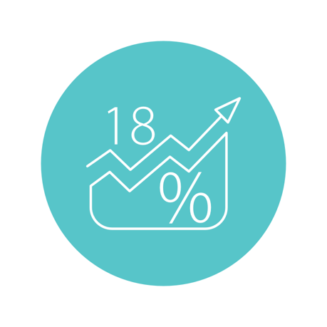
18% MORE
AREA COVERAGE
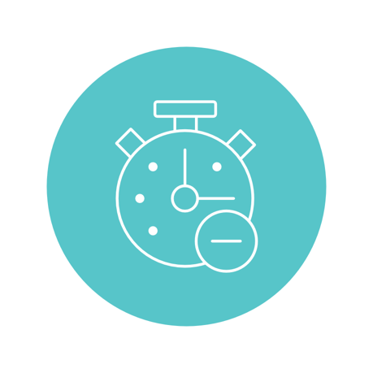
DUAL SCULPTING
MEANS LESS TIME

H2 COOLSCULPTING BEFORE AND AFTER IMAGES*
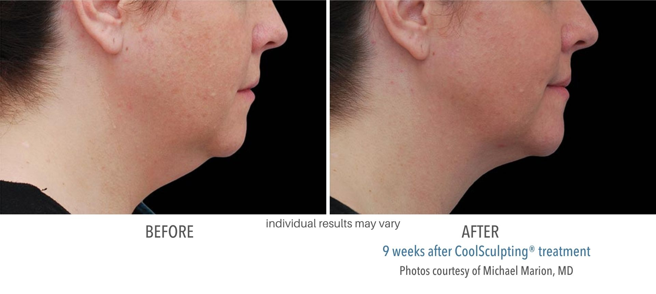
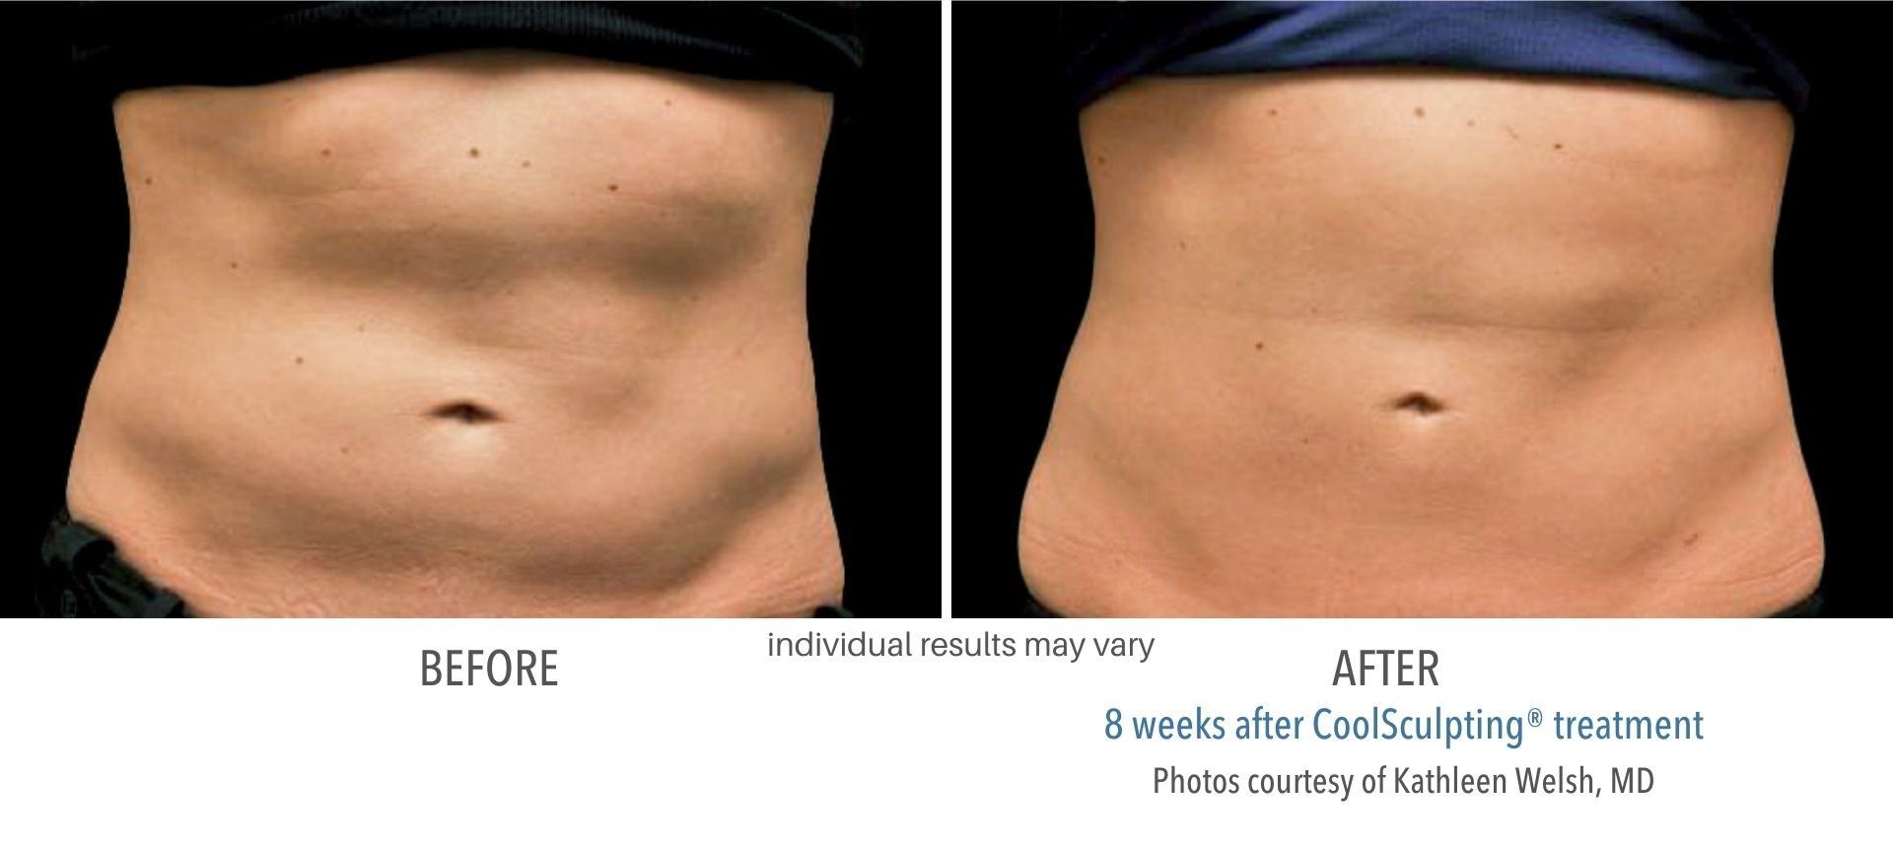
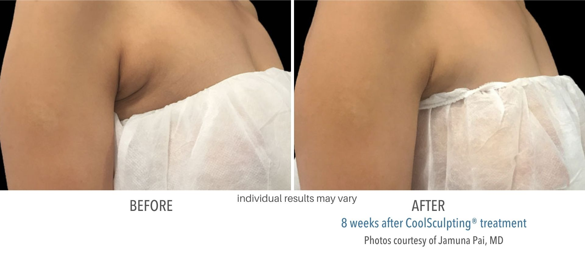
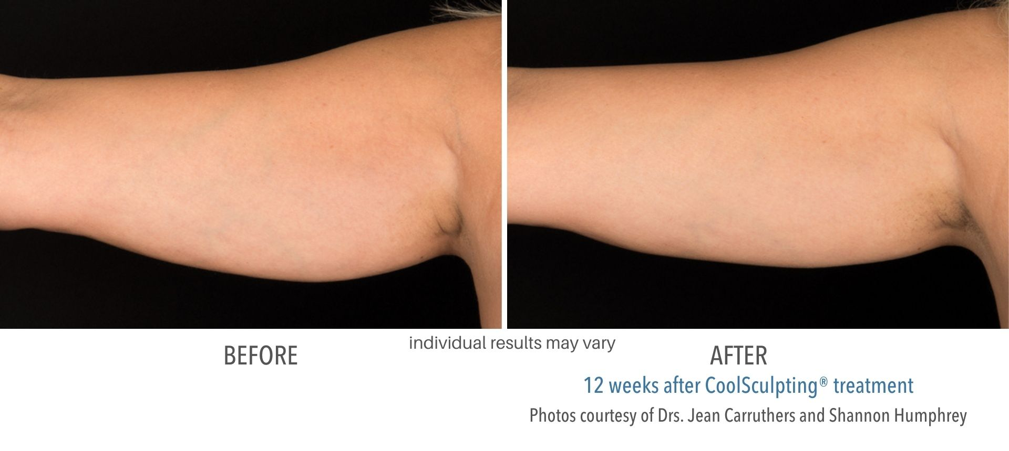
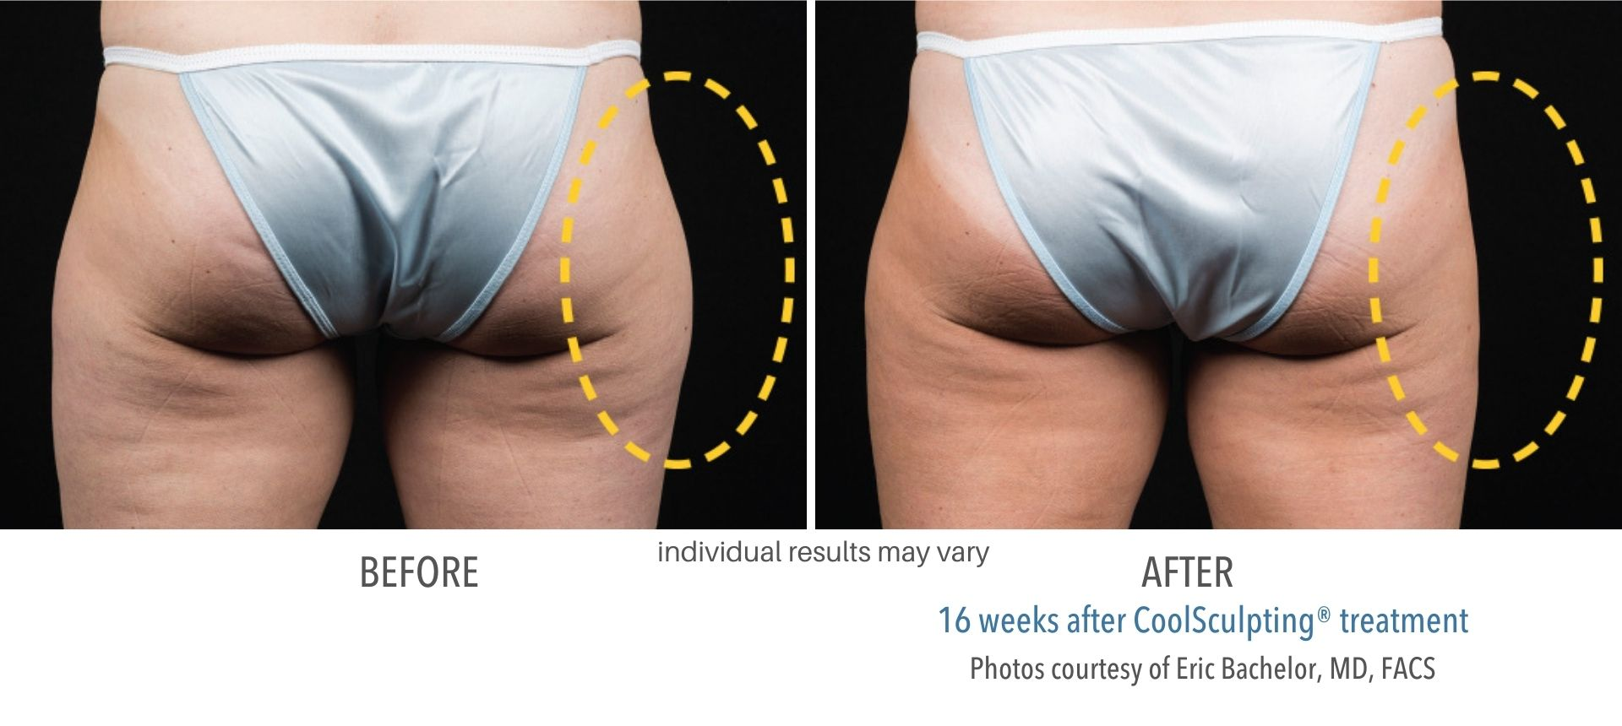
CoolSculpting before and after images showcase how effectively fat freezing works. As with all body shaping treatments, results may vary.*

H2 HOW FAT FREEZING WORKS
50% OFF*COOLSCULPTING ELITE
Please call (508) 812-7935 or fill out the form:

By submitting this form you agree to be contacted via phone/text/email. Reply ‘STOP’ to opt-out of marketing at any time.
*Must purchase 8+ treatments for 50% off.


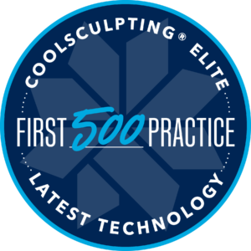
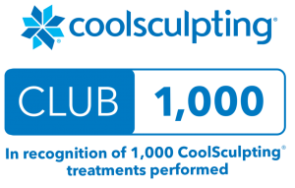
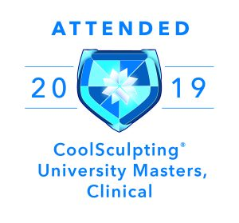
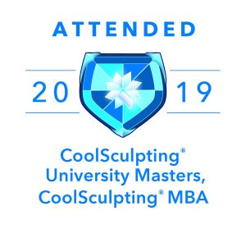
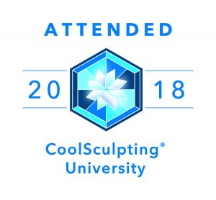

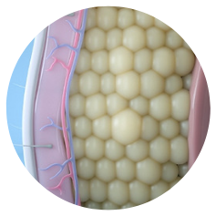
During treatment, an applicator exposes an unwanted bulge to freezing temperatures. The precise cooling safely penetrates the skin and chills underlying fat deposits.
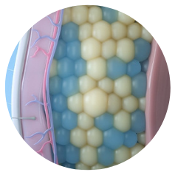
The treatment utilizes a scientific process known as Cryolipolysis (“cryo” = cold + “lipo” = fat cells + “lysis” = cell death and removal) to damage the fat cells permanently.
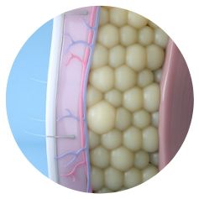
Over the course of several weeks, the frozen fat cells are gathered up by the lymphatic system and gradually eliminated from the body as waste. Results are long-lasting.

H2 THE SCIENCE OF CRYOLIPOLYSIS
Numerous clinical studies prove fat freezing safe and effective. Noteworthy findings from peer-reviewed journals include:
- “Reduction of fat at the treatment site by up to 25% after one treatment.”¹
- 86% of patients saw “visible reductions” in fat from the abdomen, back, and flanks. ¹
- “82% of patients recommend…the cryolipolysis procedure.” ³
- “Cryolipolysis…is a very safe method for body contouring and is accomplished with only minimal discomfort” ³
- “Cryolipolysis is…safe and efficient, with a high patient satisfaction rate.”¹
- “The procedure [is] well-tolerated. 89% of [patients] report a positive perception of treatment duration.” ³
- “96% [of patients] report[ed] minimal to tolerable discomfort. ³

FREQUENTLY ASKED QUESTIONS

H2 COOLSCULPTING ELITE TREATMENT AREAS
• Stomach/Abdomen
• Love Handles/Flanks
• Under the Neck (Double Chin)
• Back/Bra Area
• Thighs
• Male Chest (Pseudogynecomastia)
• Arms
• Under Buttocks (Banana Roll)

H2 AFTER THE COOLSCULPTING TREATMENT
Immediately following treatment, patients may continue their daily activities (including exercise) as usual.

Adverse side effects are rare. However, patients commonly experience mild symptoms of tenderness, redness, bruising, or swelling, isolated to the treatment site. These symptoms indicate activity from your immune system as your body begins the metabolism of the frozen fat cells. Such symptoms typically reside in a week or two.

Visible reduction in fat is possible after one treatment. However, most patients opt for a package of cooling cycles to obtain optimal outcomes.

Patients may see results in as little as four weeks. However, most require 8 to 12 weeks to see the full effects of their fat-freezing procedure. As with all body contouring treatments, individual experiences may vary.*

H2 COOLSCULPTING RESULTS*
CoolSculpting results last. Once the body eliminates frozen fat cells, they are not replaced and cannot grow back. A scientific study following patients over a decade proves the longevity of CoolSculpting results. The study found, “local reductions in fat” after one treatment demonstrate “significant longevity.” The study concluded, “results from Cryolipolysis may be very long-lasting.” As always, individual results will vary.*

H2 COOLSCULPTING FAT LOSS VS. WEIGHT LOSS

Understanding the difference between fat loss and weight loss is important when committing to CoolSculpting cooling sessions. First, CoolSculpting is a fat-reduction treatment. It is not a weight loss treatment. This means that during cooling sessions, a percentage of fat cells within the target treatment area is “frozen” and eliminated from the body. This results in fat cell loss which is different from weight loss. During weight loss treatments, the fat cells merely shrink. The body does not remove those cells, so they remain in place with the possibility of re-expanding in the future. If you regain your weight, those fat cells will expand again, leading to weight gain. However, after CoolSculpting treatments, those fat cells are gone for good and cannot re-expand, re-grow, or return. This is the difference between fat loss with CoolSculpting and traditional weight loss with weight loss programs.

H2 COOLSCULPTING ELITE COST
Cool Sculpting prices vary per patient. Cost depends on several factors. These include the specific applicator utilized, the number of areas treated, and available discounts from specials or package pricing.

As your premier body sculptor in Central MA, RenovoMD offers complimentary consultations to ensure the fat freezing treatment is right for you. During the consultation, we’ll go over CoolSculpting Elite costs and tailor a treatment plan that aligns with your circumstances, budget, and aesthetic goals.

H2 EXPERIENCE THE BEST COOLSCULPTING IN WORCHESTER
Fat freezing is a technique-dependent procedure. The technician’s skill and expertise impact the patient’s experience and results. Therefore, to find the best CoolSculpting in Worcester and Middlesex counties, select a reputable provider with an extensive background performing the fat freezing treatment.

We were Coolsculpting before it was cool!

H3 COOLSCULPTING AT RENOVOMD

Knowing the importance of experience, discerning patients choose RenovoMD as their preferred CoolSculpting Elite provider.

At RenovoMD, we’ve been CoolSculpting before it was Cool. We were among the first providers in the nation, offering treatments for as long as the fat freezing technology has existed. As a member of the coveted CoolSculpt 1000 club, we have performed thousands of fat freezing treatments. Indeed, our skill and experience remain unmatched.

On top of unparalleled experience, we ensure all our technicians receive the utmost training, including exclusive education from CoolSculpting University. This, coupled with our commitment to patient safety and satisfaction, makes RenovoMD the clear choice for fat freezing in Central MA.

H2 COOLSCULPTING REVIEWS from RENOVOMD PATIENTS
After years of strict dieting and exercise still left me unsatisfied, I turned to CoolSculpting to take care of my “problem” areas and boy did it exceed my expectations! Jean and her staff were very informative and genuinely interested in helping me achieve my goals. I would recommend RenovoMD to anyone!
Chef Eddie

Going to Dr. Casello was the best decision I made. After doing my research I brought in all my questions and she took the time to answer everything and explained every step of the procedure and after care. I went in for CoolSculpting under my chin (an area of fat that is very difficult to get rid of regardless of exercise) and I noticed results within the week. It was not painful at all.
Lina N.

H2 COOLSCULPTING IN WORCHESTER
Take the first step towards sculpting a slimmer, more confident you. Sign up for a free consultation with RenovoMD. Conveniently located in Northborough, RenovoMD is the premier body sculptor for Worcester, Southborough, Sudbury, and Framingham. Contact us online or call (508) 812-7935 today.

H2 COOLSCULPTING ELITE FAQS

H3 How long do CoolSculpting results last in Worchester?

CoolSculpting results are permanent when you select a reputable provider in Worchester like RenovoMD. The fat cells removed during a CoolSculpting Elite treatment are gone for good. This means they will not return to the body once they exit it as a form of waste—leading to lasting fat reduction. However, you must devote yourself to a healthy lifestyle to ensure lasting results. Fat cells in surrounding areas can still expand if you gain excessive weight, which obscures your CoolSculpting results.

H3 What is the downside of CoolSculpting?

CoolSculpting touts many positive benefits. However, patients can experience bruising in the treatment area. In addition, swelling, redness, pain, or skin sensitivity are possible. These side effects can last for up to two weeks after the treatment. However, they will resolve on their own and are normal effects associated with the immune system’s response to removing dead fat cells.

H3 Does CoolSculpting leave your skin saggy?

Since CoolSculpting sessions reduce fat naturally and gradually, it is unlikely to cause sagging skin or make loose skin worse. Fat cells break down and are slowly removed from the body through the lymphatic system, mimicking natural fat loss. As a result, the skin typically retracts around the new slim contours with ease.

H3 Is CoolSculpting worth it for belly fat?

CoolSculpting is often used on the belly area to reduce stubborn belly fat. You can typically reduce 20% to 30%, resulting in the loss of inches off of the waistline.

H3 Is one session of CoolSculpting worth it?

Patients can see a slight reduction in areas like the stomach, thighs, or chin in as little as one session. However, providers suggest you complete a full treatment schedule to ensure optimal fat reduction. Speak to your provider during your consultation to ensure you receive the right amount of treatments to result in optimal fat loss.

