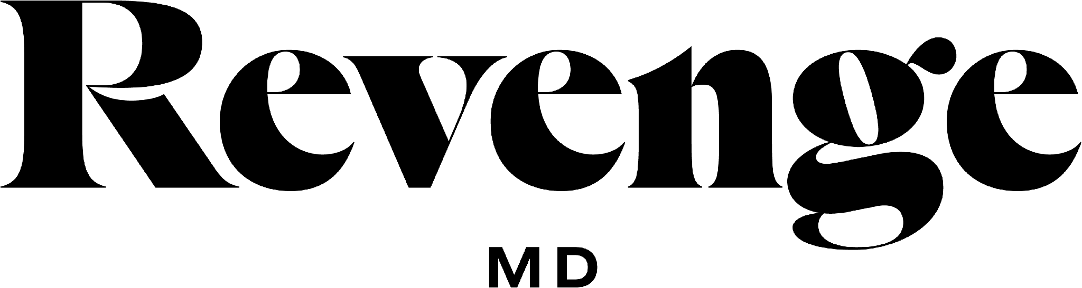

June Specials

25% OFF Ultherapy For All New Patients!

Brows $750  Upper Face $1,500  Lower Face $2,500  Full Neck $2,000  Full Face $3,500  Décolleté $1,500  Full Face & Neck $4,250  Lower Face & Neck $4,000 | This Month $562.50  This Month $1,125  This Month $1,875  This Month $1,500  This Month $2,625*  This Month $1,125  This Month $3,187.50  This Month $3,000

Package Specials

Acne Awareness Month  Free Gift With Purchase  Micro-Needling  $450  Salt Resurfacing  $350  Revenge Signature Facial  $145 | Father’s Day Package  *Micro  Dermabrasion Facial Treatment  *50 Units of Xeomin  $465  Receive $50 Gift Card to use on your next service & FREE Gift ZO Product Gift | Don't Neglect Your Neck  Purchase Full Face Ultherapy  Get Full Neck for FREE  (SAVE $2,000)  Can Not Be Combined  with any other Promo | Lip Filler Add On  Add Versa Lips Filler to today's services and get $100 OFF  Can Not Be Combined  with any other Promo  Must be purchased and used on same day

