CoolTone Body Contouring Treatment in Los Angeles, CA
CoolTone is a noninvasive body contouring treatment that uses Magnetic Muscle Stimulation (MMS) technology to strengthen, tone, and firm the muscles of the abdomen, buttocks, and thighs. The CoolTone™ device is FDA-cleared for improvement of abdominal tone, strengthening of the abdominal muscles, and development for firmer abdomen. CoolTone™ is also FDA-cleared for strengthening, toning, and firming of buttocks and thighs.

Benefits of CoolTone
- 20,000 situps in 30-minutes
- Flatter stomach, tighter buttocks & firmer thighs
- FDA-cleared and Clinically Proven
- Natural-Looking Results
- Non Invasive treatment
- No pain + little to no downtime

What areas can be treated with CoolTone?
- Abdominals
- Buttocks
- Thighs
- Biceps

The CoolTone Treatment
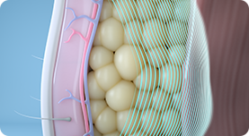
CoolTone’s Magnetic Muscle Stimulation, or MMS technology, penetrates through the skin and fat layers to target only the muscle layer, inducing involuntary muscle contractions.

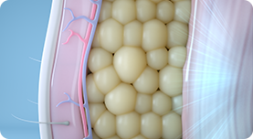
The body’s response to these contractions is to strengthen its muscle fibers, resulting in improved muscle conditioning.

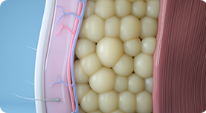
After treatments, abdomen, buttocks, and thighs are firmer and have a more defined and toned appearance.

CoolTone Before and After
The CoolTone™ treatment improves muscle conditioning with powerful magnetic muscle stimulation (MMS). Abdomen, buttocks, and thighs will be firmer and have a more defined and toned appearance. As with any body-shaping treatment, results may vary. *

How does CoolTone work?
The CoolTone applicator generates a magnetic field that creates a current when it passes through a conductive material. Muscles are good conductors of magnetic fields, unlike skin and fat, which are poor conductors. The induced current is stronger in the muscle layer and the body responds to these contractions by strengthening its muscle fibers and improving muscle conditioning. The result is stronger, firmer, and more toned abdomen, thighs, and buttocks.

CoolTone Near Me
Begin your journey to a strong and sculpted physique. Schedule a free consultation with Sculpt DTLA. We have two convenient locations to help you find the best CoolTone prices & schedules to meet your needs. One location is Sculpt DTLA at the following address: 705 S. Olive street Suite A Los Angeles, CA. 90014. Our other Sculpt Silverlake location is located at 4443 W Sunset Blvd Los Angeles, CA. 90027.

With two convenient locations in Los Angeles, we are proud to serve all of downtown L.A. as well as Los Feliz, Echo Park, and Hollywood. Contact us online by filling out the form below or call (323) 209-1122 today.

