500 Word Dermal Filler Update.Sculpt DTLA.KA

Link to page: https://www.sculptdtla.com/services/juvederm-los-angeles/

NEW H1: FILLERS LOS ANGELES: EXPERIENCE THE BEST INJECTABLES LA HAS TO OFFER
Facial fillers, such as Juvéderm, Restylane, Radiesse, Belotero, Sculptra, and Versa, are cosmetic injections and popular anti-aging treatments. Face fillers, also known as dermal fillers or soft tissue fillers, primarily restore volume below the skin. In addition, they fill fine lines and wrinkles, plump recessed areas, and restore symmetry. Fillers also make excellent lip injections for fuller, more voluminous lips. While the face is the most popular treatment, fillers can rejuvenate the hands, chest or décolletage area.

If you want to learn more about the benefits of facial fillers and how they can reverse the signs of aging, contact Sculpt DTLA. We are the top-rated filler provider in Los Angeles, California. With two convenient locations, we can better serve LA's fantastic clients. Call us at our Sculpt DTLA LA location at (213) 265-7285 or Sculpt Silver Lake location on Sunset Blvd at (323) 922-6058 to schedule your consultation and learn how dermal fillers can enhance your appearance and turn back the clock!

H2 BENEFITS OF DERMAL FILLERS
- FDA-cleared + scientifically proven
- Natural-looking results
- Non-surgical facial rejuvenation
- Fill in fine lines and wrinkles
- Plump up sunken areas
- Augment lips, chin, and cheeks
- Restore symmetry
- Rejuvenate the chest and hands

H2 HOW DERMAL FILLERS WORK
There are many types of dermal fillers. However, all dermal fillers consist of a volumizing substance. Many fillers consist of Hyaluronic Acid (HA.) Hyaluronic acid is a naturally occurring molecule found in the skin. HA maintains moisture, helping skin look plump and healthy. The various HA fillers differ in formulation, viscosity, and longevity. Other fillers consist of calcium or synthetic materials.
Dermal fillers safely and effectively improve: _{1,2,3}
- Tear troughs– the lines under your eyes that make you look tired.
- Naso-labial folds– smile or laugh lines.
- Acne scars– fills in atrophic acne scars for a smoother appearance.
- The corners of the mouth- restores symmetry to drooping mouth corners.
- Vertical lip lines– smoker’s lines.
- Marionette lines– the deep creases that start at the corner of the nose and run down to the edges of the lips or the creases that begin at the corners of the lips and run down the chin.
- Cheeks and temples – plump up sunken cheeks or temples and volumize cheekbones.
- Lips – lip injections contour and plump lips.
- Jawline – restore symmetry to the jawline and volumize pre-jowl depressions
- Chin – add volume to the chin or reduce a vertical chin line.
In addition to treating areas of the face, fillers also provide:
- Hand rejuvenation – rejuvenates the appearance of the hands by restoring volume.
- Chest rejuvenation – rejuvenate the décolletage.

H2 THE BEST DERMAL FILLERS IN LOS ANGELES AVAILABLE AT SCULPT DTLA
Sculpt DTLA is the premier provider of cosmetic injections in the Los Angeles area. As such, we offer the full spectrum of injections from the top manufacturers of dermal fillers. During your free consultation from Sculpt DTLA, our professional injectors will assess your skin and listen to your aesthetic goals to determine which filler is best suited for you.
Face Fillers Available from Sculpt DTLA include:
THE JUVÉDERM LINE FROM ALLERGAN
Juvéderm is the top-selling line of dermal fillers. The Hyaluronic acid filler consists of a smooth gel, making it ideal for filling in fine line and wrinkles that form around the mouth and nose.
- JUVÉDERM XC smooths moderate to severe parentheses lines (nasolabial folds) and marionette lines.
- JUVÉDERM VOLLURE softens moderate to severe parentheses lines (nasolabial folds) and other wrinkles by restoring volume around the nose and mouth.
- JUVÉDERM VOLUMA adds volume to the cheek area to correct age-related volume loss.
- JUVÉDERM VOLBELLA softens the appearance of vertical lip lines (smoker’s lines or perioral lines) and adds subtle volume to lips for naturally fuller lips.
- JUVÉDERM ULTRA Formulated to be a lip injection. Adds fullness and plumps lips. Ultra also softens moderate to severe parentheses lines (nasolabial folds.)

H2 JUVÉDERM BEFORE AND AFTER*
Juvéderm before and after images depict actual patients and genuine results. Nevertheless, results may vary. *
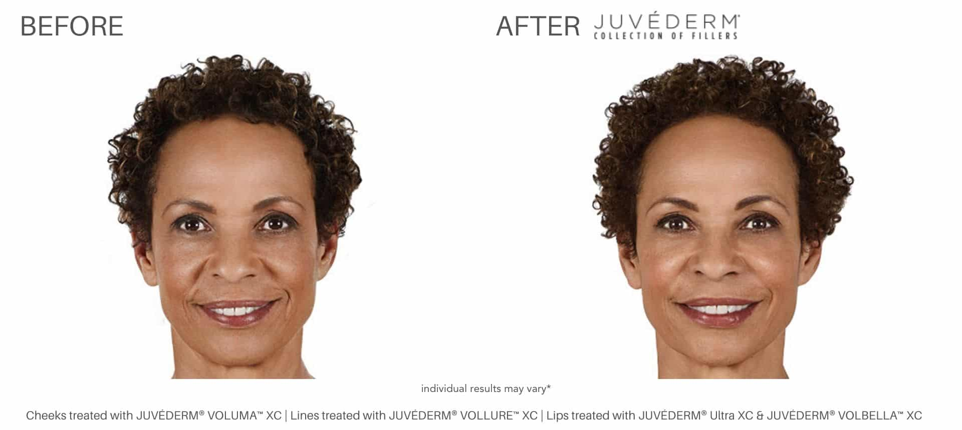
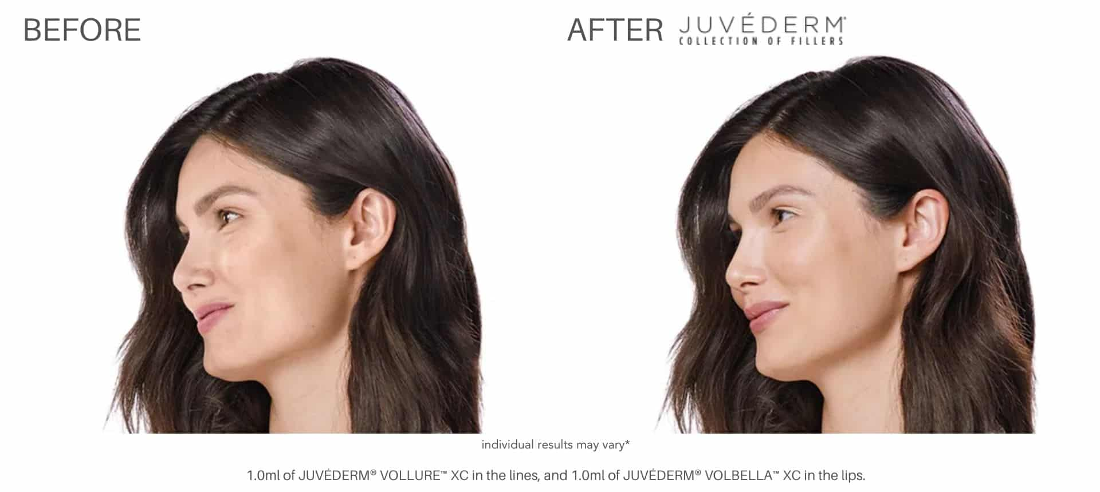
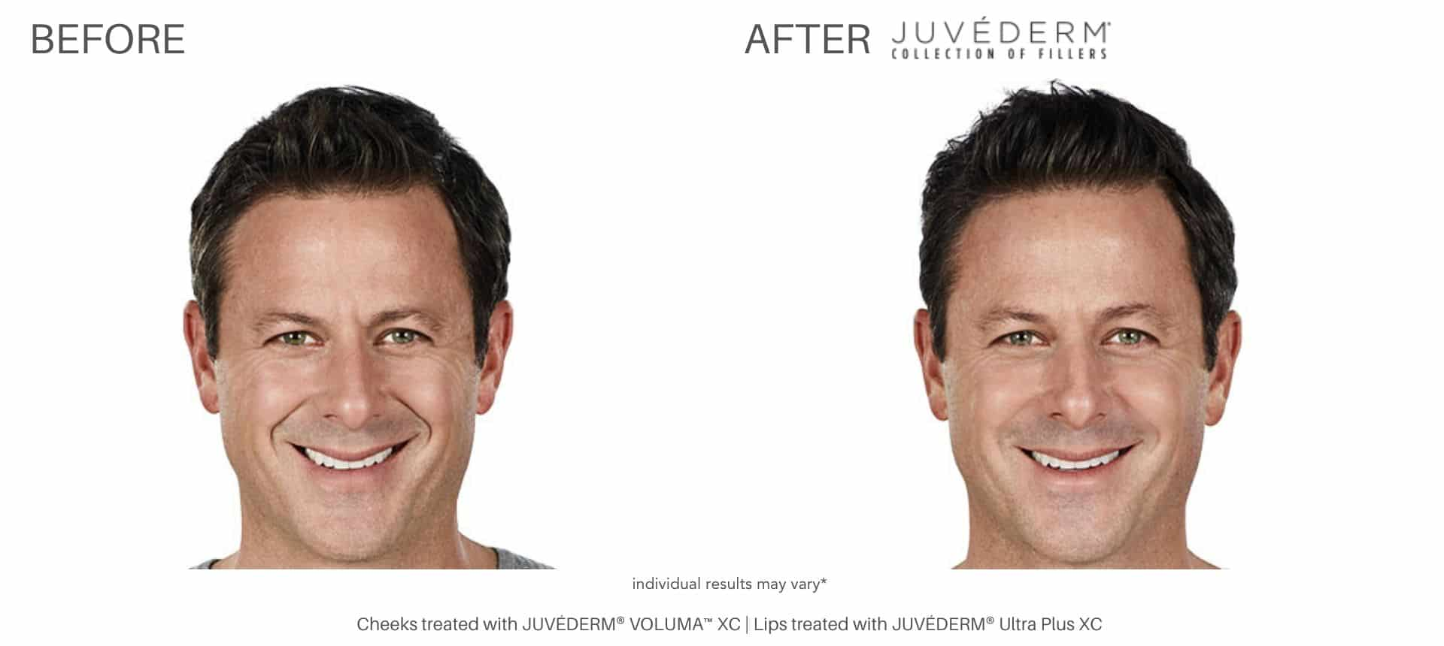

THE RESTYLANE LINE FROM GALDERMA
Restylane is another line of Hyaluronic Acid fillers. While Juvéderm consists of a smoother substance, Restylane offers a more granular formulation of HA. This makes Restylane well suited for restoring volume, plumping lips, and rejuvenating hands.
Restylane L: The original Restylane filler. It adds volume and fullness to correct moderate to severe facial wrinkles and folds. Restylane L also improves under eye bags through the treatment of tear troughs.
Restylane Lyft: Designed for deep injections to correct moderate to severe facial wrinkles and folds, such as nasolabial folds. It also restores volume for cheek augmentation. Restylane Lyft is the first FDA-cleared filler for hands.
Restylane Refyne: Softens laugh lines (marionette lines and nasolabial folds.)
Restylane Defyne: Smooths deep laugh lines (marionette lines and nasolabial folds.)
Restylane Silk: The first FDA-cleared cosmetic injection specially formulated for lip enhancement and the smoothing of wrinkles around the mouth. A popular lip injection for adding subtle, natural-looking volume. Ideal for patients suffering from a thinning upper lip.
Restylane Kysse: The first HA filler expressly indicated for lip augmentation using Optimal Balance Technology (OBT,) also known as XpresHAn Technology. This long-lasting filler provides natural-looking, fuller lips for up to one year.

H2 RESTYLANE BEFORE AND AFTER*
Restylane before and after images depict actual patients and genuine results. Nevertheless, results may vary. *
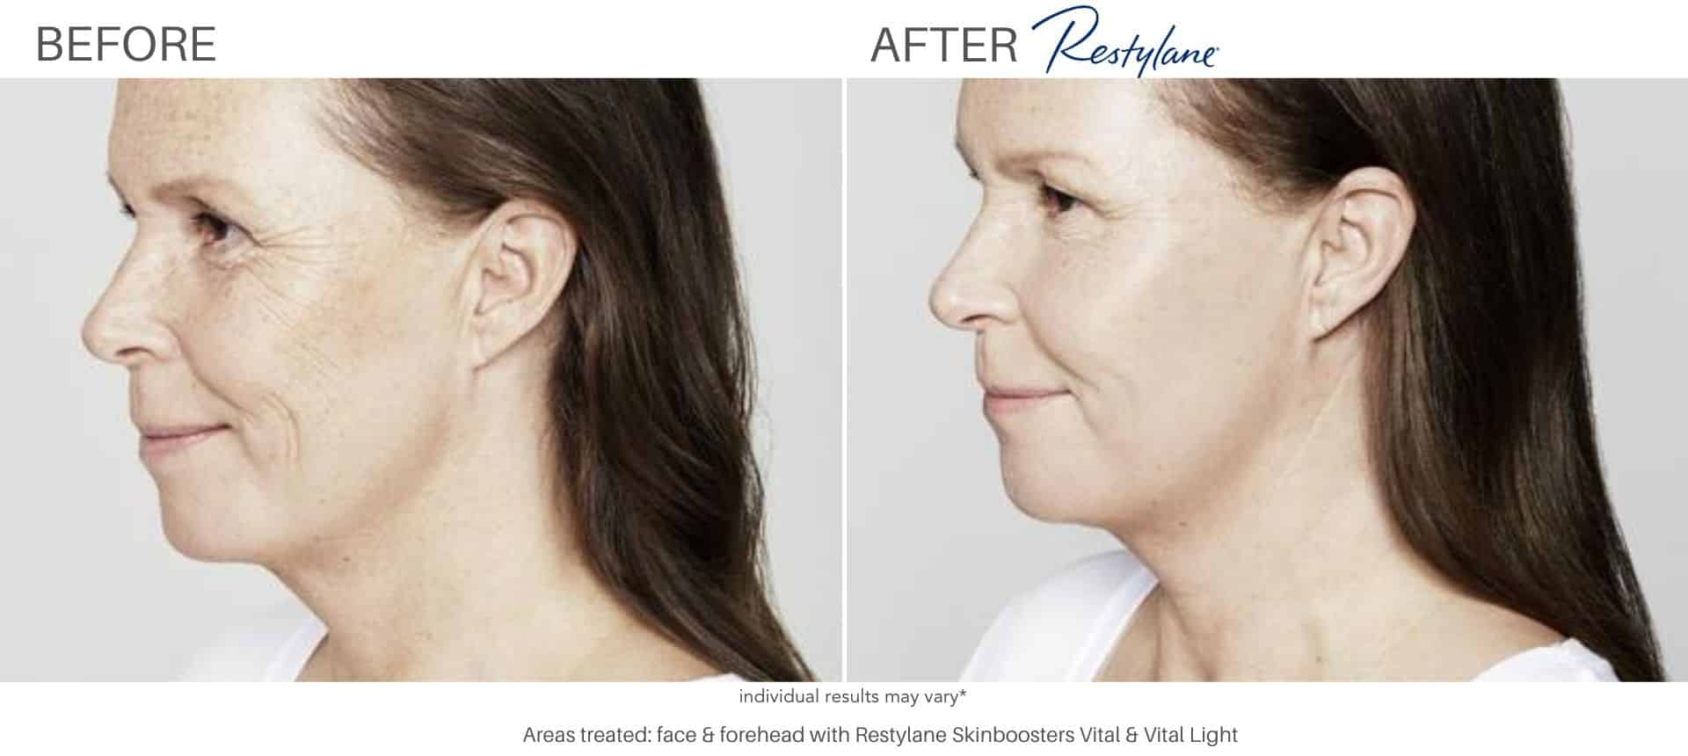
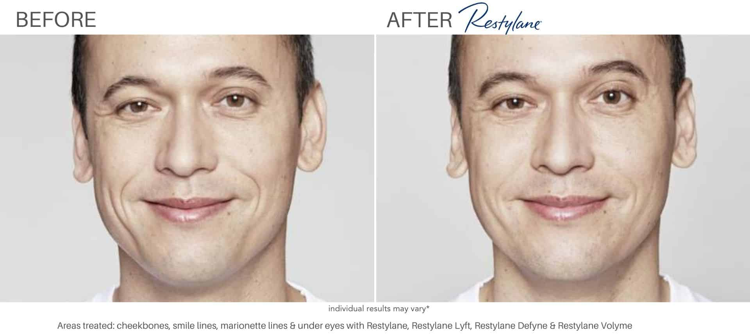
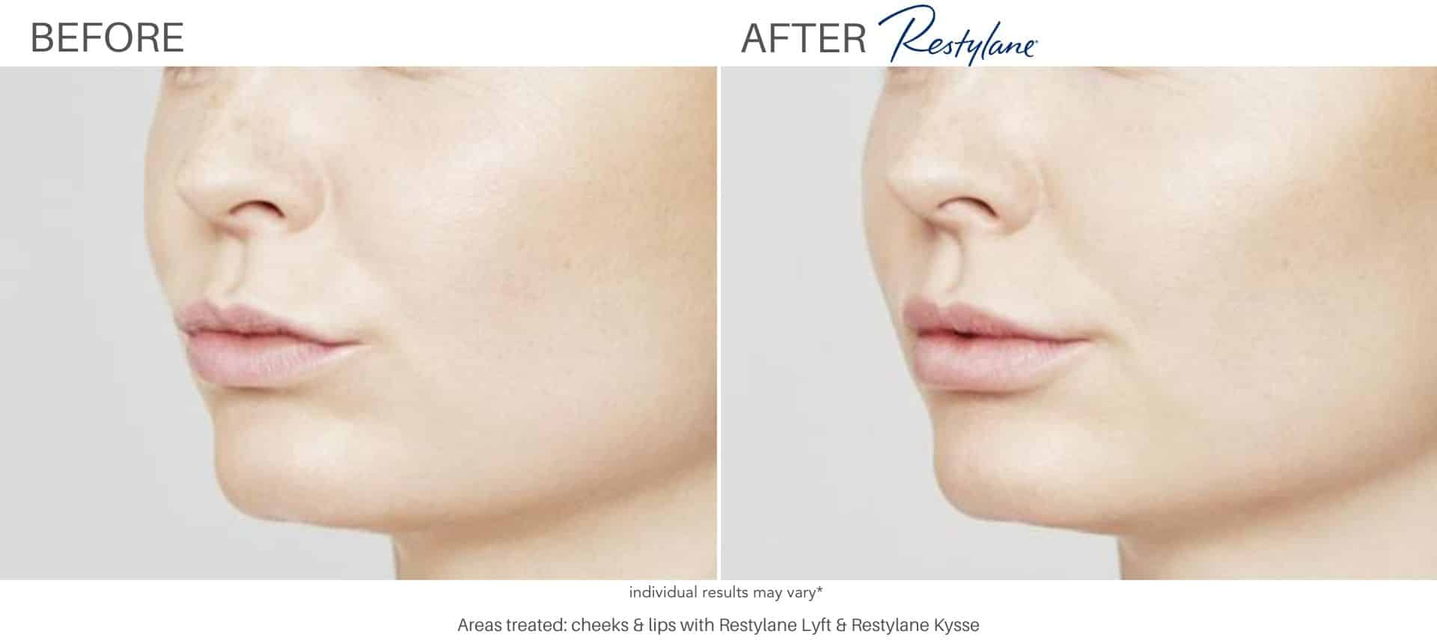
FILLERS FROM MERZ AESTHETICS
Radiesse: Unlike Juvéderm, Restylane, and other HA fillers, Radiesse consists of calcium microspheres (CaHa suspended in a gel). The microspheres provide long-lasting, anti-aging results by restoring volume. The effects are both immediate and progressive. Instant fullness is achieved by plumping up areas with age-related volume loss. Radiesse produces long term results by stimulating natural rejuvenation. Radiesse does this by providing scaffolding in the skin that promotes the production of collagen. Results are shown to last for a year or longer. *

H2 RADIESSE BEFORE AND AFTER*
Radiesse before and after images depict actual patients and genuine results. Nevertheless, results may vary. *
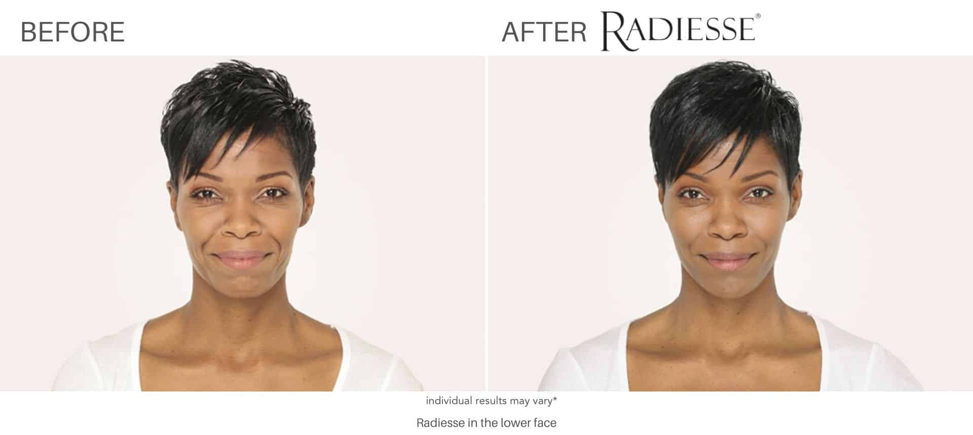
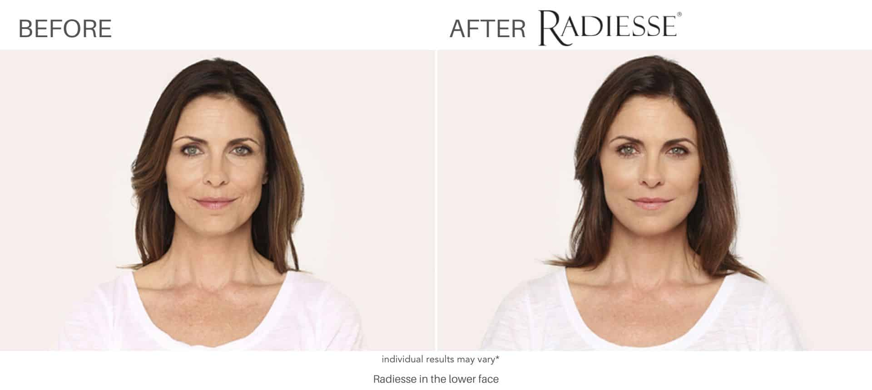
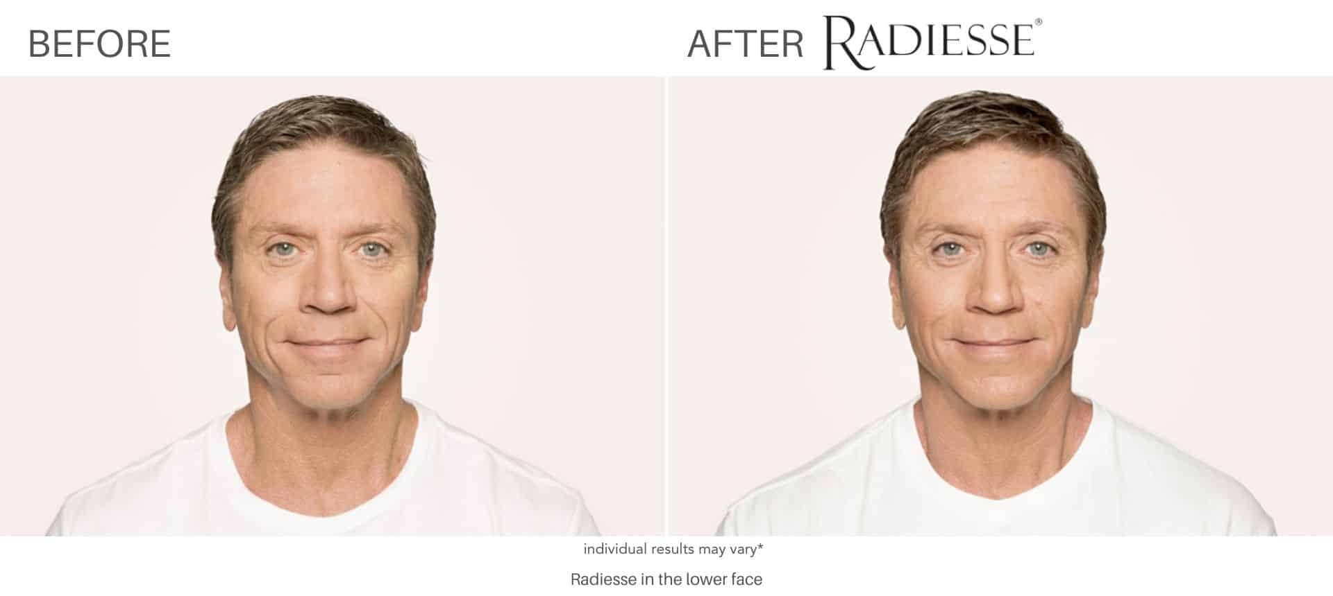
Belotero: Belotero is another HA filler. It differentiates itself from Juvéderm and Restylane with a specific formulation designed to treat moderate to severe wrinkles such as vertical lip lines above and around the lips. Belotero consists of a smooth, flexible gel that blends into the natural structure of your skin using the proprietary Cohesive Polydensified Matrix (CPM) process.

H2 BELOTERO BEFORE AND AFTER*
Belotero before and after images depict actual patients and genuine results. Nevertheless, results may vary. *
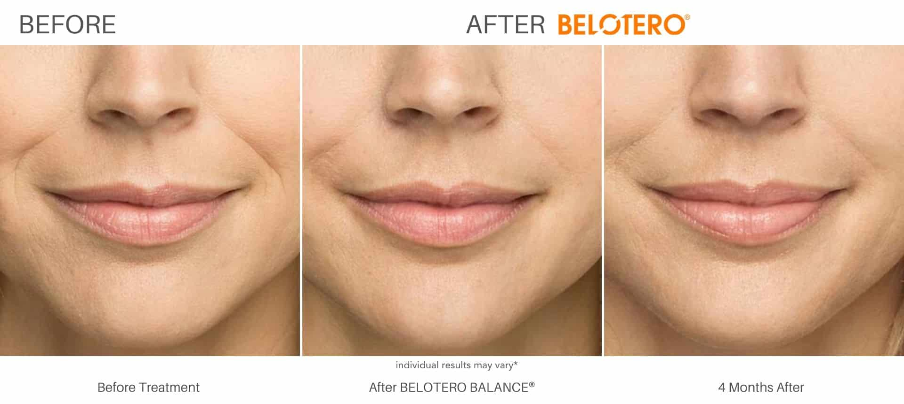
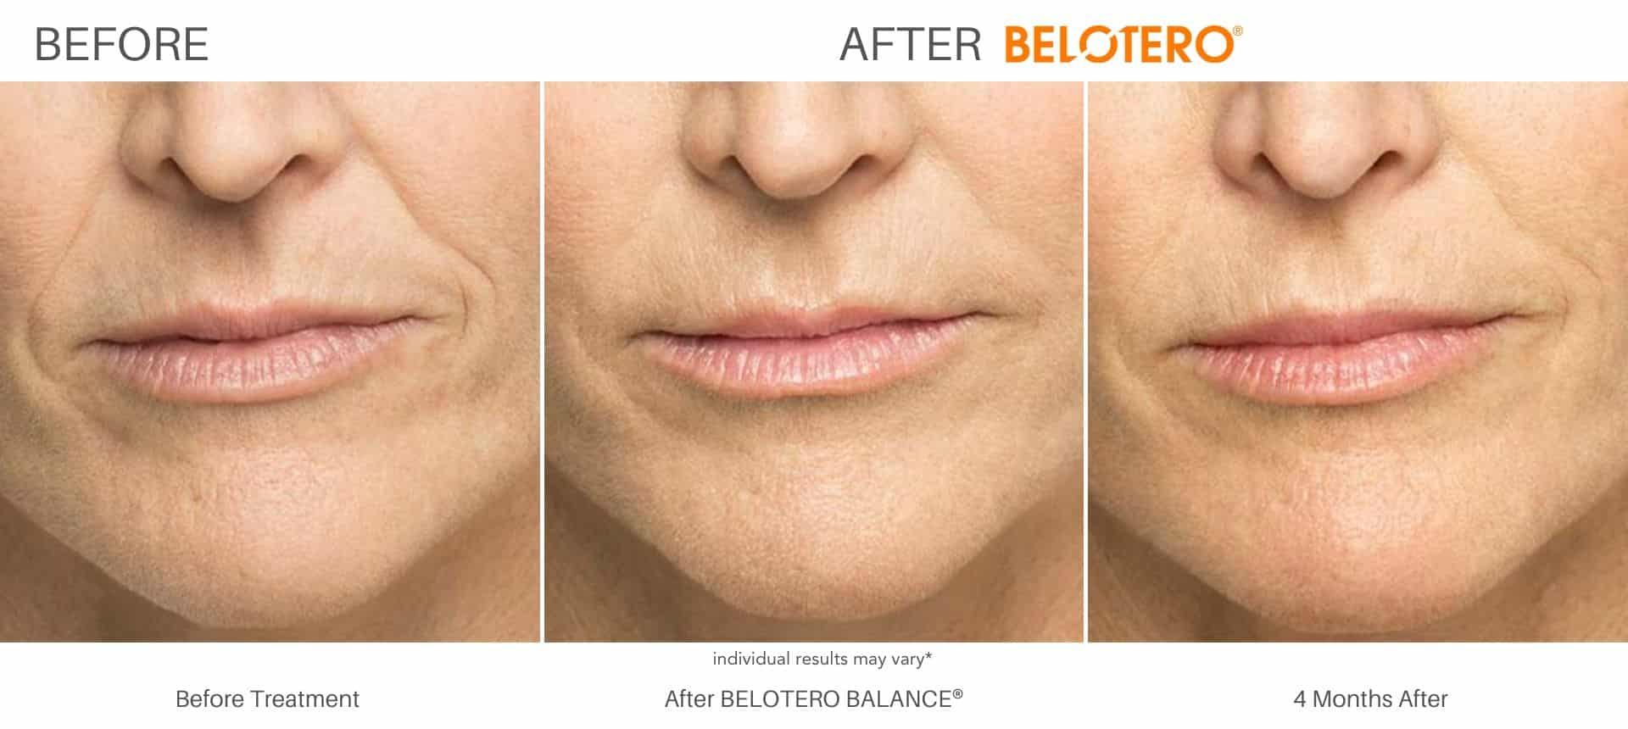
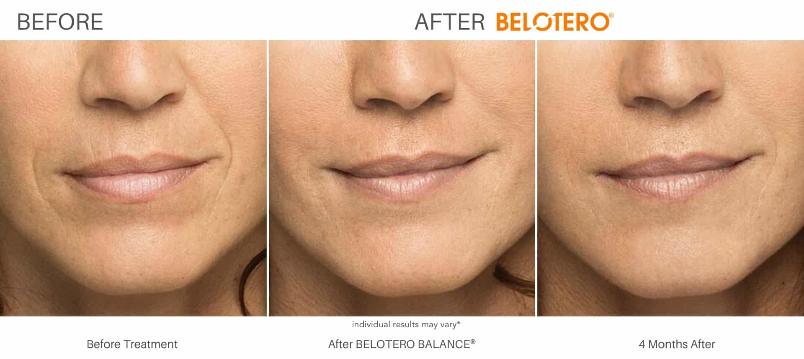
VERSA FILLER FROM REVANESSE
Revanesse Versa is an up and coming Hyaluronic acid filler. It is ideal for filling in fine lines and wrinkles. It differentiates itself from other HA fillers with a unique formulation of Hyaluronic acid consisting of small, spherical particles with a high molecular weight. The round particles produce less swelling compared to other HA fillers. Moreover, the high molecular weight disintegrates more slowly, offering longer results (up to a year) compared to other Hyaluronic acid fillers.

H2 VERSA BEFORE AND AFTER*
Versa before and after images depict actual patients and genuine results. Nevertheless, results may vary.
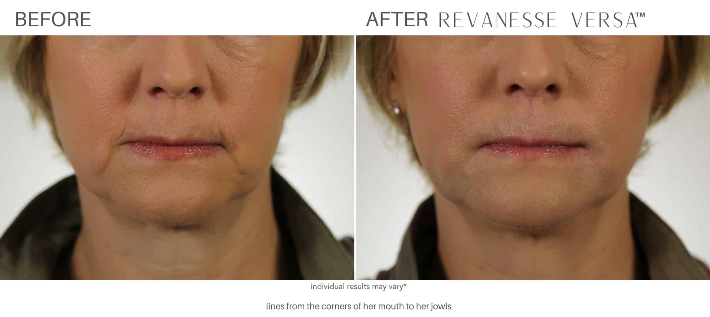
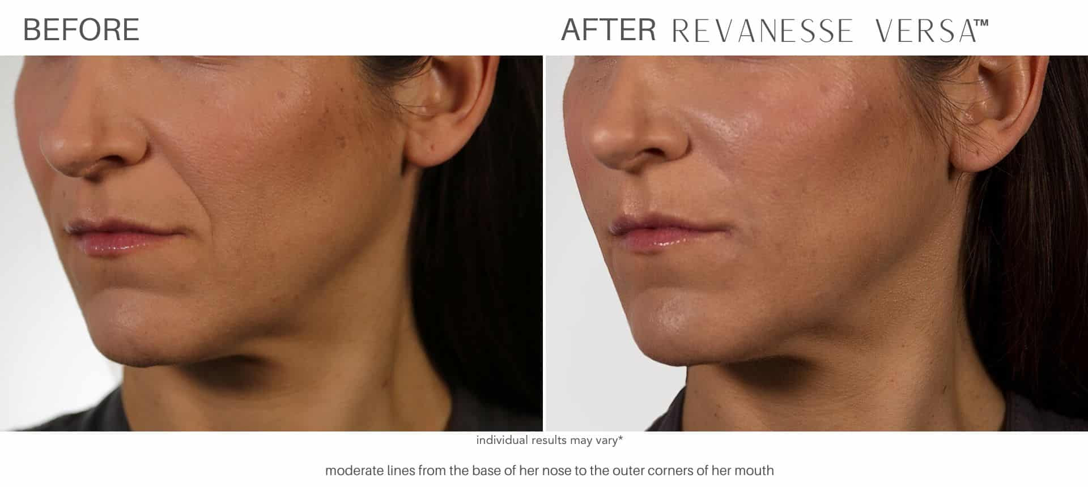
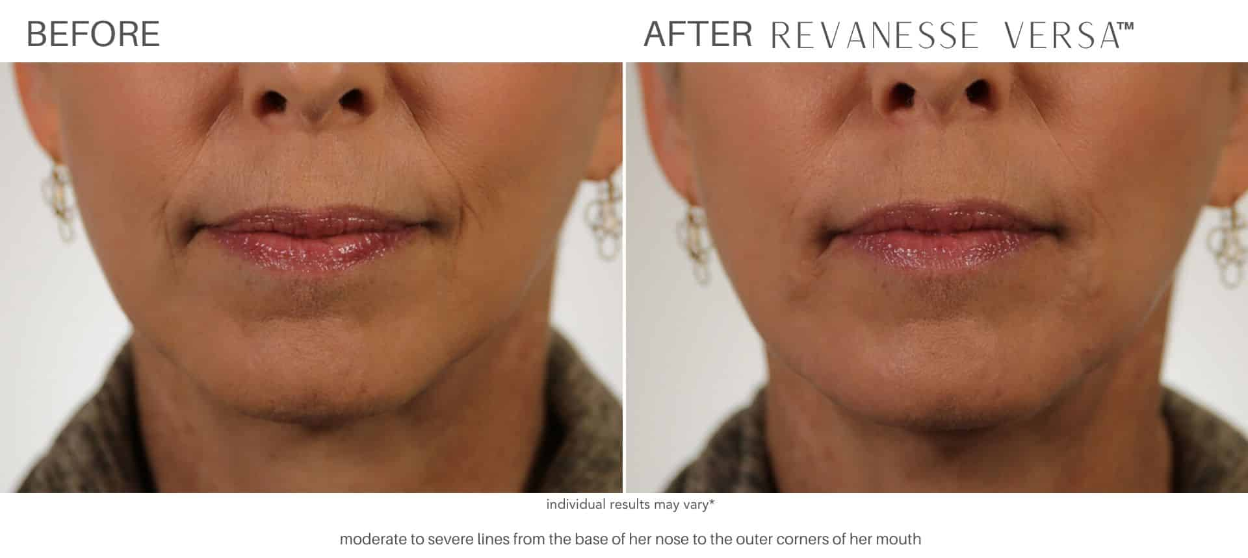

H2 lip fillers

Lip fillers in Los Angeles are the perfect way to enhance and plump your lips using natural substances. Like dermal fillers injected into the face, lip fillers also consist of Hyaluronic Acid and other naturally occurring substances easily absorbed by the body. It is important to note that lip enhancements with fillers are an extremely skill-sensitive treatment. Therefore, you should only trust the most knowledgeable individual to enhance your lips with fillers.

Thankfully, with the expertise of the injectors at Sculpt DTLA, countless men and women can enjoy perfectly plumped lips. To learn more about enhancing your lips with fillers in Los Angeles, contact Sculpt DTLA for a consultation and discover how our team can help you achieve expertly enhanced lips.

INSERT LIP INJECTION BAS

H2 UNDERSTANDING THE LOS ANGELES DERMAL FILLERS COST
Cosmetic injections are incredibly customizable. Each patient receives a tailored treatment plan, curated to address their specific needs and goals. Treatment plans differ in injection location, the number of injections needed to obtain optimal results, and more. Therefore, Juvéderm cost, Restylane cost, Belotero cost, Sculptra cost, Versa cost, and Radiesse cost varies per patient. During your complimentary consultation from Sculpt DTLA, face filler prices will be discussed in detail.
Save on cosmetic injections: As the foremost provider of cosmetic injections in Los Angeles, SCULPT DTLA offers some of the best prices on face fillers. This includes new client specials and military discounts. Call (323) 209-1122 to learn about additional ways to save.

H2 FACE FILLERS RESULTS*
When performed by a skilled injector, results look natural and are long-lasting. Individual experiences vary, but anti-aging effects typically last between 4 months to 3 years, depending on the specific filler utilized. *

H2 DERMAL FILLERS FAQS

H3 Do fillers make you age slower?

While fillers can reduce noticeable signs of aging, like volume loss, wrinkles, and fine lines, they do not stop aging. Therefore, avoiding aging is not possible. However, you can age gracefully using dermal fillers and other popular cosmetic injectables like Botox.

H3 What are the normal face fillers results?*

When performed by a skilled injector, results look natural and are long-lasting. Individual experiences vary, but anti-aging effects typically last between 4 months to 3 years, depending on the specific filler utilized. *

H3 Are dermal fillers better than Botox?

Botox and dermal fillers are completely different types of anti-aging treatments. Botox treats dynamic wrinkles in the upper face, like the forehead, in-between the brows, and crow’s feet. In contrast, fillers add volume to the skin to improve facial features.

H3 What are the side effects of dermal fillers?

The side effects of dermal fillers are not severe or problematic. Instead, the effects involve slight redness, swelling, pain, bruising, and sometimes itching. These effects are typical and go away on their own within a few days of your injection appointment.

H3 At what should you get fillers?

Most people agree that getting injectable fillers in the mid to twenties and thirties is a good idea. By injecting the muscles that cause age-related concerns like sunken depressions, you can prevent them from becoming too noticeable.

H3 What happens when you stop using fillers?

The effects of fillers begin to wear off after several months, sometimes up to a year. After that, the treated area will likely return to its original state.

H3 Do fillers work on a 60-year-old adult?

The effectiveness of cosmetic treatments works for anyone of any age. Injectables are always ideal for any adult wanting to refresh and rejuvenate their appearance for a youthful look.

H2 EXPERIENCE THE BEST FACIAL FILLERS IN LOS ANGELES AT SCULPT DTLA
Like all cosmetic injections, face fillers are technique sensitive. The expertise and experience of the injector significantly influence your overall results. At Sculpt DTLA, our injectors are medical professionals who specialize in cosmetic injections. Each injector offers unparalleled expertise and experience, a preoccupation to detail, and an artistic eye. Therefore, discerning patients living in Los Angeles and the surrounding areas choose Sculpt DTLA for all their cosmetic injections.

Love the skin you’re in and claim the confidence that comes with a rejuvenated, youthful appearance. Get started with Juvéderm, and other popular face fillers, by booking a free consultation with Sculpt DTLA. With two convenient locations in Los Angeles, Sculpt DTLA is happy to serve all downtown LA as well as Los Feliz, Echo Park, and Hollywood. Contact Sculpt DTLA online or call (323) 209-1122 today.

