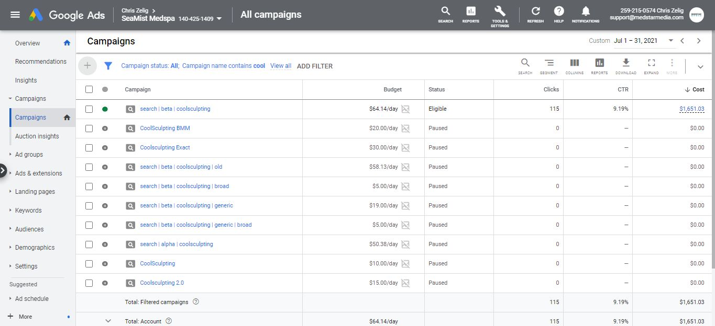
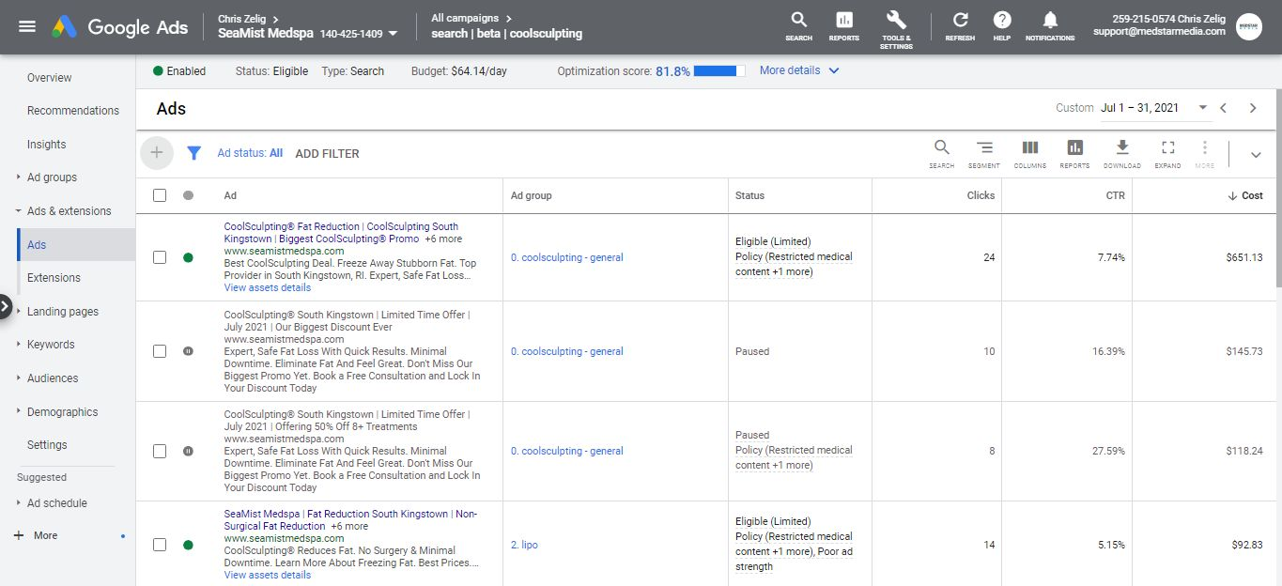
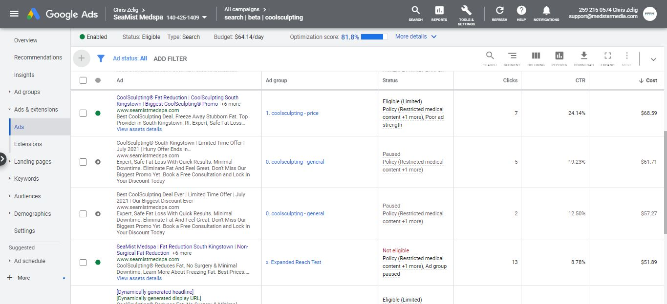
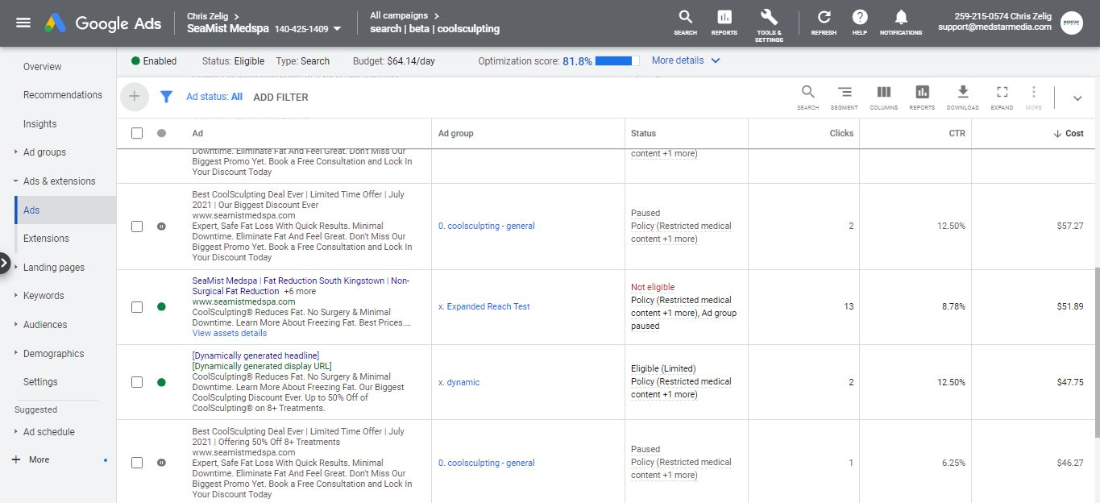
CoolSculpting Marketing Services Seamist Medspa July 1 - July 31, 2021 Total Marketing Expenses (07/1/2021 - 07/31/2021)

Google Ads: $ Total Service Fee: $ Total Marketing Spend: $
1,651.03 2,650.00 4,301.03

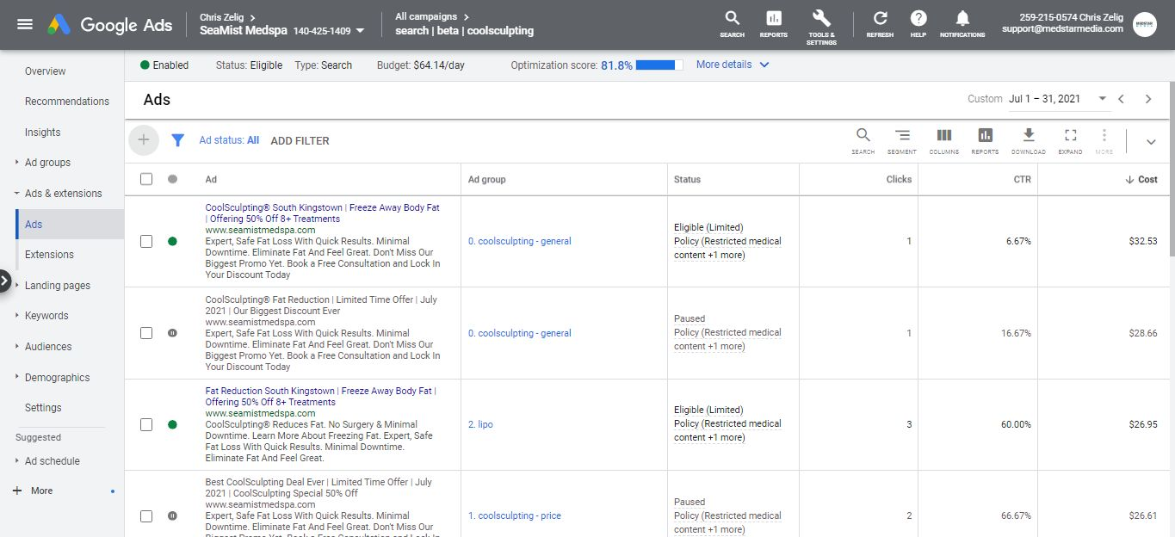
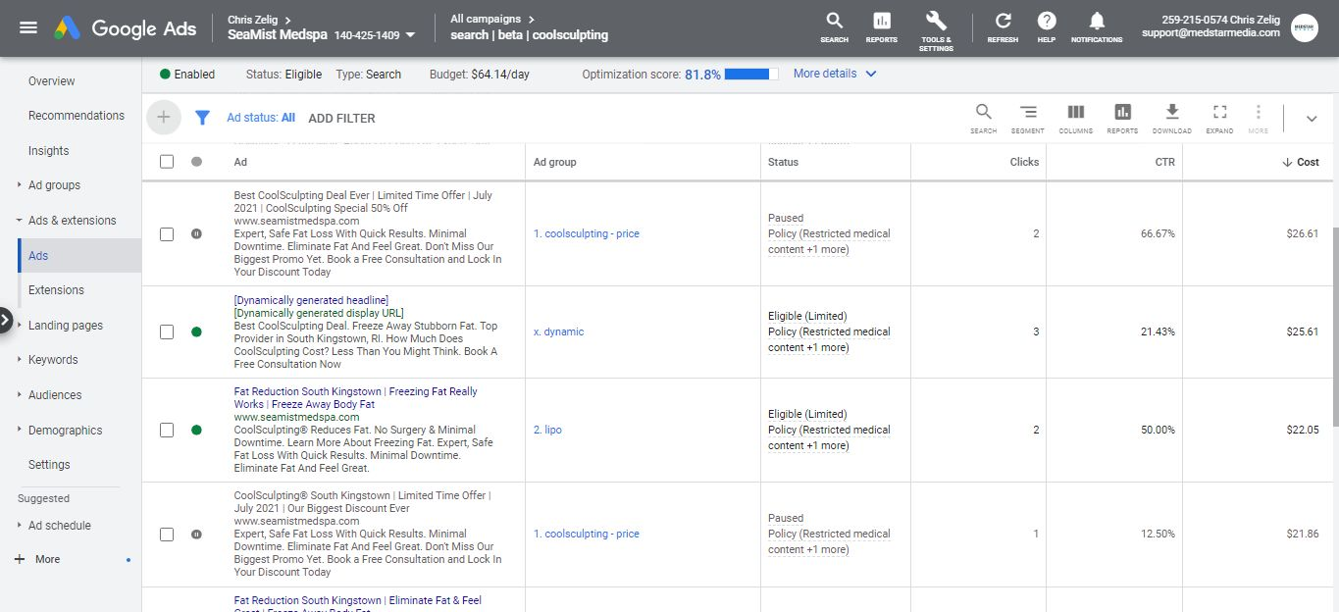
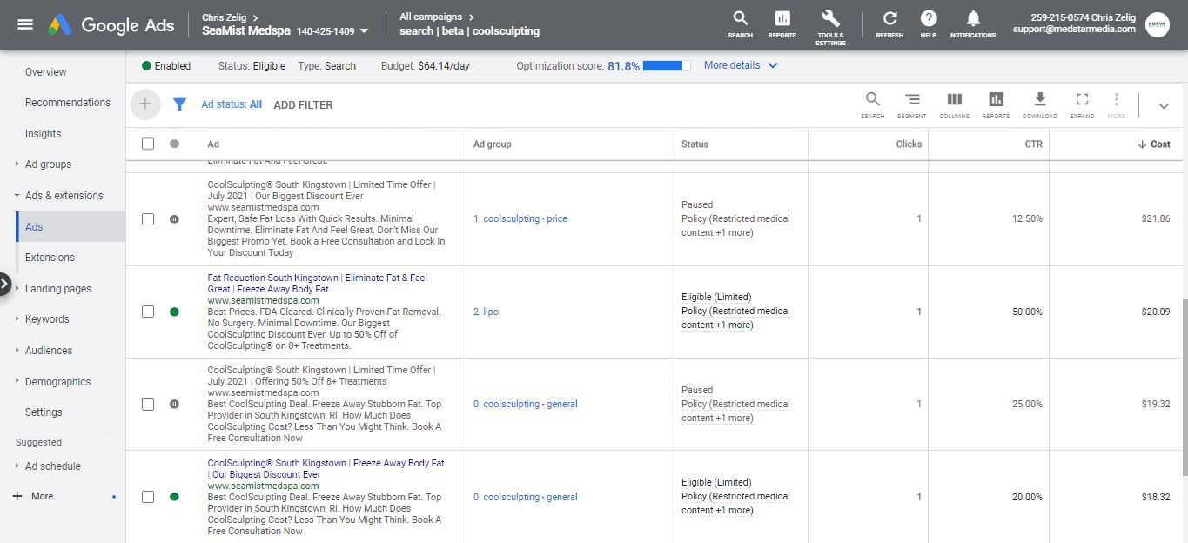
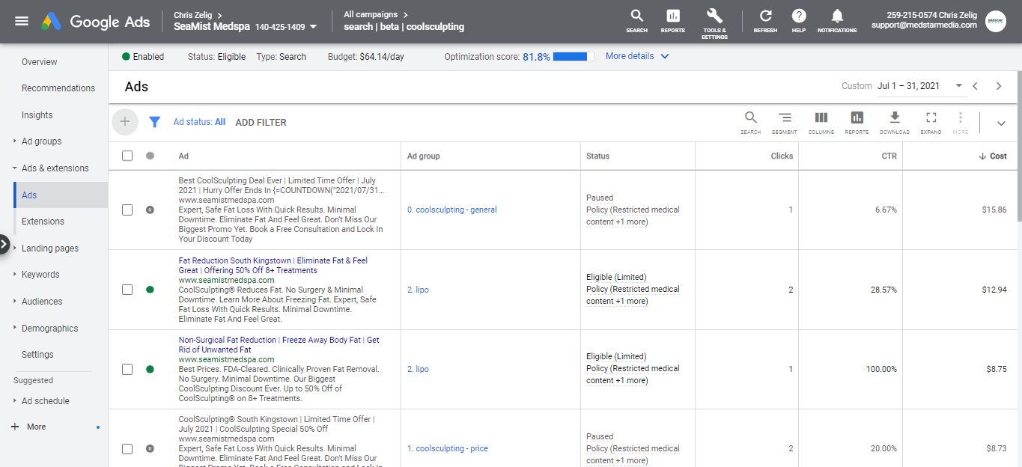
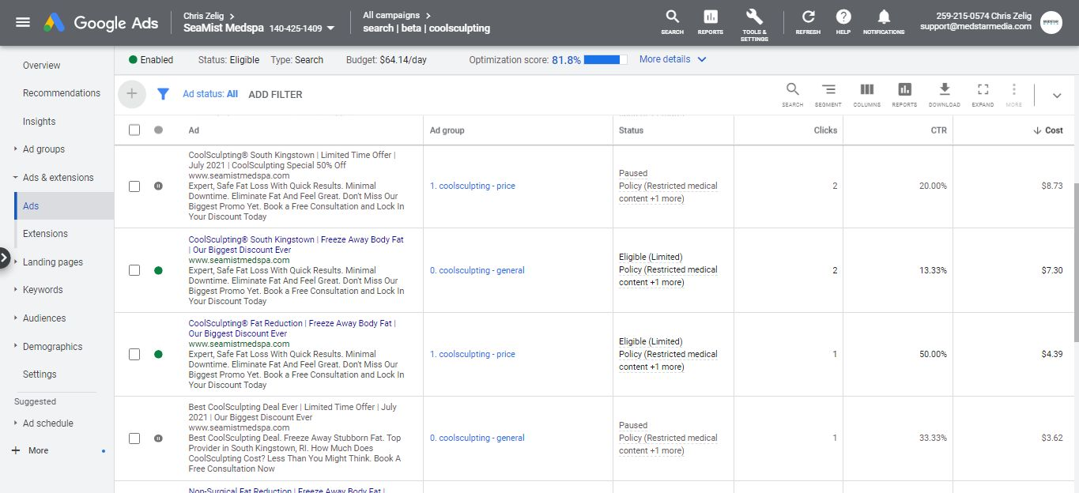

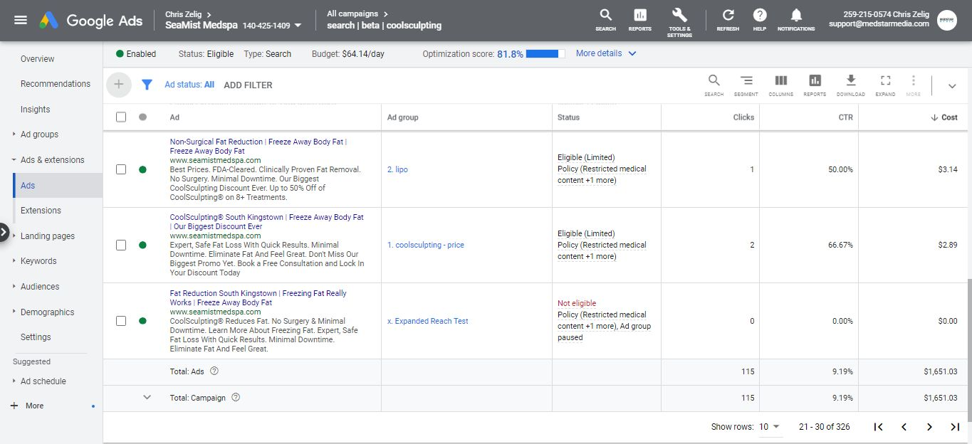
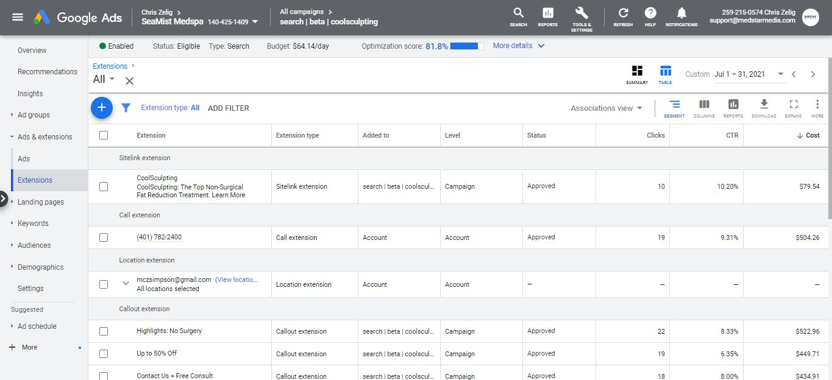
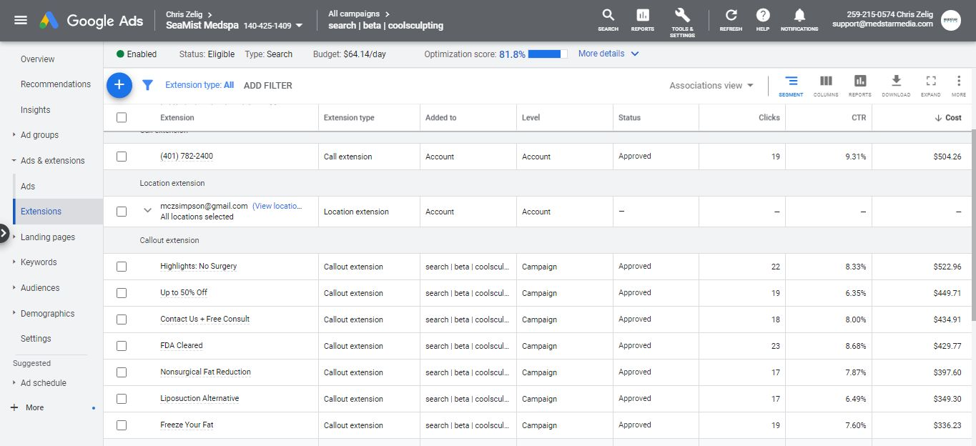
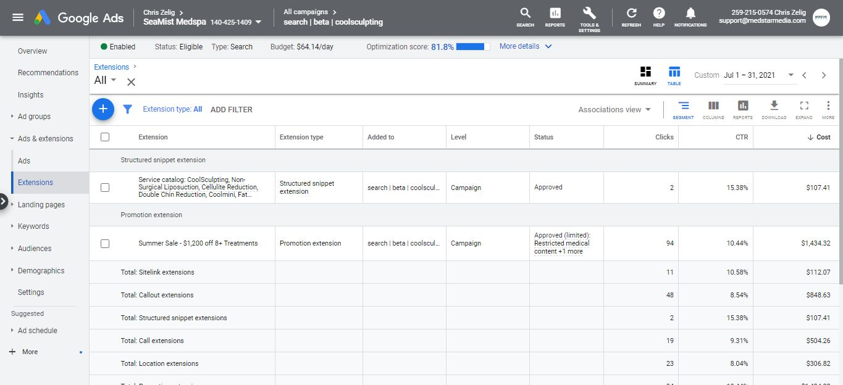
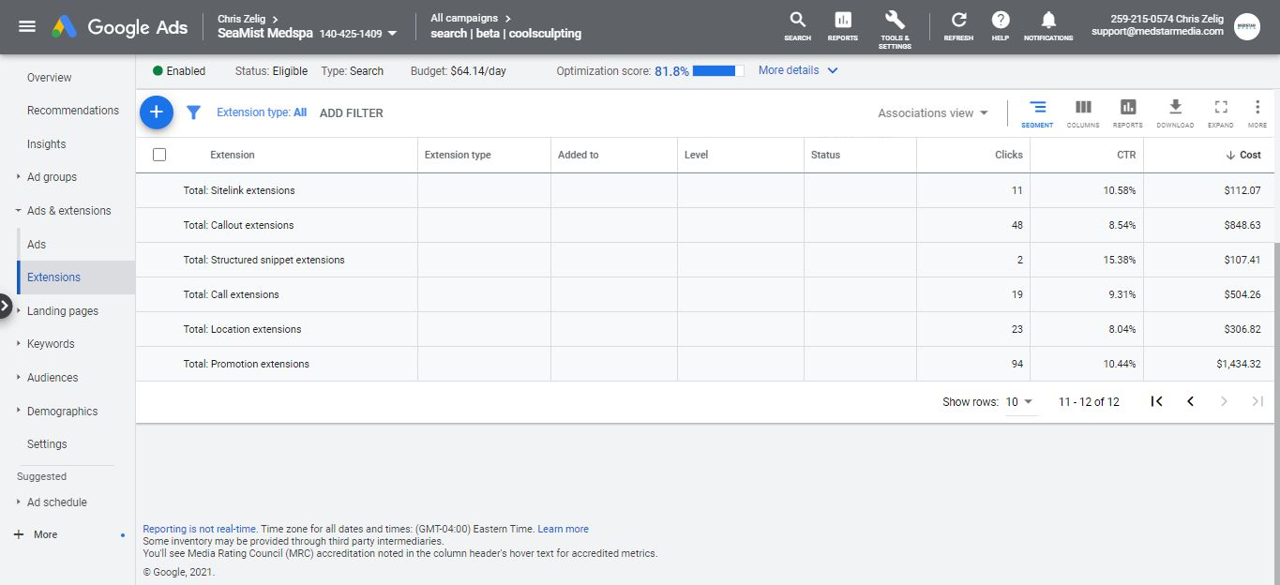

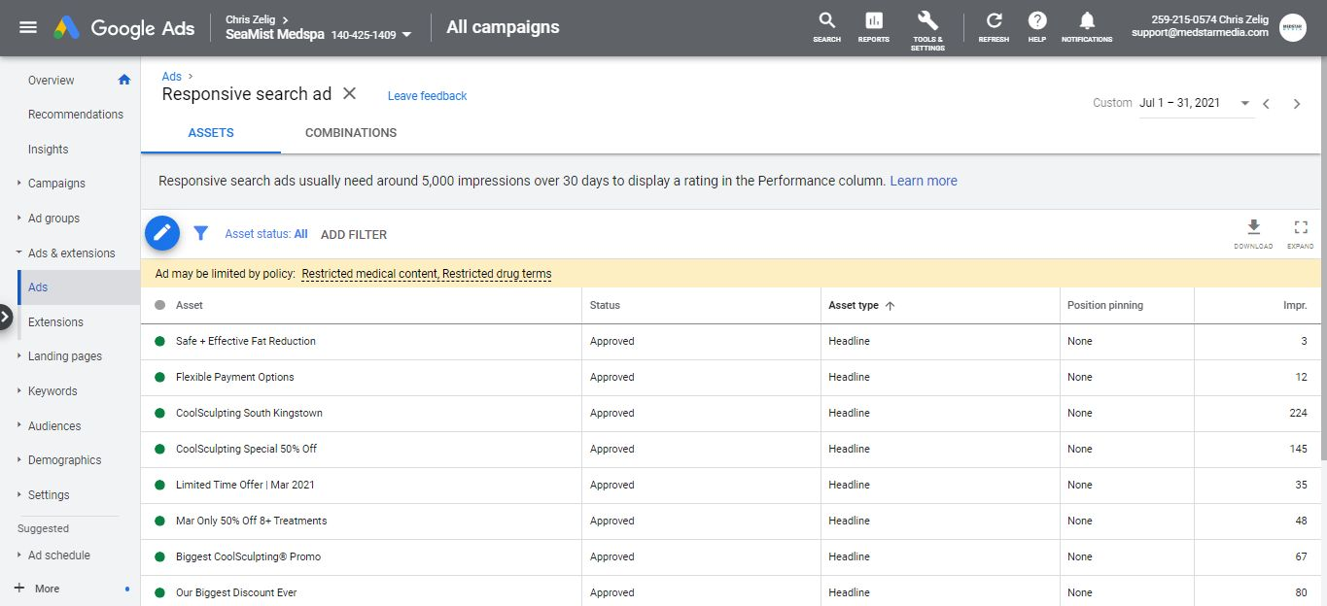
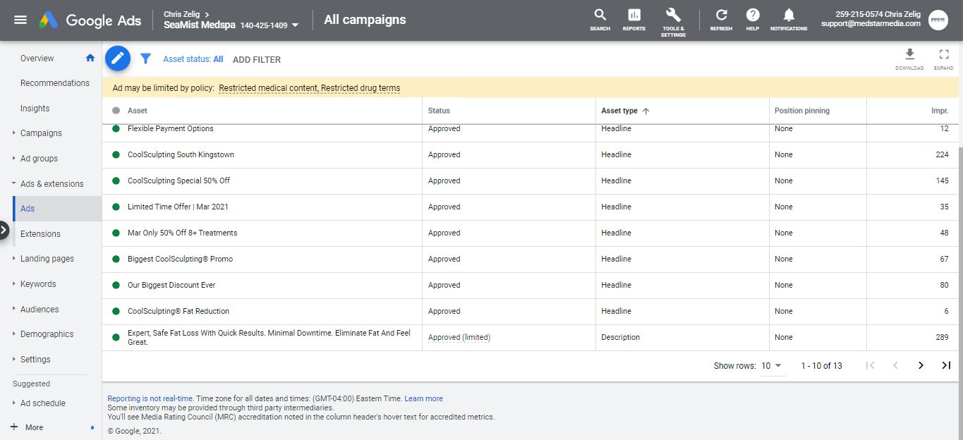
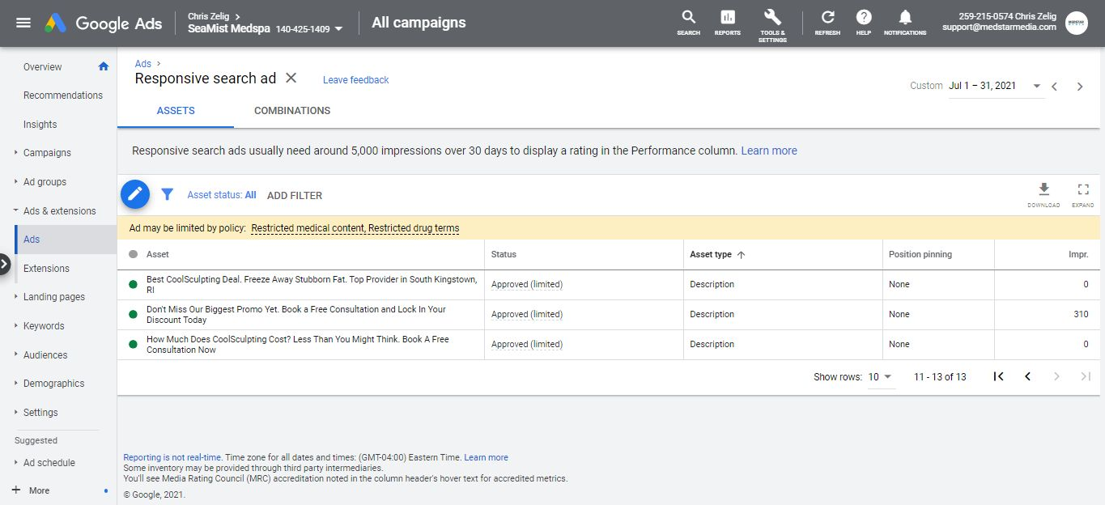


INVOICE

Medstar Media, Inc. 10808 S. River Front Parkway Suite 3020
South Jordan, Utah 84095 United States

6466949450

BILL TO
Sea Mist Medspa Mary Simpson

mczsimpson@gmail.com

Invoice Number:

Invoice Date:

Payment Due:

Amount Due (USD):

WV 2021_149

July 1, 2021

July 1, 2021

$0.00

Items

Digital Marketing Monthly Management Service • Monthly management of Google Adwords and active Facebook and Instagram campaigns.
• Optimize campaigns for conversions monthly
• Monitor budget and adjust bids to gain better ROI • Manage keyword selection and audience targeting • Consult Exit pop technology
to increase leads.
Discounted from $1750. Includes management of two locations.

Service Page Content
Credit for overbilling on PDO Threads

Website Design + Development Website speed optimization
Quantity

1

1

8
Price

$1,250.00

($200.00)

$200.00
Amount

$1,250.00

($200.00)

$1,600.00

Total:

Payment on July 1, 2021 using ending in 3005:
$2,650.00

$2,650.00

Amount Due (USD): $0.00

