1000 Word Emsculpt NEO Update.Seaside Skin Care.KA

Link to page: https://seasideskincare.com/emsculpt/

*Note to developer: please keep their page design as in-tact as possible while updating this Emsculpt Neo page.

*KEEP THIS THE SAME*
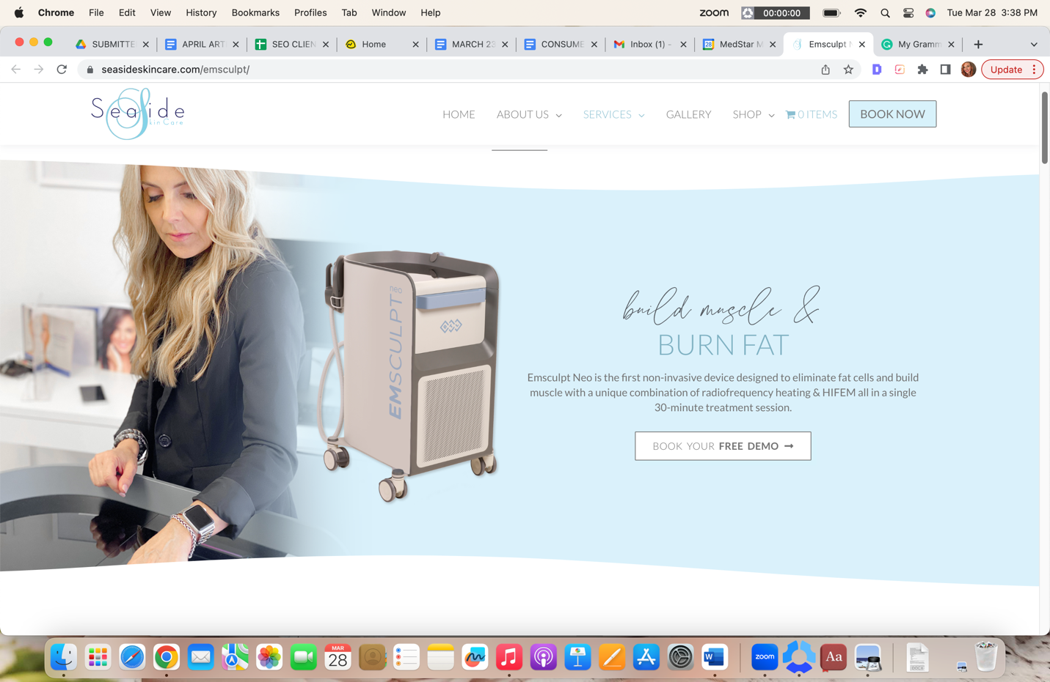

CHANGE THE H2 TO “EMSCULPT NEO IN SAN CLEMENTE, CALIFORNIA
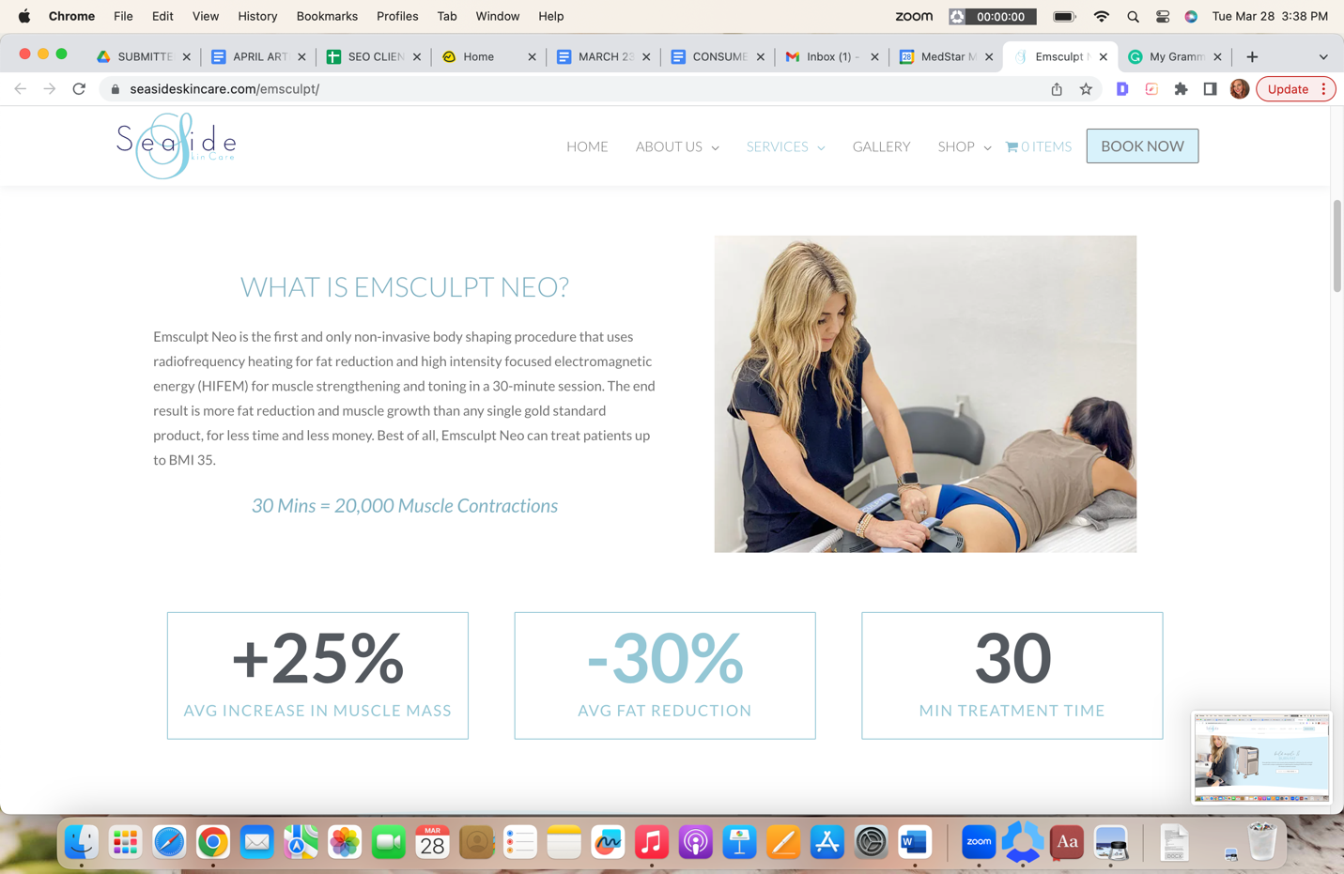

*CHANGE THE TEXT TO READ: See Seaside’s Emsculpt Neo before and after photos of ACTUAL patients for authentic “real-life” results.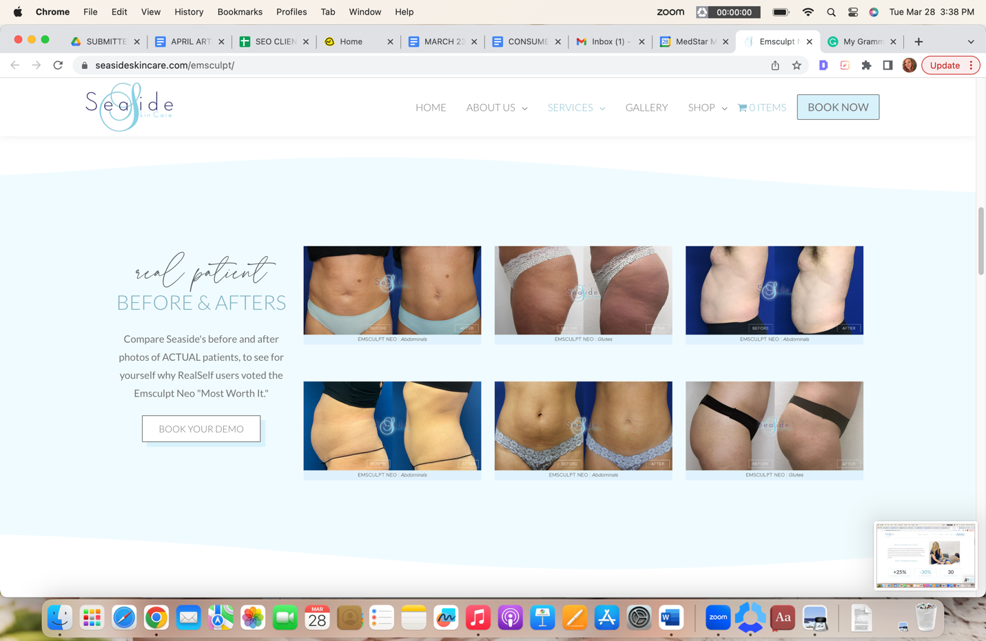

*KEEP THIS SECTION THE SAME*
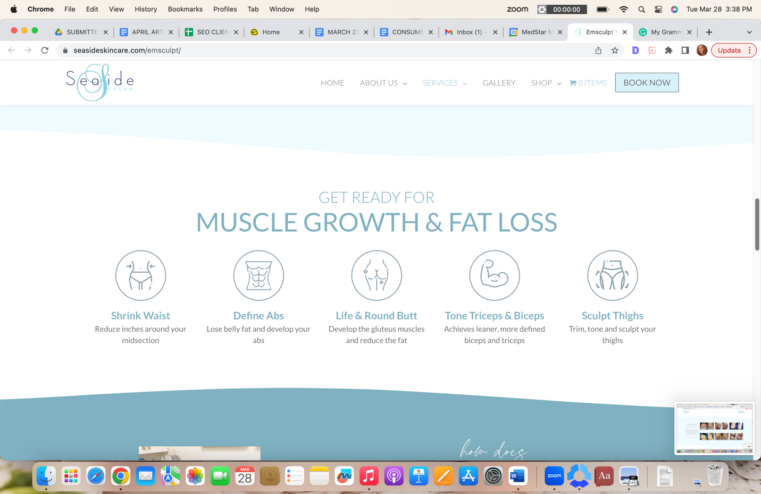

*KEEP SECTION THE SAME BUT CHANGE H2 TO UNDERSTANDING EMSCULPT NEO TECHNOLOGY*
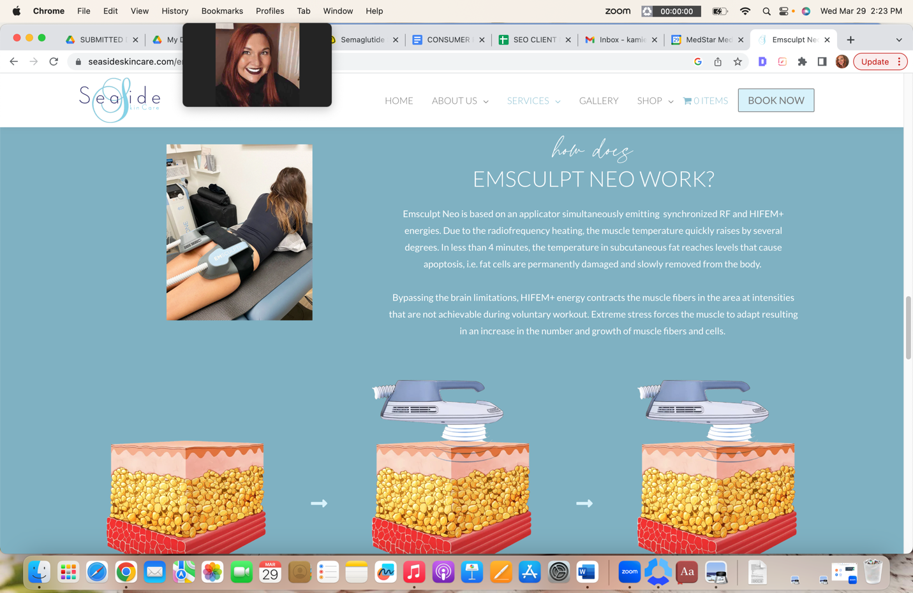

H2 Benefits of Body Shaping with Emsculpt Neo

- Slim, sculpt, and strengthen your physique
- Build, tone, and firm muscle
- Natural, long-lasting fat reduction
- FDA cleared + scientifically proven
- Painless + no downtime
- Convenient 30-minute treatments

H2 Emsculpt Neo vs the Original Emsculpt

The NEW Emsculpt Neo uses the same muscle-building technology as the original treatment. The difference? Emsculpt Neo introduces the combination of High-Intensity Focused Electromagnetic (HIFEM) energy with powerful Radiofrequency (RF) energy. This addition of RF energy enhances the fat-burning results possible with this body-shaping treatment. In addition, Emsculpt Neo is ideal for most body types, including adults with a BMI of up to 35.

H2 Emsculpt Neo Treatment Areas

Emsculpt Neo is FDA-cleared to build, strengthen, and define muscles AND burn fat from 4 specific locations on the body. These include the abdomen, the arms, the legs, and the buttocks.

H3 Emsculpt for the Abdomen: Emsculpt Neo’s revolutionary technology makes achieving that coveted “washboard ab” look easy. Treatments strengthen your core muscles, define abdominal muscles, and burn off stubborn belly fat.

H3 Emsculpt for the Arms: The arms are a typically problematic area. Emsculpt Neo’s applicators make it easy to target any pesky fat buildup in the upper arms while strengthening and building the biceps and triceps.

H3 Emsculpt for the Legs: Emsculpt Neo treats both the thighs and the calves. Treatments firm the upper leg muscles for solid, defined thighs. In addition, Emsculpt for the legs targets those hard-to-work calf muscles for slim, defined calves.

H3 Emsculpt for the Buttocks: Enjoy a non-surgical butt lift using Emsculpt Neo. This technology makes it possible to lift, tone, and firm your buttocks for flawless BBL-like results without the painful surgery.

H2 Emsculpt Neo Results*

Most clients see their Emsculpt Neo results within 3 months of the body shaping experience. As always, individual experiences will vary.*

Clinical studies show Emsculpt Neo provides dramatic physical changes. On average, people experience a 25% increase in muscle and/or a 30% decrease in stubborn fat cells.

H2 Emsculpt Neo FAQs

H3 Are there side effects to Emsculpt Neo?

There are no adverse side effects to Emsculpt Neo. However, people can expect to experience mild muscle soreness for a few days afterward. This feeling is comparable to the soreness you may feel after a hard workout in the gym.

H3 How long do Emsculpt Neo treatments take?

Emsculpt Neo is a quick, convenient 30-minute treatment.

H3 What is the typical Emsculpt Neo treatment plan?

Most people will need 4 Emsculpt Neo sessions scheduled 1 week to 10 days apart. When you schedule a consultation with Seaside Skin Care, you can speak in-depth with a treatment specialist to determine how to best achieve your optimal aesthetic body goals.

H3 How much does Emsculpt Neo cost in San Clemente?

Each body shaping treatment is tailored to the unique needs and goals of the client. Therefore, Emsculpt Neo cost varies per person. During your consultation at Seaside Skin Care, prices are discussed in detail.

H3 Who is not a candidate for Emsculpt Neo?

Emsculpt Neo is not a good treatment option for women who are currently pregnant or nursing. It is also not a good treatment for anyone with a metal or electronic implant in the treatment area. Additionally, anyone with a BMI over 35 may not be suitable for Emsculpt Neo.

Let the professionals at Seaside assess your treatment candidacy by scheduling a consultation.

H2 Experience Emsculpt Neo in San Clemente, California

If you want to achieve the impossible, consider body shaping with Emsculpt Neo. You can sculpt, define, tone, and strengthen your physique at a superhuman rate while simultaneously burning off stubborn fat. Learn more about Emsculpt Neo by scheduling a consultation with the experts at Seaside.

Seaside Skin Care is proud to provide safe and effective Emsculpt Neo body shaping in San Clemente, CA. We also proudly serve clients in Orange County, South Orange County, and San Juan, California. Call us now at (949) 276-2777 or fill out the online form to schedule your consultation and begin your body-shaping journey with the best Emsculpt Neo provider in Orange County.

