750 Word Update to Emtone Service Page.Seaside Skin Care.KA

Link to page: https://seasideskincare.com/emtone/

*Jonnamae, same with this page: Keep their design intact as much as possible but make these slight changes to the page:

Keep this section the same but change FDA-approved to FDA-cleared
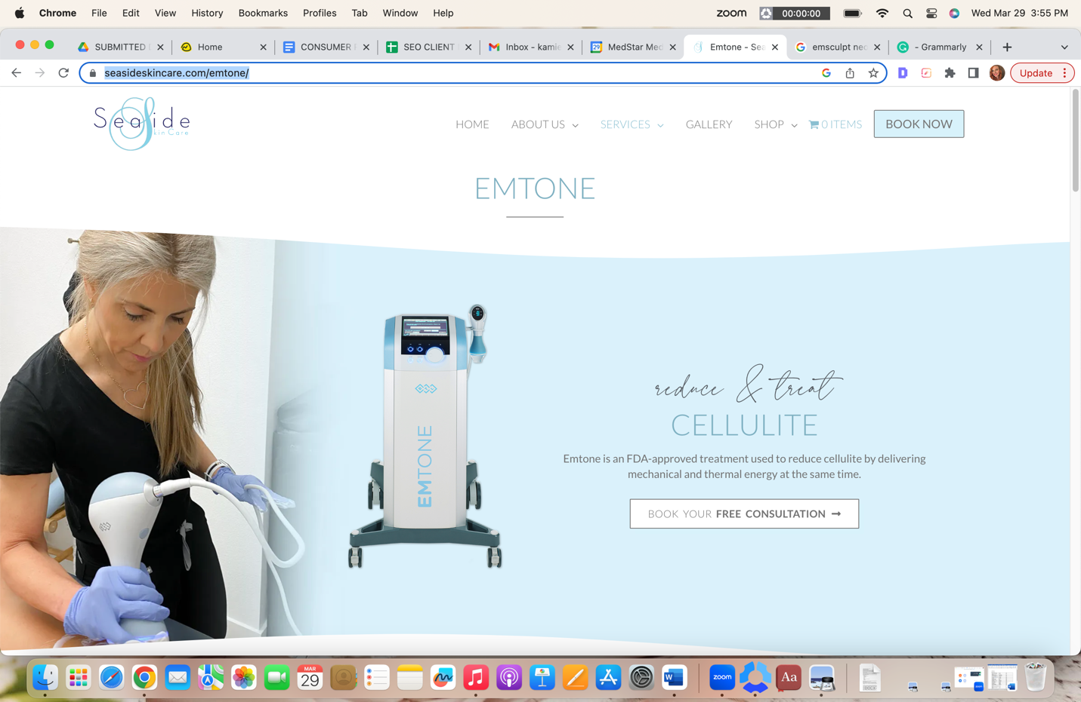

Keep this section the same but change the H2 to UNDERSTANDING EMTONE TECHNOLOGY

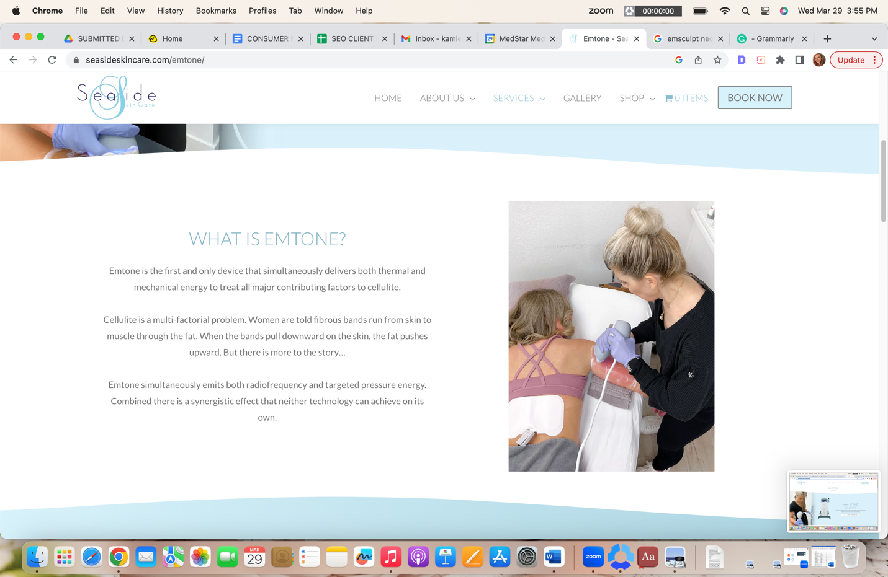
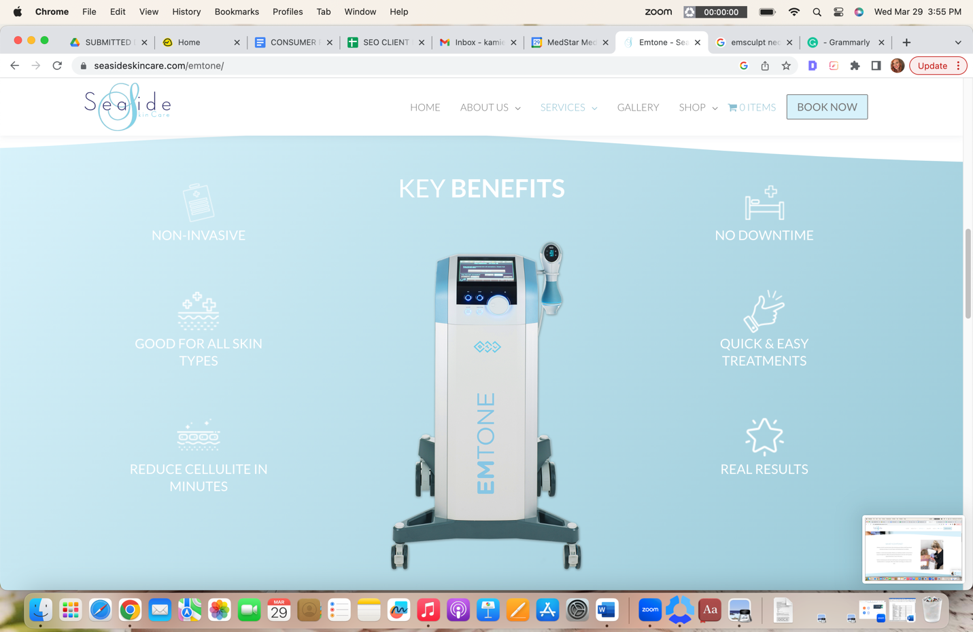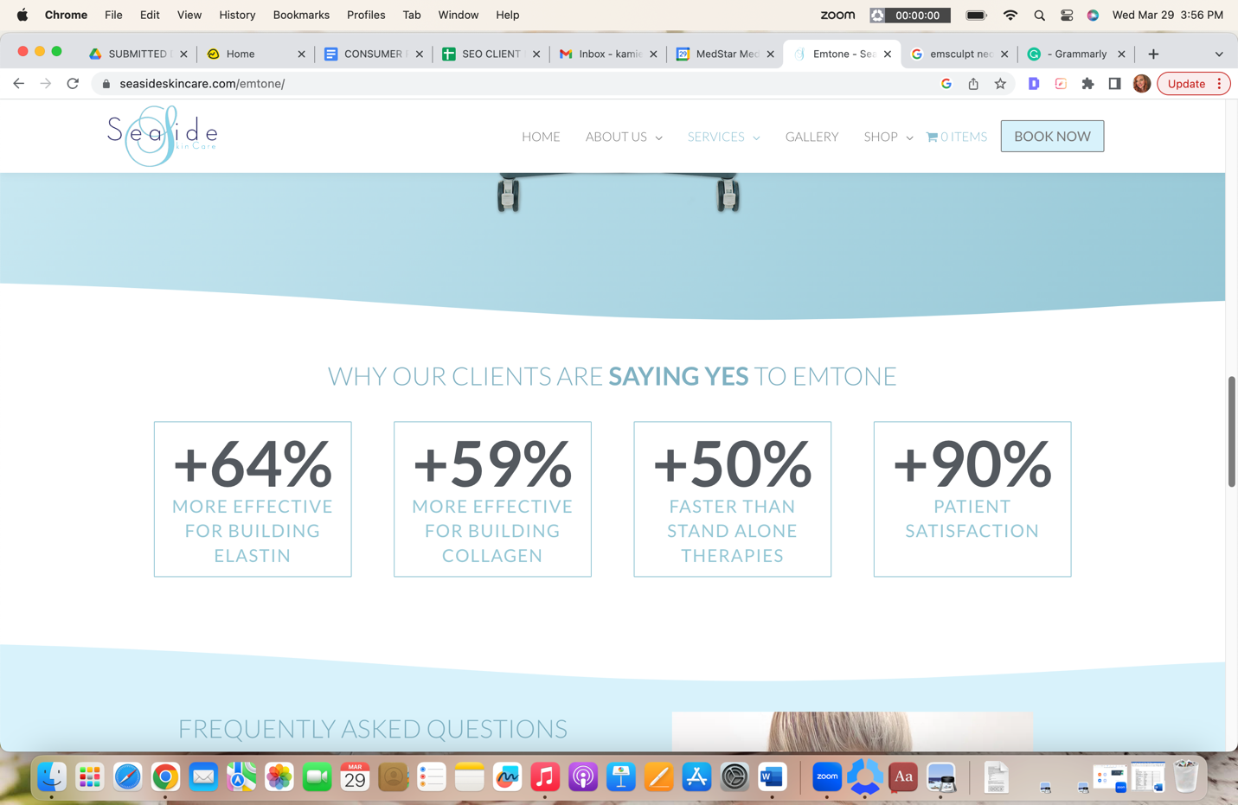
KEEP TOP TWO SLIDES THE SAME

H2 Benefits of Reducing Cellulite with Emtone
- Non-surgical skin rejuvenation
- FDA-cleared and scientifically proven
- Painless treatments
- No downtime
- Targets all causes of cellulite
- Achieve smooth, dimple-free skin
- Treatments from a leading skin spa
H2 Emtone Cellulite Reduction Before and After*
The Emtone before and after results show real patients achieving impressive reduction in their cellulite. As with any cosmetic procedure, results may vary.* However, as seen in the pictures, each person achieves improvements to their skin’s texture. It is important to note that the best way to ensure optimal cellulite reduction is to select a professional Emtone provider like Seaside. We have ample experience in administering this skill-sensitive cellulite treatment.
INSERT BAS
H2 How Cellulite Forms
Cellulite is a notorious problem for millions worldwide, especially adult women. Studies show that 90% of women have cellulite somewhere on their bodies. Cellulite tends to form in any area, but mostly the skin dimpling appears on the stomach, thighs, arms, and buttocks.
Cellulite appears when connective strands or fibers that secure the fat in place under the skin weaken and stretch out. The connective fibers no longer tightly woven together allow underlying fat to bulge through, causing the appearance of rippled or dimpled skin.
While many believe cellulite directly correlates with lifestyle choices, that is not always the case. In fact, cellulite can affect anyone. Contributing factors include the deterioration of collagen and elastin, enlarged fat cells, loss of elasticity, poor blood circulation, fluid retention, and an accumulation of metabolic waste.
H2 How Emtone Targets and Reduces Cellulite
Emtone treatments target the major causes of cellulite using mechanical targeted pressure energy, also known as acoustic waves, and powerful Radiofrequency (RF) energy.
During treatments, the Radiofrequency energy and acoustic waves penetrate the surface of the skin, causing a disruption in the fat cells and heating deeper layers of the skin tissues. The energy also causes several physiological responses, causing the fibers to contract and tighten. In addition, it also stimulates tissue remodeling by triggering a boost in collagen production.
Emtone also triggers the body’s healing mechanisms, increasing blood circulation, and removing metabolic wastes.
H2 Emtone Treatment Areas
Emtone is FDA-cleared to treat cellulite on the most commonly problematic areas on the body. These include:
- The upper arms
- Stomach area
- Front of thighs
- Inner thighs
- Back of thighs
- Love handles
- Buttocks
H2 Emtone Results*
Most people report seeing an improvement in their skin after a single Emtone treatment. However, it takes an estimated four treatments, one to two weeks apart. The 20-minute treatment is painless and requires no downtime. Most people see an improvement in skin dimpling within weeks of the procedure, with continual improvements lasting for several months more. As with all cosmetic skin treatments, results will vary.*

H2 Emtone FAQs

H3 Is Emtone painful?

Emtone is a painless cellulite reduction treatment. The mechanical energy assists in an even distribution of the treatment. As a result, it is painless with no side effects or downtime.

H3 Does Emtone get rid of fat?

Emtone works well at reducing the appearance of cellulite. It uses RF energy and acoustic waves to reduce fat cells and reduce the appearance of cellulite. Treatments make the skin look smoother and more toned. It is an excellent treatment if your primary concern is cellulite reduction. However, if you are more worried about fat reduction, there may be better treatments for you than Emtone.

During a consultation with the professionals at Seaside, you can talk more in-depth about your individual needs and expectations for this treatment.

H3 How long do Emtone results last?

Emtone treatment consists of a series of 4 sessions performed twice a week over two weeks. Some people may require maintenance treatments periodically. These are usually needed every 6 to 12 months to maintain optimal cellulite reduction.

H2 Experience Cellulite Reduction with Emtone in San Clemente
Get silky smooth, dimple-free skin with Emtone. Seaside Skin Care is proud to be the leading provider of Emtone in San Clemente, CA. At Seaside, we specialize in non-surgical skin treatments and are committed to providing you with a positive experience that yields incredible results. Learn more about this revolutionary cellulite reduction treatment by scheduling a consultation. Call us at (949) 276-2777 and begin your journey towards loving the skin you’re in!

