750 Words Update to Neck Filler Service Page.KA

Link: https://seasideskincare.com/cheek-filler/

NEW H1 ORANGE COUNTY NECK FILLERS
NEW H2 REJUVENATE YOUR NECK IN SAN CLEMENTE

UNVEIL A YOUNGER NECK
As we age, parts of our body become more susceptible to noticeable changes—including the neck. Neck lines and wrinkles are a common cosmetic concern for several women and men. Using the powerful Radiesse filler, the professionals of Seaside Skin Care offer a cutting-edge treatment for boosting collagen and elastin, tightening neck skin, and ultimately improving the decolletage. Using a hyper-diluted formula, Radiesse filler injections provide subtle volume to reduce fine lines and wrinkles on the neck and improve the appearance of crepe skin. Radiesse neck filler provides immediate results. In addition, it induces progressive improvements to collagen production prompting long-lasting benefits.
If you are unhappy with your neck’s appearance, contact Seaside Skin Care today. We are proud to be the leading provider of neck filler in Orange County, CA, serving people in San Clemente and surrounding areas. Call us now at (949) 276-2777 to schedule an appointment and discover how the Radiesse dermal filler improves the appearance of your skin, unveiling a more youthful neck.

NECK FILLER BENEFITS
- Increased collagen and elastin production
- Reduced visibility of neck lines and wrinkles
- Skin tightening
- Mild to little pain
- Immediate and progressive results
H2 THE RADIESSE FORMULA (include an image of the filler vial beside this information)

Radiesse and Radiesse (+) are popular dermal fillers, also known as facial fillers or simply fillers. This popular injectable is the only CaHA filler. What is CaHA? Calcium hydroxylapatite. This makes Radiesse unique. Treatments using this formula provide both immediate and progressive, or long-term, improvements to the skin, a year or more later in most patients.*

During treatments, Radiesse is injected into the skin, where it smooths moderate to severe facial wrinkles and folds. Most common treatments include nasolabial folds (the creases from the corner of your nose to the corner of the mouth.) In addition, Radiesse is also commonly used to correct volume loss in the back of the hands.

Now the professionals at Seaside Skin Care are using a hyper-diluted Radiesse formula to rejuvenate the neck. This treatment painlessly improves the look of aging or crepey skin and improves neck bands or lines for a rejuvenated look. Best of all, Radiesse’s innovative formula boosts collagen production. As a result, you will see noticeable improvements to your skin’s texture, including tighter and firmer skin, months after your treatment.

H2 HOW RADIESSE FILLER IMPROVES WRINKLES AND LINES

Radiesse is a dermal filler like other popular brands Juvéderm and Restylane. These common cosmetic injectables are made of a formula that acts as volumizing substance. When it injects under the skin, it plumps up that area helping reduce wrinkles, lines, and areas that are sunken due to age.

H3 NECK FILLER BEFORE AND AFTERS*

*MOVE BEFORE AND AFTER IMAGE HERE BESIDE OF THE HOW RADIESSE FILLER IMPROVES WRINKLES AND LINES*

As always, results will vary per person.*

H2 WHAT TO EXPECT DURING NECK FILLER INJECTIONS

All filler appointments begin with a consultation with one of the Seaside nurses to discuss your goals and evaluate your facial structure. During this time, we determine which filler is best suited to obtain your desired results. A treatment plan will then be discussed and agreed upon prior to beginning the injections.

The neck filler appointment itself generally takes 45 minutes. Your nurse will guide you through every step of the process so that you are completely comfortable during treatment.

H2 NECK FILLER AFTERCARE*

After your neck filler injections, you should not apply makeup for 24 hours afterward. In addition, you should avoid dental work for 2 weeks. We also recommend avoiding strenuous work or exercise for 24-48 hours, as it can worsen the swelling and bruising. You should also avoid intense heat and sun exposure, including saunas or laying out in the sun. Also, no exposure to extreme cold, such as skiing or snowboarding, for at least 3 days following the injections.

H2 COMMON SIDE EFFECTS OF TREATMENT WITH RADIESSE

Common side effects of Radiesse filler include typical dermal filler side effects: bruising, redness, swelling, and itching at the injection site. If you are concerned about side effects, you can speak more in-depth with the Seaside Skin Care professionals during a consultation.
H2 NECK FILLER FAQs *(make sure accordion is collapsed)
H3 HOW MANY NECK FILLER INJECTIONS DO I NEED?*
This filler is generally performed in 2 injection treatments, with some patients needing up to 3 injections. These appointments are spaced 4-6 weeks apart. The exact amount of filler injections you need to rejuvenate your neck will depend on your specific aesthetic concerns.*
H3 LONG DOES NECK FILLER LAST?*
Neck filler typically lasts between 1 year to 18 months. However, some clients metabolize the filler faster than others. As always, results will vary.*
H3 IS FILLER OR BOTOX BETTER FOR A SAGGY NECK?
The best treatment to improve the appearance of your neck depends on the severity of the wrinkles and your goals. For example, people with deeper lines are usually better candidates for filler. On the other hand, people with more superficial lines or who want a little tightening may benefit better from Botox.
When you schedule a neck filler consultation with the professionals at Seaside, we can evaluate your neck and listen to your specific concerns to determine if Radiesse filler or Botox would be best for you.
H3 HOW MANY SYRINGES FOR NECK FILLER?
So, you want to know how many syringes you need for your neck filler? Most people only require, at the most, 1 syringe of filler. During your consultation with Seaside Skin Care, we evaluate your neck and determine exactly how many syringes of filler you will need to correct your cosmetic concerns.
H3 WHO IS NOT A GOOD CANDIDATE FOR RADIESSE NECK FILLER?
You should not use Radiesse filler if you have an allergy to any ingredient in the product or if you have a history of severe allergies. In addition, you should not have fillers if you have a bleeding disorder, are pregnant, or are breastfeeding.

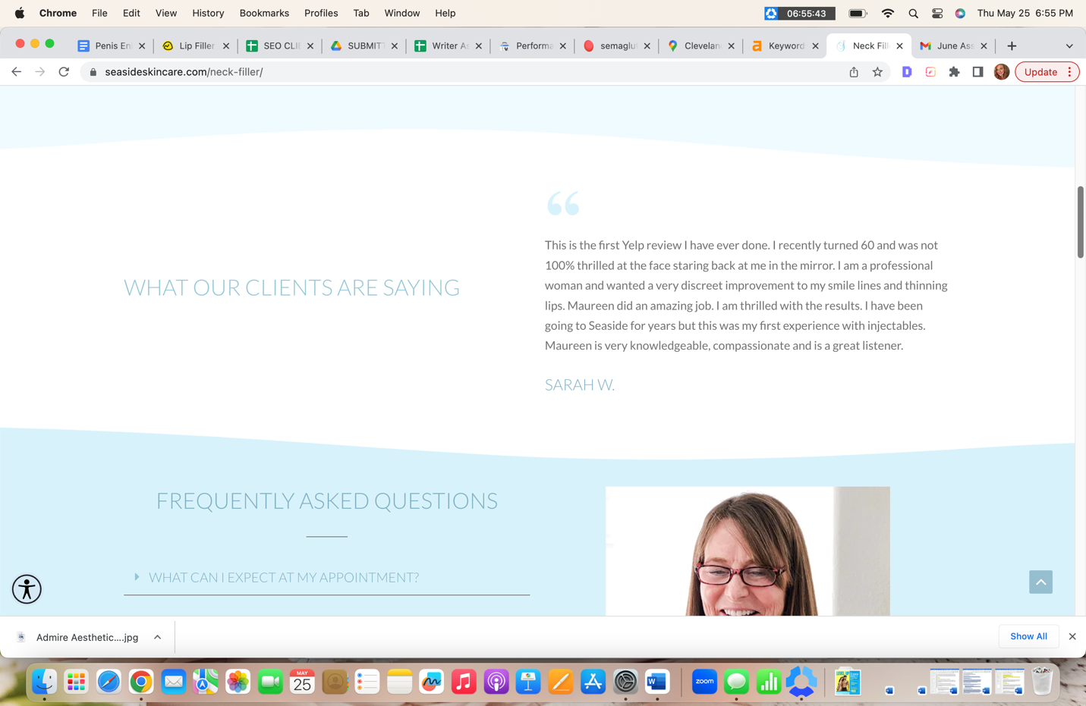

*KEEP CLIENT REVIEWS THE SAME BUT MOVE DOWN THE PAGE UNDER THE CLOSING PARAGRAPH*

H2 REJUVENATE YOUR NECK WITH RADIESSE NECK FILLER IN SAN CLEMENTE

If you live in San Clemente, CA, or the surrounding areas in Orange County and want to rejuvenate your neck, contact the experts at Seaside Skin Care. We are proud to be the leading provider of safe and effective neck fillers using Radiesse in Orange County. Call us now at (949) 276-2777 or reach out to us online to schedule a consultation and discover how these simple cosmetic injectables can improve the appearance of your neck.

